2021 Summer Splash
July 9 – 11, 2021
Sanction #: IN21321

Host: Brownsburg Swim Club (BBSC)

Location: Brownsburg High School, 1000 S. Odell Street, Brownsburg, IN, 46112

Facility: The Brownsburg Aquatic Center is an 8 lane, 50 meter pool. The pool is equipped with non-turbulent lane dividers, Omega touchpads and Daktronics electronic timing system. Bleacher seating is available for more than 600 spectators. The facility has not been certified in accordance with 104.2.2C(4). The water depth at the start end is 5’ and 13’ at the turn end.

Eligibility: Swimmers must be registered with USA Swimming. Age as of July 9th, 2021 will determine the swimmers age for the entire meet.

Fees: $5.00 per Timed Final events
$6.00 per Prelim/Final events
$2.00 ISI
$18.00 Covid surcharge

Admission: Free - Only one adult spectator per athlete. This will be strictly enforced. Children ages 12 and younger will be allowed to accompany adult.

Eligibility: Swimmer(s) must be registered with USA Swimming prior to the competition. Age as of July 9, 2021 shall determine swimmer’s age for the entire meet. Indiana Swimming does not process on-site registration.

Format: All distance events (400m Free, 400m IM and 1500m Free) and 10 & Under and 11-12 events are Timed Finals.

All other events will be Prelim/Final swimming with the top 21 swimmers advancing to Finals. Finals will be swum in the order of C-B-A heats.

For all sessions, other than Session 1 (1500m Free), competition will be held in lanes 1-7 with lane 8 remaining open for warm-up, warm-down throughout the meet.
The Scratch Deadline for preliminary and timed-finals sessions will be 30 minutes prior to the start of the session. The Scratch rule as stated in the current USA Swimming Rule Book, Section 207.11.6, will be in effect, modified as stated below. Note: Swimmers in the 13-14 and Open Preliminary Sessions, who have checked in and miss an event that they did not scratch, will be scratched from their next individual event that session. Swimmers in the 13-14 and Open who fail to compete in a Finals will be scratched from any subsequent events in that session and will be required to sign an Intent to Compete form prior to the Scratch Deadline for their next session or they will be scratched. An Intent to Scratch form will be available.

For 10 & U and 11-12 Events, there will be no penalty for failure to compete.

The Brownsburg Swim Club reserves the right to limit the number of entries in one or more events to maintain a reasonable length of the meet. In the event that entries are limited, the host club will return the entry fees to the club(s) whose swimmers are not allowed to compete in the specific event(s).

Entry Limits: 13 & Over swimmers are limited to 3 events per day (Timed Finals and Prelims combined). 11-12 and 10 & Under swimmers are limited to 4 events per day. After the scratch deadline, if too many events are entered, swims will be accepted in numerical order. No refunds of entry fees will be made to swimmers who enter more than three events per day.

Entries: Entries will be accepted starting 8:00am Wednesday, June 16th 2021 until 11:59pm Tuesday, June 29, 2021. The entry deadline will be extended if the meet does not fill. Teams not accepted will be notified by Wednesday, June 30th. Events will be seeded LCM, SCM, SCY.

Entry Format: The meet will be run using Hytek’s Meet Manager. Entries must be made by emailing an Entry File (jschrier248@gmail.com). BBSC will send an acknowledgement that your entry file has been received within 48 hours of submission. Should you not receive an acknowledgement of entry within 48 hours, please contact the entry chair.

For all teams, Release and Hold Harmless agreement and payment for entry fees must be received prior to the start of warm-ups on the first day of the meet that your team has participants unless other arrangements have been made in advance.

Make checks payable to Brownsburg Swim Club.

Entry Chair: Brownsburg Swim Club
Jen Schrier
PO Box 971
Brownsburg, IN 46112
jschrier248@gmail.com

Meet Directors: Jen Schrier (jschrier248@gmail.com) and Renee Wilson (rdmwils@yahoo.com)

Meet Referee: Jay Watson (we4watsons5891@gmail.com)

Rules: Current USA Swimming rules will govern this event.
202.4.9 D – Any swimmer entered in the meet, must be certified by a USA Swimming-member coach as being proficient in performing a racing start or must start each race from within the water. When unaccompanied by a member-coach, it is the responsibility of the swimmer or the swimmer’s legal guardian to ensure compliance with this requirement. 202.4.9 E & 205.2.2 & 202.4.9 F- Swimmer(s) must be registered with USA Swimming to be accepted into this meet. Age as of (Host to insert first day of meet) shall determine the swimmer’s age for the entire meet. Indiana Swimming does not process onsite memberships. USA Swimming Rules 202.5.3 - At a sanctioned competitive event, USA Swimming athlete members must be under the supervision of a USA Swimming member coach during warm-up, competition, and warm-down. The Meet Director or Meet Referee may assist in making arrangements for such supervision, but it is the swimmer’s responsibility to make such arrangements prior to the start of the meet. The competitor must wear only one swimsuit in one or two pieces except as provided in USA Swimming Rule 205.10.1. All swimsuits shall be made of textile materials. For men, the swimsuit shall not extend above the navel nor below the knees, and for women, shall not cover the neck, extend past the shoulder, nor extend below the knee.

Coaches and Officials MUST display their current USA Swimming coach credential or Deck Pass to gain deck access. The meet referee and/or meet director reserves the right to ask for coach credential or Deck Pass and/or deny deck access if coach does not comply or card is no longer valid/current.
The use of audio or visual recording devices, including a cell phone, is not permitted in any changing area, rest rooms, or locker rooms. It is understood and agreed that USA Swimming shall be free from any liabilities or claims for damages arising by reason of injuries to anyone during the conduct of the event.
202.4.9 I – Deck changes are prohibited.
202.4.9 J – Operation of a drone, or any other flying apparatus, is prohibited over the venue (pools, athlete/coach areas, spectator areas and open-ceiling locker rooms) any time athletes, coaches, officials and/or spectators are present. Exceptions may be granted with prior written approval by the Program Operations Vice Chair.

NOTES: ONLY COACHES AND PARTICIPATING OFFICIALS ARE ALLOWED ON THE POOL DECK. NO FOOD IS ALLOWED ON THE POOL DECK. SMOKING IS NOT PERMITTED ANYWHERE ON THE PIKE HIGH SCHOOL CAMPUS.

It is the responsibility of the coaches and team parents to monitor and be responsible for your swimmers. We ask for your cooperation in taking care not to damage the school property and to clean up your area before leaving for the day.

1500 Freestyle: The 1500 freestyle will be limited to the top 16 swims by gender. If space exists BBSC reserves right to combine genders to fill all heat. All swimmers must provide a timer. Swimmers are responsible to provide a lap counter for the 1500 freestyle should they choose to use one.

Warmups: Warm ups for preliminary and timed final sessions will be broken into A and B groups of 30 minute each.

Coaches: A Coaches meeting will be held 30 minutes before the start of each session.

Awards: Ribbons will be awarded for places 1st thru 14th.

Officials: We would appreciate any help your club’s USA Swimming registered and certified officials may be willing to give us on deck. With a meet of this size, we rely on officials from other clubs. Please complete and attach the accompanying Officials Volunteer Form to your entry. Advance notice allows us to accommodate position assignments and hospitality arrangements.

Attire is whites over blues. Shorts are acceptable throughout the meet.

Official briefings will be held approximately 45 minutes prior to the start of the session in Hospitality.

CONCESSIONS: Concession stand on site.

PARKING: Parking is available in the North lot of Brownsburg High School. Please use door #14 for entry.

An inherent risk of exposure to COVID-19 exists in any public place where people are present. COVID-19 is an extremely contagious disease that can lead to severe illness and death. According to the Centers for Disease Control and Prevention, senior citizens and individuals with underlying medical conditions are especially vulnerable.
USA Swimming, Inc., cannot prevent you (or your child(ren)) from becoming exposed to, contracting, or spreading COVID-19 while participating in USA Swimming sanctioned events. It is not possible to prevent against the presence of the disease. Therefore, if you choose to participate in a USA Swimming sanctioned event, you may be exposing yourself to and/or increasing your risk of contracting or spreading COVID-19.
BY ATTENDING OR PARTICIPATING IN THIS COMPETITION, YOU VOLUNTARILY ASSUME ALL RISKS ASSOCIATED WITH EXPOSURE TO COVID-19 AND FOREVER RELEASE AND HOLD HARMLESS USA SWIMMING AND [THE LSC] AND EACH OF THEIR OFFICERS, DIRECTORS, AGENTS, EMPLOYEES OR OTHER REPRESENTATIVES FROM ANY LIABILITY OR CLAIMS INCLUDING FOR PERSONAL INJURIES, DEATH, DISEASE OR PROPERTY LOSSES, OR ANY OTHER LOSS, INCLUDING BUT NOT LIMITED TO CLAIMS OF NEGLIGENCE AND GIVE UP ANY
CLAIMS YOU MAY HAVE TO SEEK DAMAGES, WHETHER KNOWN OR UNKNOWN, FORESEEN OR UNFORESEEN, IN CONNECTION WITH EXPOSURE, INFECTION, AND/OR SPREAD OF COVID-19 RELATED TO PARTICIPATION IN THIS COMPETITION.
Safe Sport 360: The Minor Athlete Abuse Prevention Policy prohibits Applicable Adults (as defined) from having one-on-one interactions with minor athletes which are not within an observable and interruptible distance from another adult. Applicable Adults are required to abide by this policy in full during this meet.
§ Pursuant to USA Swimming Rules and Regulations and federal law, it is every member’s responsibility to immediately (i.e., within 24 hours) report any incident of child abuse, including physical or sexual abuse, to law enforcement and the U.S. Center for SafeSport. Reporting must occur when an individual has firsthand knowledge of misconduct or where specific and credible information has been received from a victim or knowledgeable third party. A report to the U.S. Center for SafeSport may be made via telephone at 720-531-0340 or online at www.uscenterforsafesport.org/report-a-concern. Various state laws may also require reporting to law enforcement or to a designated child protection agency.
§ All athletes age 18 and older must complete Athlete Protection Training in order to be a USA Swimming registered member in good standing. Any athlete who turns 18 on or after [insert date that is 30 days prior to the last date of the actual competition], who has not completed Athlete Protection Training by the first day of competition, will be prohibited from participating in the competition until such time as all membership requirements are completed. Times achieved by an athlete who turns age 18 on or after [insert same date], who competes in this USA Swimming sanctioned event without completing this membership requirement, will NOT count for qualification or recognition. This includes participation as a member of a relay.

Event Sessions

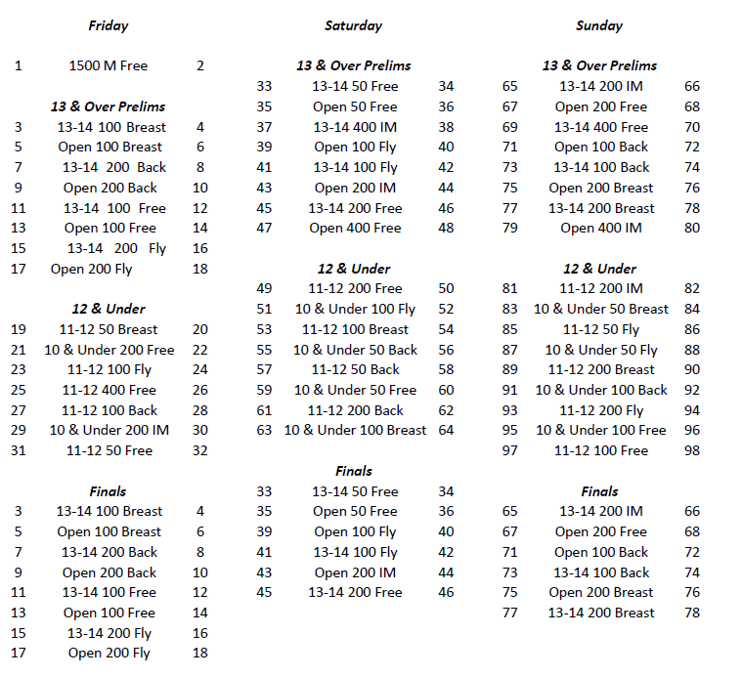
Warm up and Start Times
Friday, 7/9 | 1500 Session | 7:15 | 8:00 AM
 | 13 & Over AM | Not before 9:15 AM | Not before 10:15 AM
 | 12 & under PM | Not before 1:15 PM | Not before 2:15 PM
 | 13 & Over Finals | Not before 5:15 PM | Not before 6:15 PM
Sat. 7/10 and Sun. 7/11 | 13 & Over AM | 7:00 AM | 8:00 AM
 | 12 & Under PM | Not before 12:30 PM | Not before 1:30 PM
 | 13 & Over Finals | Not before 5:30 PM | Not before 6:30 PM
TEAM SUMMARY REPORT
Please send this in once you are accepted into the meet!

Club Name: ______________________________ Club Code: _________

Number of Swimmers Entered: Boys ____ Girls ____ = Total _____

Total Number _____ X $20.00 = __________ (Indiana Swimming Surcharge)
Number of Girls’ Timed Final Events ________ X $5.00 each = $ __________
Number of Girls’ Prelim/Final Events ________ X $6.00 each = $ __________
Number of Boys’ Timed Final Events ________ X $5.00 each = $ __________
Number of Boys’ Prelim/Final Events ________ X $6.00 each = $ __________
Release and Hold Harmless Agreement:
In consideration of being permitted to participate in this swim meet, and for other good and valuable consideration, the undersigned for himself, his successors and assigns, hereby releases and forever discharges the Pike Township Swim Club, and its Board of Directors, USA Swimming, Indiana Swimming and each of their respective officers, agents, employees, members, successors, and any other persons and any way connected with this meet, from any and all liabilities, claims, demands, actions, or causes of action of whatever kind of character arising out of or in connection with said event. Further, the undersigned shall indemnify and hold harmless Pike Township Swim Club, USA Swimming, Indiana Swimming and the officers, trustees, agents, employees and members of the foregoing and all other persons in any way and claims arising out of or in connection with any injury, including death or alleged injury of damage to property sustained or alleged to have sustained in connection with or to have arisen out of said event.
Executed this _______________day of _______________, 2021.

Signature of Club Official or Coach_______________________________________________________________________

