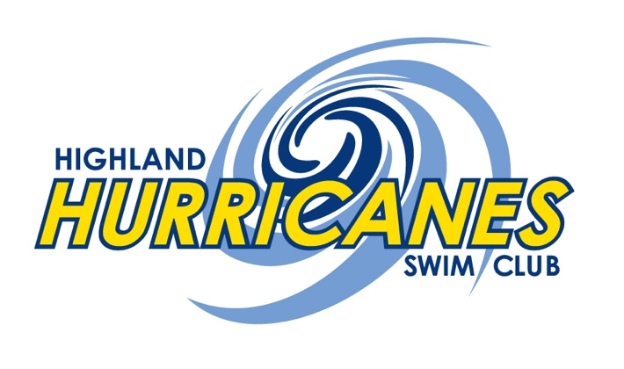

Highland Hurricanes Swim Club (HHSC) is a competitive swim club with membership comprised of age group (age 14 and under) and senior (age 15 to 19) located in Highland, Indiana. We were founded in 1971. Our club is governed by Indiana Swimming and USA Swimming and is a proud participant in the Northwest Indiana Swim Conference.

We are a feeder team for the Highland High School Swimming & Diving Team. HHSC exists to provide a healthy atmosphere where swimmers learn leadership skills, teamwork, the importance of a healthy lifestyle, and the benefits of self-motivation. Our philosophy is to encourage growth in participation of swimming as a competitive sport. This is accomplished by the successful coaching of swimmers through various techniques and sets designed to challenge the limits of each child. As a result, the swimmer will exhibit a high level of swimming ability and enjoy the sport long into their life.

We measure success not only in races won, but also in terms of swimmer enjoyment and participation, individual improvement, and setting achievable goals. We have many different objectives at HHSC, including:
- To provide an opportunity for all children to engage in a lifetime sport and recreational activity
- To promote physical fitness
- To encourage good patterns of physical development and proper conditioning
- To provide opportunities for social, emotional and educational development while encouraging peer and family participation
- To promote and encourage swimmers to continue with the sport of swimming through the high school level and even into the college level swim programs.
- We want your experience at HHSC to be a positive and enjoyable one.

Our team has reached state level recognition through their hard work and dedication.

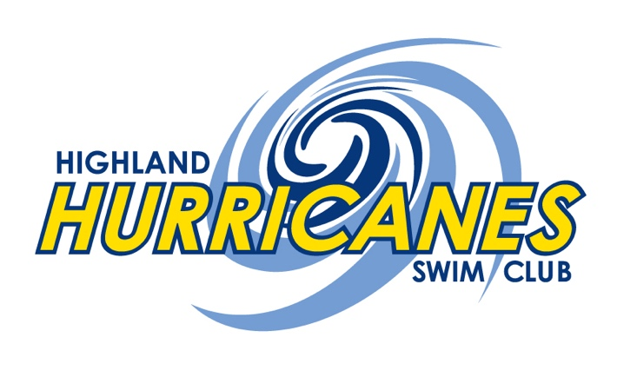
2017-2018 Sponsorship Levels
Bronze Level – Cost $350.00
Your organization will enjoy the following benefits:
- Thank you listing in our heat sheets
- Small banner displayed at all home duals/invitational
- Sponsor listing on website
- Sponsor name listed on T-Shirt (If Received by October 31, 2017)
Silver Level – Cost $550.00
Your organization will enjoy the following benefits:
- Thank you listing in our heat sheets.
- Thank you announcements at all our home meets
- Medium banner displayed at all home duals/invitational
- Sponsor listing on website
- Sponsor name listed on T-Shirt (If Received by October 31, 2017)
Gold Level – Cost $800.00
Your organization will enjoy the following benefits:
- Full page black and white ad attached to heat sheets printed at all sessions at or home invitational
- Thank you listing in our heat sheets
- Thank you announcement at home invitational and duels
- Larger banner displayed at all home duals/invitational
- Sponsor listing on website
- Sponsor name listed on T-Shirt (If Received by October 31, 2017)

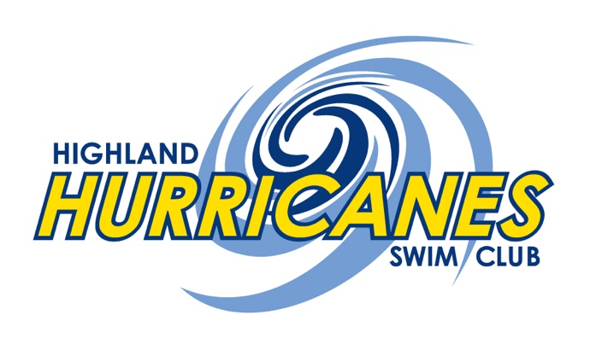 P.O. Box 9357
Highland, Indiana 46322
219-595-9357
www.highlandhurricanes.net

2017-2018 Sponsor Return Form

Name:____________________________________________________
Address:__________________________________________________
City/State/Zip:______________________________________________
Website:__________________________________________________
Bronze Sponsor @ $350.00 = _________________________________
Silver Sponsor @ $550.00 = __________________________________
Gold Sponsor @ $800.00 = ___________________________________
Total = _________________
Make checks payable to Highland Hurricanes Swim Club,
PO Box 9357, Highland, IN 46322
All donations are tax deductible. 501c(3) not-for profit organization Tax ID # 35-1338404
Don’t forget to include your art work, website or business cards

