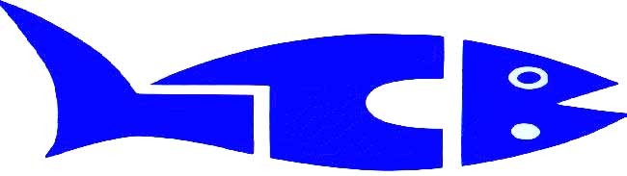

Lake Central Barracudas is a swim team for kids ages 5 to 14. In order to join the swim team your child needs to be able to swim 25 yards (one lap).
The Barracudas practice at the Lake Central Aquatic Center. Attend the practices that fit your schedule. New swimmers are taught how to swim the freestyle, backstroke, breaststroke and butterfly.
During the swim season there are a number of swim meets. You choose what meets to swim. At the swim meets the kids compete
According to age groups (8 & under, 9-10, 11-12, and 13-14). For
New swimmers the swim season starts September 16th and ends mid February.

Lake Central Barracudas Sign-Ups

When: Saturday, September, 14th 9:00 to 11:00AM or
Wednesday, September 18th 5:00PM to 7:00PM
Where: Lake Central Aquatic Center (Enter Door C)
Age: 5 years and up

First time Barracudas bring your suit, towel, and birth certificate copy
Any questions or to arrange a different sign up time, please contact Coach Jeff Kilinski at coachjeff@lcbswim.com or (219) 689-8074 .
Please print the Fall/Winter signup package from our web site at www.lcbswim.com

