HOLLY JOLLY INVITATIONAL
DECEMBER 11-12-13, 2020
Valparaiso Aquatics Center (VAC)

SANCTION: This meet is sanctioned by USA Swimming and Indiana Swimming. Sanction #IN21066

HOST: Valparaiso Swim Club

DATE: December 11, 12, and 13, 2020
LOCATION: Valparaiso High School, 2727 N. Campbell Street, Valparaiso, IN 46383
FACILITY: Competition Pool: One 50-meter pool with ten-7.5-foot wide lanes each with non-turbulent lane markers. Colorado Timing System will be used. One large state of the art,centrally located color score board.The competition pool will be set up with two 10 lane, 25 yard courses. The competition will be held in the south end pool, with the north end for warm-up/warm-down during the meet. No spectators will be allowed in the building.
The West end of the pool has a minimum depth of eight feet (8’). The East (diving well) end of the pool has a minimum depth of fourteen feet (14’) The competition course has not been certified in accordance with rule 104.2.2C(4).
PARKING: Free parking will be available in the lots adjacent to Valparaiso High School. Enter the VAC at Door 16.
COACHES: Coaches and officials must constantly display their USA Swimming credentials or deck pass to gain deck access. The meet referee reserves the right to ask for coach credential display and/or deny deck access to a coach who does not comply. Coaches will be required to show their credentials at the sign-in table before access to pool is granted.
RULES: Current USA Swimming Rules, including the Minor Athlete Abuse Prevention Policy (“MAAPP”), will govern this meet.
202.5.3 - At a sanctioned competitive event, USA Swimming athlete members must be under the supervision of a USA Swimming member coach during warm-up, competition, and warm-down. The Meet Director or Meet Referee may assist in making arrangements for such supervision, but it is the swimmer’s responsibility to make such arrangements prior to the start of the meet.
202.4.9 D – Any swimmer entered in the meet, must be certified by a USA Swimming-member coach as being proficient in performing a racing start or must start each race from within the water. When unaccompanied by a member-coach, it is the responsibility of the swimmer or the swimmer’s legal guardian to ensure compliance with this requirement.
202.4.9 H – Use of audio or visual recording devices, including a cell phone, is not permitted in changing areas, restrooms or locker rooms.
202.4.9 I – Deck changes are prohibited.
202.4.9 J – Operation of a drone, or any other flying apparatus, is prohibited over the venue (pools, athlete/coach areas, spectator areas, and open ceiling locker rooms) any time athletes, coaches, officials, and/or spectators are present. Exceptions may be granted with prior written approval by the Program Operations Vice Chair.
202.4.9 E & 205.2.2 & 202.4.9 F- Swimmer(s) must be registered with USA Swimming to be accepted into this meet. Age as of December 11, 2020 shall determine the swimmer’s age for the entire meet. Indiana Swimming does not process onsite memberships.
202.4.9 G - The competition course has not been certified in accordance with 104.2.2C(4).
202.4.9 C – The water depth of the pool has a minimum dive depth ranging from 6.7’-14’.
ELIGIBILITY: Age as of DECEMBER 11, 2020 shall determine the age for each swimmer entered into the meet. All swimmers must be registered with USA Swimming. These registration numbers must accompany entry. Indiana Swimming does not process on-site registrations. Coaches must present their USA Swimming coach credential to gain deck access. The meet referee or meet director reserves the right to ask for coach credential display and/or deny access if the coach does not comply.
CHECK-IN: The Holly Jolly Invitational will be pre-seeded prior to the date of the meet. No positive check-in required. All athletes will be assigned sections for seating in the stadium area and be clerked in the lower hallway for participation in the meet.
ENTRIES: Teams will be limited to 250 swimmers per session. Each swimmer will be limited to 5 (five) individual events Saturday and Sunday and 1 relay (total of up to six events per swimmer per day). Friday each swimmer will be limited to 2 individual events. If an entry is submitted with an individual entered in more events than this rule allows, the entry will be made by order of events starting with Event #1 until the rule is satisfied; there will be NO refunds.
MEET FORMAT: All meet events will be timed finals format with one session Friday and two sessions on Saturday and Sunday.
- VSC reserves the right to use “Fly Over” starts for all events.
- VSC reserves the right to limit the number of entries in any one or more events to achieve a four-hour maximum timeline per session. Refunds will be provided for any entries in events that are limited. The Meet Entry Chair will notify all affected teams of any limited events.
- At the Meet Referee’s discretion, events may be combined by age, gender, distance, and/or stroke provided there is at least one empty lane between such combined events.
CLERK OF COURSE: Clerk of Course will be provided for all events. Swimmers will be clerked in the lower hallway.

ENTRY FEES: Please make a check payable to: Valparaiso Swim Club. Checks must accompany the entry or be paid prior to the start of the meet. No entry fees will be returned except those received after the limit has been reached.

Individual Events $5.00 each Relay Events $8.00 each Indiana Swimming Surcharge $2.00 per swimmer (Required by Indiana Swimming)
Indiana Swimming Club Support Grant Program $2.00 per swimmer (Required by Indiana Swimming)
Indiana Swimming Club COVID-19 Relief Athlete Surcharge $3.00 per swimmer

DECK ENTRIES: Will NOT be permitted at this meet.
ENTRY PROCEDURE: Entries will be accepted starting Saturday, November 14, 2020 at 8:00AM and must be received no later than Thursday, December 3, 2020 by 5:00PM.
Any accepted team entries may be updated until 5:00 PM on Friday, December 4, 2020. Updated times must be received via email.
Email confirmation of receipt will be returned. All email entries must be followed by a paper entry and check for entry fees. Please make your check payable to Valparaiso Swim Club and enclose it in your entry. The meet will be run using Hy-Tek Meet Manager computer program.

If the meet is over-entered, VSC has sole discretion to determine which entries to accept. In making this decision, teams will not be split. Order of arrival of entries submitted before the entry deadline will not be a consideration.
All times must be submitted in Short Course Yards (SCY) and completed to the hundredth of a second.
Mail entries and fees to Entry Chairperson:
Christopher Pieroni
683 N 50 W Valparaiso, IN 46385 219-614-2123
Email: coachchris@valparaisoswimclub.com
AWARDS: High Point boys and girls awarded in each age group (8&Under, 9-10, 11-12, 13 & Over) and a team trophy.
SCORING will be: 24-21-20-19-18-17-16-15-14-13-11-9-8-7-6-5-4-3-2-1
HOLLY JOLLY SPIRIT: In the spirit of the swim meet, VSC encourages everyone (swimmers, volunteers, and coaches) to wear green/red holiday wear on Saturday and their favorite ugly sweater on Sunday. A jolly VSC elf may be handing out prizes for most spirited!
CONCESSIONS: There will be a limited number of pre-packaged food and drinks available for swimmers to purchase during the meet. VSC reserves the right to cancel concessions at any time leading up to and/or during the meet.
HEAT SHEETS: No paper heat sheets will be provided. Heat Sheets will be available electronically on Meet Mobile.
ADMISSION: Two (2) chaperones will be allowed per team in the stands. It is requested that chaperones help swimmers maintain social distance from one another and direct them to the clerking in the lower hallway to get to their events on time. No spectators will be allowed at this meet.
WEBCAST: The Holly Jolly Invitational will be live streamed. Go to the Valparaiso Swim Club website for the link.

TIME SCHEDULE: All times are local, Central Standard Time. The below time schedule is tentative and subject to change.

Friday, December 11, 2020 Session #1: Warm-ups: Not before 5:00PM
Meet Begins: Not before 6:00PM

Saturday, December 12,2020 Session #2: Warm-ups: Not before 7:00AM
Meet Begins: Not before 8:00AM

Saturday, December 12, 2020 Session #3: Warm-ups: Not before 12:00PM
Meet Begins: Not before 1:00PM

Sunday, December 13, 2020 Session #4: Warm-ups: Not before 7:00AM
Meet Begins: Not before 8:00AM

Sunday, December 13, 2020 Session #5: Warm-ups: Not before 12:00PM
Meet Begins: Not Before 1:00PM
Meet Director: Arene Lee - - arene821@yahoo.com
Meet Referee: Doug Galinsky -- jdgalinsky@gmail.com
OFFICIALS: VSC will need the help of your USA Swimming Officials. If you have officials interested in helping, please provide his/her name & email address on the entry summary form where requested. Per USA Swimming Guidelines, 8 Officials are allowed on deck per session. The Meet Referee requests that all officials sign up and/or contact him ahead of time so that he can plan accordingly.
SUIT RULE: In swimming competitions, the competitor must wear only one swimsuit in one or two pieces except as provided in 205.10.1. All swimsuits shall be made from textile materials. For men, the swimsuit shall not extend above the navel or below the knees, and for women, shall not cover the neck, extend past the shoulder, nor extend below the knee. As a reminder Tech. Suits are no longer permitted for swimmers ages 12 and under. To find out if your suit is allowable, please visit this link.

FACILITY NOTES: It is important that all people attending this meet, whether swimmers, coaches, or chaperones, treat this facility with the utmost care. The following rules will be strictly enforced:
- Keep areas free of trash.
- Do not enter unauthorized areas. This includes other athletic facilities or school grounds.
- Due to USA Swimming insurance requirements, only swimmers, coaches, officials and assigned volunteers will be allowed on deck. There are NO exceptions.
- Mask wearing is mandatory for everyone in the building except when in the water. More details under the COVID guideline for the facility.
- No smoking or use of vapor devices are allowed on VHS property.
- There will be locker room access but NO showers available. Social distancing and mask wearing will still be required. It is up to each team to reinforce that with their swimmers.
- Athlete restrooms are located through the double doors on the northeast end of the second floor. Single occupancy restrooms for volunteers and officials are located in the hospitality area and inside door 16 of the VAC.

HOTELS: Valparaiso has a number of hotels within 10 minutes of the pool. Contact the hotels for rates and availability.

SAFETY: Important information regarding COVID-19 and Safe Sport

An inherent risk of exposure to COVID-19 exists in any public place where people are present. COVID-19 is an extremely contagious disease that can lead to severe illness and death. According to the Centers for Disease Control and Prevention, senior citizens and individuals with underlying medical conditions are especially vulnerable.
USA Swimming, Inc., cannot prevent you (or your child(ren)) from becoming exposed to, contracting, or spreading COVID-19 while participating in USA Swimming sanctioned events. It is not possible to prevent against the presence of the disease. Therefore, if you choose to participate in a USA Swimming sanctioned
event, you may be exposing yourself to and/or increasing your risk of contracting or spreading COVID-19.

BY ATTENDING OR PARTICIPATING IN THIS COMPETITION, YOU VOLUNTARILY ASSUME ALL RISKS ASSOCIATED WITH EXPOSURE TO COVID-19 AND FOREVER RELEASE AND HOLD HARMLESS USA SWIMMING AND [THE LSC] AND EACH OF THEIR OFFICERS, DIRECTORS, AGENTS, EMPLOYEES OR OTHER REPRESENTATIVES FROM ANY LIABILITY OR CLAIMS INCLUDING FOR PERSONAL INJURIES, DEATH, DISEASE OR PROPERTY LOSSES, OR ANY OTHER LOSS, INCLUDING BUT NOT LIMITED TO CLAIMS OF NEGLIGENCE AND GIVE UP ANY
CLAIMS YOU MAY HAVE TO SEEK DAMAGES, WHETHER KNOWN OR UNKNOWN, FORESEEN OR UNFORESEEN, IN CONNECTION WITH EXPOSURE, INFECTION, AND/OR SPREAD OF COVID-19 RELATED TO PARTICIPATION IN THIS COMPETITION.

SAFE SPORT 360: The Minor Athlete Abuse Prevention Policy prohibits Applicable Adults (as defined) from having one-on-one interactions with minor athletes which are not within an observable and interruptible distance from another adult. Applicable Adults are required to abide by this policy in full during this meet.

§ Pursuant to USA Swimming Rules and Regulations and federal law, it is every member’s responsibility to immediately (i.e., within 24 hours) report any incident of child abuse, including physical or sexual abuse, to law enforcement and the U.S. Center for SafeSport. Reporting must occur when an individual has firsthand knowledge of misconduct or where specific and credible information has been received from a victim or knowledgeable third party. A report to the U.S. Center for SafeSport may be made via telephone at 720-531-0340 or online at www.uscenterforsafesport.org/report-a-concern. Various state laws may also require reporting to law enforcement or to a designated child protection agency.

§ All athletes age 18 and older must complete Athlete Protection Training in order to be a USA Swimming registered member in good standing. Any athlete who turns 18 on or after [insert date that is 30 days prior to the last date of the actual competition], who has not completed Athlete Protection Training by the first day of competition, will be prohibited from participating in the competition until such time as all membership requirements are completed. Times achieved by an athlete who turns age 18 on or after [insert same date], who competes in this USA Swimming sanctioned event without completing this membership requirement, will NOT count for qualification or recognition. This includes participation as a member of a relay.

Order of events:

Girls | Age-group | Event | Boys
Session #1
Friday PM Warmups 5:00 pm; Meet Begins 6:00pm
1 | 10 & Under | 200 Free | 2
3 | 11-12 | 200 IM | 4
5 | 13 & Over | 400 IM | 6
7 | 10 & Under | 200 IM | 8
9 | Open | 500 Free | 10
11 | 13 & Over | 1000/1650 | 12
Session #2
Saturday AM Warmups (not before) 7:00am;
Meet Begins (not before) 8:00am
13 | 8 & Under | 100 Medley Relay | 14
15 | 13 & Over | 400 Medley Relay | 16
17 | 8 & Under | 25 Free | 18
19 | 13 & Over | 200 Free | 20
21 | 8 & under | 50 Back | 22
23 | 13 & Over | 100 Back | 24
25 | 8 & Under | 100 IM | 26
27 | 13 & Over | 200 Breast | 28
29 | 8 & Under | 25 Fly | 30
31 | 13 & Over | 100 Fly | 32
33 | 8 & Under | 25 Breast | 34
35 | 13 & Over | 50 Free | 36

Girls | Age | Event | Boys
Session #3
Saturday PM Warmups (not before) 12pm;
Meet Begins (not before) 1pm

37 | 11-12 | 200 Medley Relay | 38
39 | 9-10 | 200 Medley Relay | 40
41 | 11-12 | 50 Fly | 42
43 | 9-10 | 100 Bk | 44
45 | 11-12 | 100 Breast | 46
47 | 9-10 | 50 Free | 48
49 | 11-12 | 100 Free | 50
51 | 9-10 | 50 Breast | 52
53 | 11-12 | 50 Back | 54
55 | 9-10 | 100 Fly | 56
57 | 11-12 | 200 Free | 58

Girls | Age | Event | Boys
Session #4
Sunday AM Warmups not before 7:00am;
Meet Begins not before 8:00am
59 | 8 & Under | 100 Free Relay | 60
61 | 13 & Over | 100 Breast | 62
63 | 8 & Under | 50 Free | 64
65 | 13 & Over | 200 Back | 66
67 | 8 & Under | 25 Back | 68
69 | 13 & Over | 100 Free | 70
71 | 8 & Under | 50 Fly | 72
73 | 13 & over | 200 Fly | 74
75 | 8 & Under | 50 Breast | 76
77 | 13 & Over | 200 IM | 78
79 | 8 & Under | 100 Free | 80
81 | 13 & Over | 400 Free Relay | 82

Girls | Age | Event | Boys
Session #5
Sunday PM Warmups not before12:00pm;
Meet Begins not before 1:00pm
83 | 11-12 | 200 Free Relay | 84
85 | 9-10 | 200 Free Relay | 86
87 | 11-12 | 100 Fly | 88
89 | 9-10 | 50 Back | 90
91 | 11-12 | 50 Breast | 92
93 | 9-10 | 100 Free | 94
95 | 11-12 | 50 Free | 96
97 | 9-10 | 50 Breast | 98
99 | 11-12 | 100 Back | 100
101 | 9-10 | 50 Fly | 102

SUMMARY OF ENTRIES
THIS FORM IS REQUIRED WITH PAYMENT DUE BY DAY 1 – START OF MEET
Please fill out the information requested below and mail with your entry form and check. Please refrain from sending cash and make checks payable to Valparaiso Swim Club or VSC

Club Name: |  |  | Club Code:
Indiana Swimming Surcharge |  | Total Swimmers: |  | X | $2.00 | $
Indiana Swimming Club Support Grant Program |  | Total Swimmers: |  | X | $2.00 | $
Indiana Club COVID-19 Relief Athlete Surcharge |  | Total Swimmers: |  | X | $3.00 | $
Total Individual Entries |  | Number of Entries: |  | X | $5.00 | $
Total Relay Entries |  | Number of Entries: |  | X | $8.00 | $
Total Fees for Holly Jolly Invitational: |  |  |  |  |  | $

Club Official Submitting entry: |  |  | Coaches Names:
Name:
Email:
Phone:

Release and Hold Harmless Agreement:
In consideration of being permitted to participate in this swim meet, and for other good and valuable consideration, the undersigned for himself, his successors and assigns, hereby releases and forever discharges the host club Valparaiso Swim Club (VSC) and its Board of Directors, the Valparaiso Aquatics Center, USA Swimming and each of their respective officers, agents, employees, members, successors and any other persons in any way connected with this meet, from any and all liabilities, claims, demands, actions or causes of action of whatever kind of character arising out of or in connection with said event. Further, the undersigned shall indemnify and hold harmless the host club (VSC), VAC, USA Swimming, and the officers, trustees, agents, employees and members of the foregoing and all other persons in any way and claims arising out of or in connection with any injury, including death, or alleged injury of damage to property sustained or alleged to have sustained in connection with or to have arisen out of said event

Executed this ___________ day of ________________________, 2020.

Signature of Club Official or Coach: ______________________________________

Printed Name of Signature: _____________________________________________

You may have one designated spokesperson for your team to talk to the referee or Clerk-of-Course. The coach would be the logical person. Please print the name of your spokesperson: ____________________________

Entry Method: _______ Email ______ Disk

How would you like your results communicated:
______ Hard Copy (snail mail or .pdf file emailed)
______Meet Manager Backup (emailed)
______Team Manager .c12 file (emailed)
______All of the above Email address to send above to: _____________________________

Did you include:
________ Check for entries and surcharges
________ Hard copy of entries (if applicable)
________ I have read the meet letter and understand it

Additional COVID Guidelines

VSC will be following the guidelines provided by the Valparaiso Aquatic Center (VAC), USA Swimming, Indiana Swimming, local, state and national government guidelines.

Dry Guidelines (outside the pool)
A VSC designate will be asking three questions to each swimmer prior to entrance
1. Have you exhibited any flu like symptoms in the last 48 hours?
2. Has any family member exhibited flu like systems or positive case of COVID 19 in the last 14 days?
3. Have you come into contact with anyone with flu like systems or positive case of COVID 19 in the last 14 days?
If the answer is YES to any of these questions the swimmer will not be allowed to swim and is to immediately be picked up by their parents/guardian.
In addition, temperatures will be taken. If the swimmer’s temperature is > 100.4 then the swimmer will be sent home

It is required to wear a face covering at all times.

All coaches, officials, volunteers and chaperons will need to obtain their credentials when checking in prior to each session.

DROP OFF NOTE:
For swimmers 10 and under a parent/guardian must accompany swimmer to ensure swimmer fully understands the questions.
When dropping off you swimmer/s please form a car line at Door 16. The board member/designate will ask the questions while the swimmers and parent/guardian are in the vehicle.
Please enter from the east and exit to the north of the VAC Door 16:
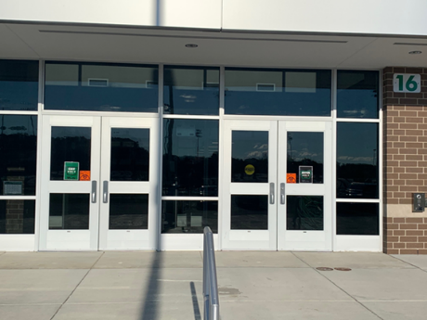

Please form a car line to drop off your swimmers:

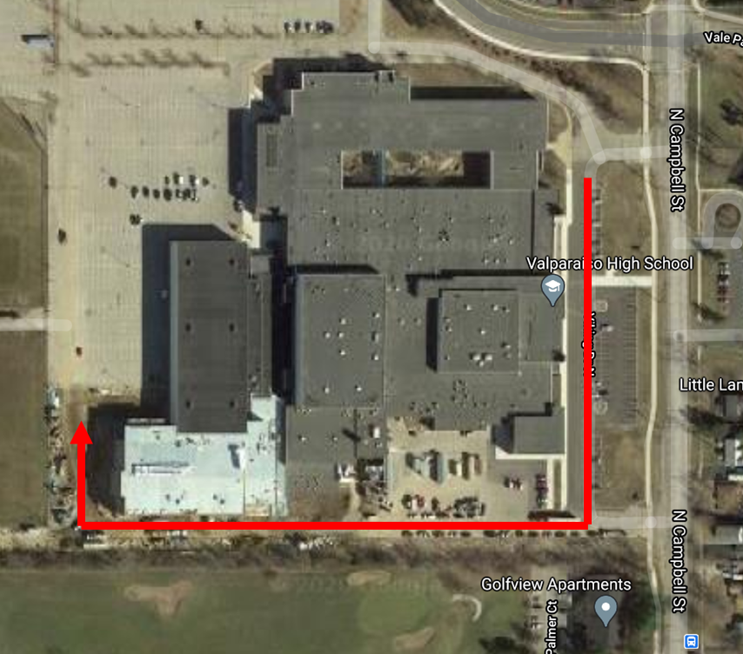

Dry Guidelines (outside the pool in the VAC)
A few key notes from the VAC COVID Swim Guidelines:
- Parents/Guardians are to stay in the vehicle while dropping off and picking up their swimmers
  - Meet is closed to viewing, viewing stands are closed
  - Drop Offs/Pick Ups at Door 16

- Swimmers each swimmer must:
  - Bring all their own gear
  - Bring their own water bottle
  - Be dressed and ready for the meet when dropped off
  - No gear bags can be left at the pool
  - Please read the entire document for a complete list of requirements
  - No chairs allowed in the stands
  - Bring a towel to/from the starting blocks to dry off prior to leaving the deck area
  - Please leave the deck and stands as you found them, clean

General Meet Procedures
- Have FUN while maintaining social distancing and wearing a face mask.
- Swimmers MUST bring a towel to sit on in the stands area and are NOT allowed to sit directly on the pool deck/floor. Swimmers are NOT allowed to share their belongings, including towel with other swimmers. Swimmers may want to bring extra swim caps, goggles, towels, face masks, and plastic baggies (for their face masks) to the meet. Please write the name of the swimmer on the plastic baggie.
- ONLY swimmers, coaches, volunteers and officials from the current session/warmup will be allowed in the facility.
- Due to social distancing policies coaches will be submitting positive check ins to the meet director.
- Masks MUST be worn at all times, except when swimmers are IN the water.
- NO drinking fountains will be available.
- Concession areas may or may not be open based on the current COVID situation. Swimmers may bring their own food and beverage to the meet. Swimmers are NOT allowed to share their food and beverage with other swimmers.
- No food from the hospitality room is allowed on deck.
- Swimmers must arrive and leave in their swimsuits.
- There can ONLY be 50 swimmers, 8 officials, 15 coaches, and 15 volunteers on the pool deck at one time.
- In the pool area, the scoreboard and video feed of the pool will be displayed. This information will also be live-streamed.
- All doors will remain closed during the meet and monitored by volunteers.
- It is the responsibility of the team coaches and chaperones to ensure their respective team is abiding by all rules/policies and ensuring swimmers are lined up in their respective heats prior to each event.
Meet Entry and Pool Area Procedures
Swimmers will only be allowed in for the current session they are swimming. Everyone must leave the VAC between sessions to accurately account for the persons in the VAC during each session.
VSC will have a dedicated spot on deck. This spot enables the swimmer to maintain the recommended 6 feet of social distances.
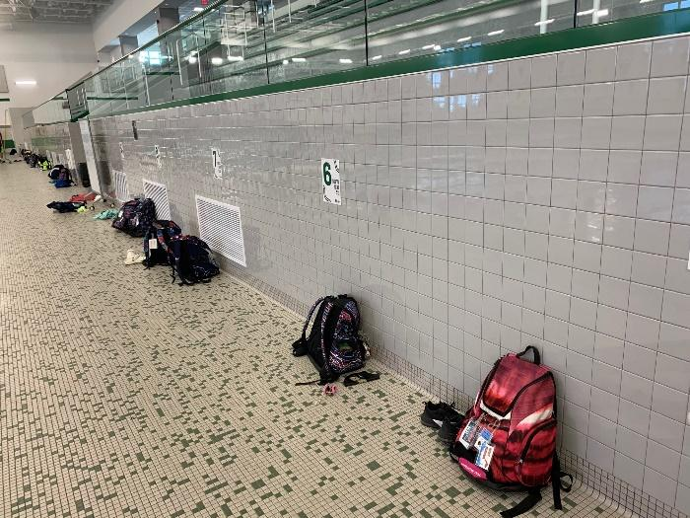
Figure 1 Example of pool deck spacing for swimmers
Swimmers, coaches, volunteers, and officials will enter through the Door #16 (same entrance as practice) and will be asked the health questions, have their temperatures taken, and be given hand sanitizer before they are allowed into the facility.

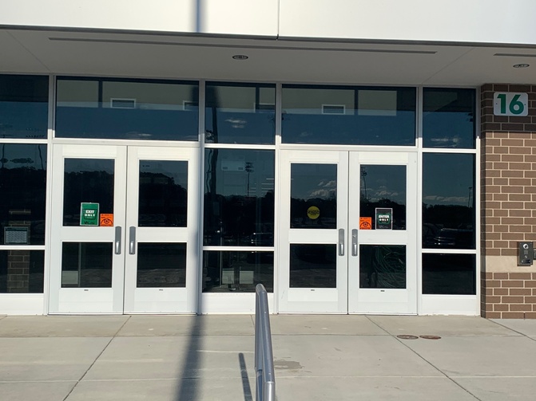
Figure 2 Door #16

The swimmers then enter the pool and put their bag near the number located on the wall of the pool deck or location in the stands.
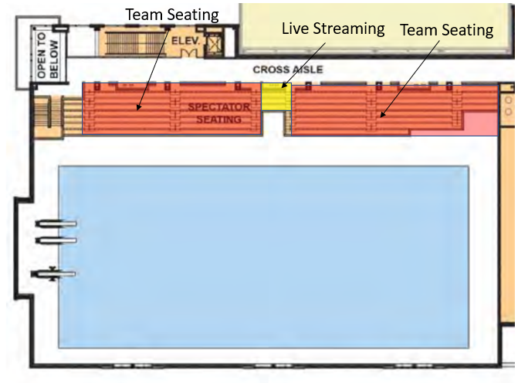
Figure 3 Team Area Assignments

The coaches and officials will proceed through the pool deck and check in.
The volunteers will proceed to their designated volunteer areas.
Volunteers will sanitize door handles and the entrance hallway after all swimmers, coaches, volunteers and officials have entered the facility for that session of the meet.
When their general warm-up time is over, swimmers MUST proceed immediately to their designated area on the pool deck or stands.
There will be lanes dedicated for each team for warmups and cool downs. No more than 4 swimmers per lane.
The next two heats will be lined up in the pool area. These areas will be marked accordingly.
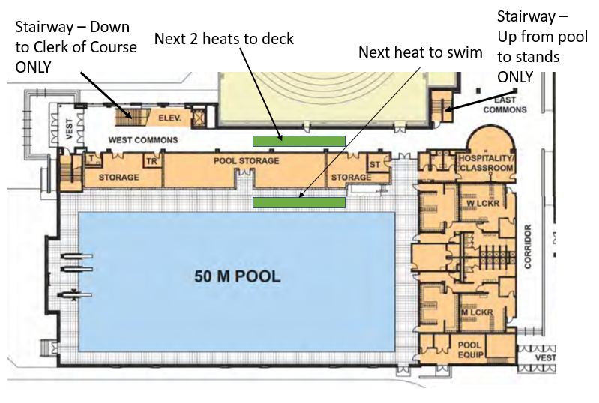
Swimmers need to bring their plastic baggie behind the blocks to put their mask in while they are racing. Swimmers will also need to bring the plastic baggie to the warm-up/cool- down pool to put behind their lane for their mask. NOTE: As soon as a swimmer is done with their race, they need to put their mask on. A swimmer will not be allowed to bring personal belongings with them to the starting block outside race attire with the exception of the baggie and face mask which should be placed behind the block.
The lane timers will sanitize the starting each heat.
Continues COVID guidelines for VAC will be displayed on the scoreboard and on the 8 monitors located within the VAC.
Meet Exit Procedures
The double doors used to exit the pool will be separated by orange safety cones into an exit side and an enter side. To enter the VAC, Door #16 will be on the right as you enter. To exit the VAC, Door #16 on the right side will be used. The only option from those doors, will be to enter the pool area (with the exception of emergency exit if the event arises).
Swimmers can leave the VAC when swimming is completed. However, no congregating around the door entrance and lobby area.

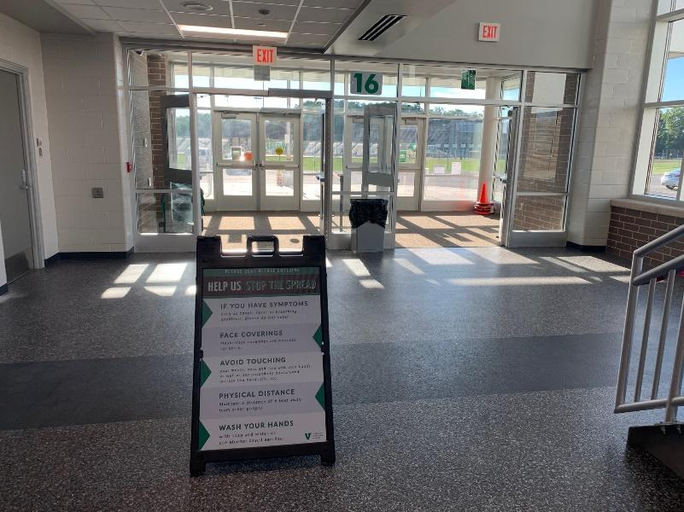
Figure 4 COVID Guidelines on display when entering

Volunteers will be used to monitor the flow of traffic in the hallways.

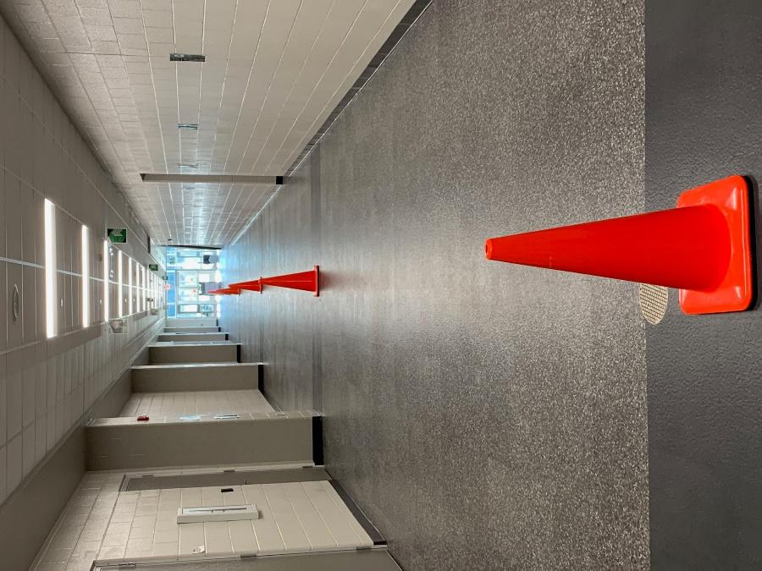
Figure 5 Hallway at entrance onto pool deck divided for entrance and exit

Hand sanitizer will be provided before entering the pool deck.
As soon as a swimmer is done with all of their races and has finished cooling down they should LEAVE the facility as soon as possible.
Volunteers will sanitize the exit hallways and exit doors after the completion of the session.

