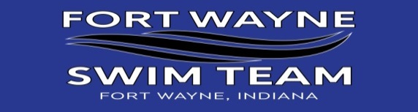



***FORT WAYNE SWIM TEAM GRIEVANCE POLICY***

FORT Wayne Swim Team is committed to providing a safe environment for all members and strives to provide a fun and friendly environment to promote the sport of swimming to children and families. As with any group, it is normal to have questions or concerns arise from time to time. Most issues can and should be resolved informally between the family and their group coach. This is the preferred approach in resolving/reporting issues.

***SAFE SPORT REPORTING PROCEDURES***: if you have a concern or an issue to report, send the information to the FORT Safe Sport Coordinator Michelle Hatfield 260-466-7999   [michelle_hatfield@ceandf.com](mailto:michelle_hatfield@ceandf.com). The Safe Sport Coordinator will meet with the Head Coach/Owner to decide next steps. They may contact you or others involved to collect additional information to assist in their decision in next steps. You may also report your concern to USA Swimming at the following link <https://fs22.formsite.com/usaswimming/form10/index.html> Please remember all reports are kept confidential and we ask that if you have a concern that it is kept confidential on your end as well.

***Categories of Complaints & Procedures for Reporting & Resolving a Grievance.***

1, Regarding Conduct of a Swimmer: If a parent or swimmer feels another swimmer’s conduct is inappropriate or violates the Athlete Code of Conduct, the parents/swimmer should discuss these concerns with the coach of the swimmer responsible for the violation. The complaint may be made in person or in writing. If after this informal meeting with the coach the issue remains unresolved, then a formal meeting with the Safe Sport Coordinator will be set up. If the issue still remains unresolved then a meeting with the Head Coach/Owner will be set to attempt to resolve the issue. If the issue is still not resolved then the Safe Sport Coordinator will select a committee made up of three(3) uninvolved parents, the Head Coach and Head Age Group coach.

2. Regarding Conduct of an Assistant or Age Group Coach: If a parent, swimmer or another coach feel an Assistant or Age Group Coach’s conduct is inappropriate or in violation of any team policies, the parent/swimmer should notify the Head Coach of these concerns and a meeting will be set up. This complaint may be made in person or in writing. If after this informal meeting with the Head Coach the issue remains unresolved, then a formal meeting with the Safe Sport Coordinator will be set up. If the issue is still not resolved then the Safe Sport Coordinator will select a committee made up of three(3) uninvolved parents, the Head Coach.

3. Regarding Conduct of Head Coach: If a parent, swimmer or another coach feels the Head Coach’s conduct is inappropriate or violates any team policies, the parent/swimmer/coach should notify the team Safe Sport Coordinator. The Safe Sport Coordinator will then meet with the Head Age Group Coach to attempt to arrive at a resolution. If the issue remains unresolved, the Safe Sport Coordinator and Head Age Group Coach will select three(3) uninvolved parents to meet to determine further steps. This complaint may be made in person or in writing.