- Long Course events  June 28 JAGS Summer Invite  July 1-6 Moratorium Week  July 4th- No Practice  July 12 Noblesville Enchanted Forest  July 18 Senior State Championship  Aug 17 Indians Game! PCA Group Activity. Registration required. | 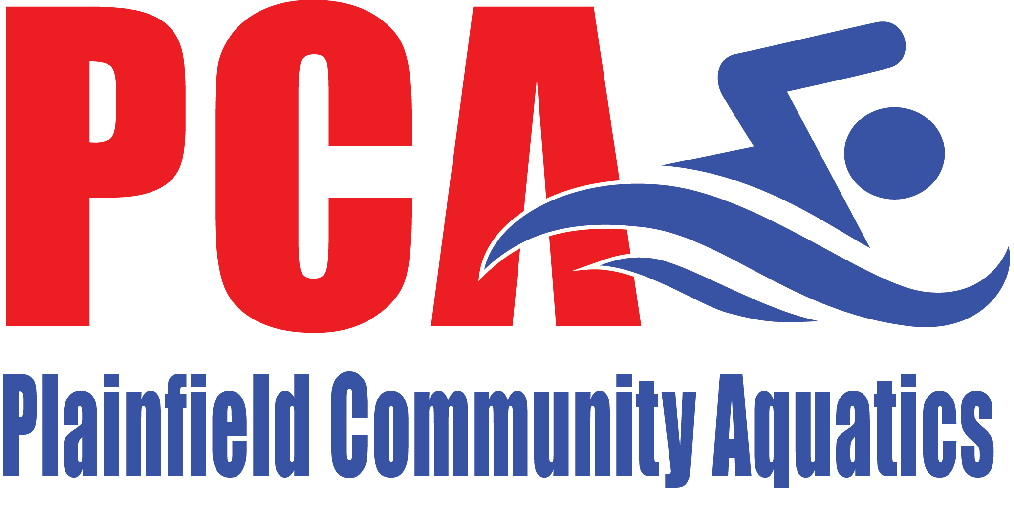  June 2019 edition  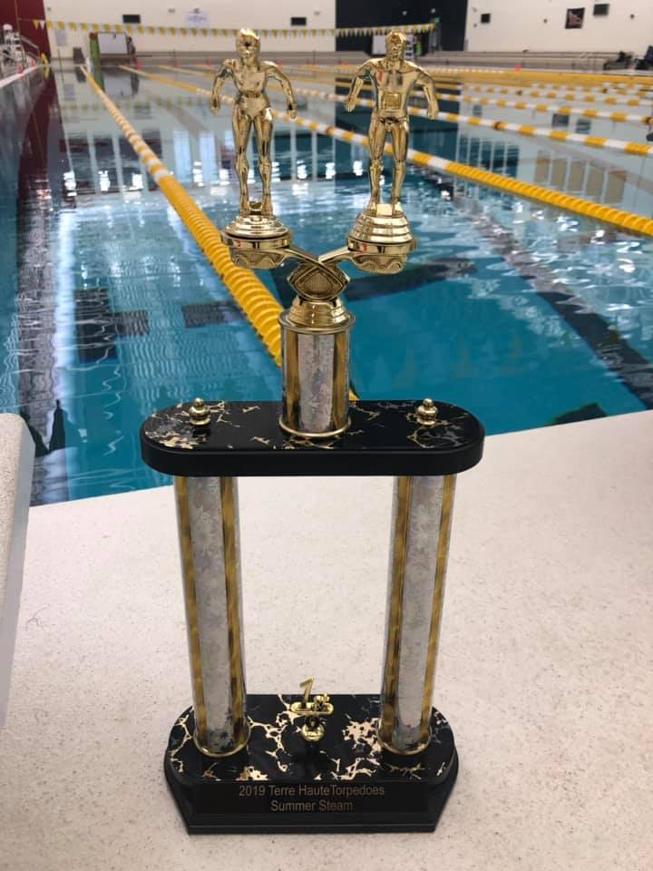  Photo of PCA trophy for combined team champions of the THT Summer Steam  Note from the Board of Directors  USA Swimming launches MAAPP program-  Recently you received an email with updates on some PCA policies. These policy updates were required by USA Swimming for all swim clubs. The MAAPP (Minor Athlete Abuse Protection Policy) was taken into effect on June 23, 2019. Updated policies include:  - One-On-One Interactions  - Social Media and Electronic Communications  - Travel  - Locker Rooms and Changing Areas  - Massages, Rubdowns and Athletic Training Modalities  - APT Requirement for Adult Athletes  Athletes and parents are REQUIRED to sign an acknowledgement stating they have received a copy of these updated policies by July 15. An event has been created on our website for this purpose. Please log in to your account. Click on the event and check the box next to both you and your athletes name.  Angela Maar -PCA Safe Sport Coordinator
- Contact Us  Plainfield Community Aquatics – PCA  Mail:  PO BOX 774  Plainfield, IN 46168  E-mail:  pcaswim@gmail.com  Website:  www.teamunify.com/team/inpca/page/home | From the Coach’s Desk  Age Group Parents-  Over the past several weeks, our age group swimmers have been tackling more yardage in preparation for our end of season championship meets. If your kiddos complain of being tired and sore all the time… it’s because they are! And it’s a good thing that will pay off here in just a few more weeks. It may not seem like it to your athlete(s), but this season is flying by and taper time will be here before they know it!  We have also been spending quality time on stroke progressions and honing in on the basics of how to be powerful in all the strokes, especially underwater and off the walls! Many of our young swimmers are still working to become strong swimmers in ALL the strokes, while others have a primary stroke or primary area of focus, like distance or individual medley. It’s this time in the season that we harness and push in those areas to prepare for championship racing! We are currently looking forward to racing in the upcoming JAGS meet, June 28th – 30th and at the Noblesville Enchanted Forest, July 12th – 14th. I expect to see many more Divisional and State cuts earned by our Age Group kids!  Coach Liz Woodruff  Greetings PCA family,  Over the past several weeks the senior group has started to hone in on speed and power. After 2 months of aerobic base building we have been folding in quite a bit of speed focus in primary stroke and freestyle. So far the swimmers have adapted well to the shift in training emphasis and are seeing some results of their hard work. Our group posted some very nice swims at the Terre Haute meet the weekend of June 7-9, which was nice to see from the coaching side considering the training load that led up to that meet. Even with the speed work we have begun to incorporate, our athletes are in the peak volume cycle of the training plan. This high volume phase is designed to “overload” the muscles so that the taper phase will be successful.  In addition to our great team effort at Terre Haute, one of our senior swimmers had an opportunity to showcase her talents at the Counsilman Classic June 15 and 17th. Futures cuts were the minimum requirement just to enter that meet. Elle Gilkerson posted fantastic swims and advanced to the “D” final (places 25-32) swims in both of her events. To give some perspective, it took junior national, senior national and Olympic Trials cuts just to qualify into the A and B finals in most events. We had the fortunate luck to be on deck to witness Regan Smith break the Junior World Record in the 100 Backstroke twice in the same day. She went 58.4!  Moratorium Week  _________________  Age group (Swells, Breakers, Tidals and Tsunamis) will have practice on July 1,2,3,5 and 6 at the outdoor Splash Island pool. Age group from 8:30-10:30am. Age group dryland will be the last 30 minutes of practice and will take place on the trail system.  Athletes need to be dropped off and picked up at the back gate by the outside lap pool. Swimmers will need to bring their equipment bags to practice. Practices will be weather dependent and all cancellations will be communicated asap.  Senior practice will be 6:30-8:30 am July 1-6 (including July 4). Dryland will be after practice Wed/Fri/Sat. Seniors should enter through the main Rec Center Entrance and wait to be led to the pool deck.  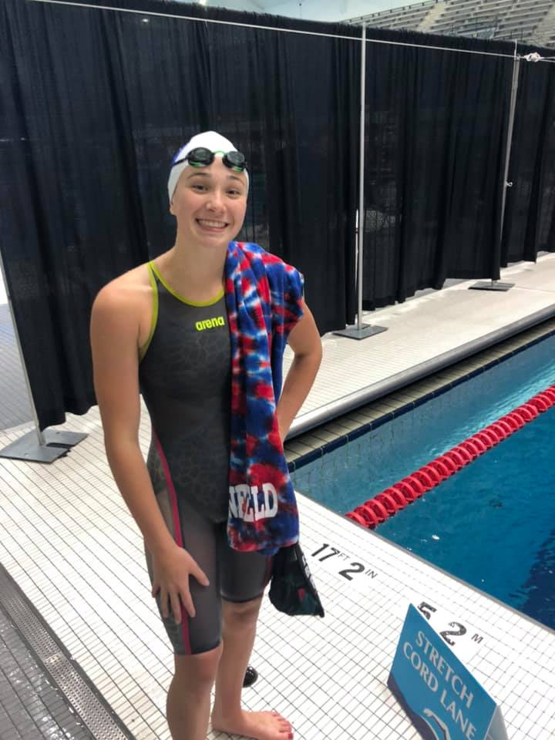  As the season carries on my excitement for our end of summer swimming grows and grows. I am looking forward to some really fast swimming at the state and divisional meets.  Coach Johnson  Parent’s Corner  In this section we want to pass along great information for parents of swimmers. Did you know that on the USA Swimming website there’s a tab just for Parent’s with all kind of helpful articles and videos? Here’s the link to access those https://www.usaswimming.org/for-you/parents  The topic for this edition of Parent’s Corner is “5 Ways to help your child develop Character Through Sport”  PCA Night at the Indians Game  ____________________  We are excited to announce our first group outing. We have reserved a section at the August 17th, 7:00 pm Indianapolis Indians Game for PCA athletes and families. Tickets are $10 for each reserved seat. An event has been posted on our website. You must go to the event and select how many tickets you need by July 26th. Your account will be directly charged. We look forward to a lot of fun with our PCA families!  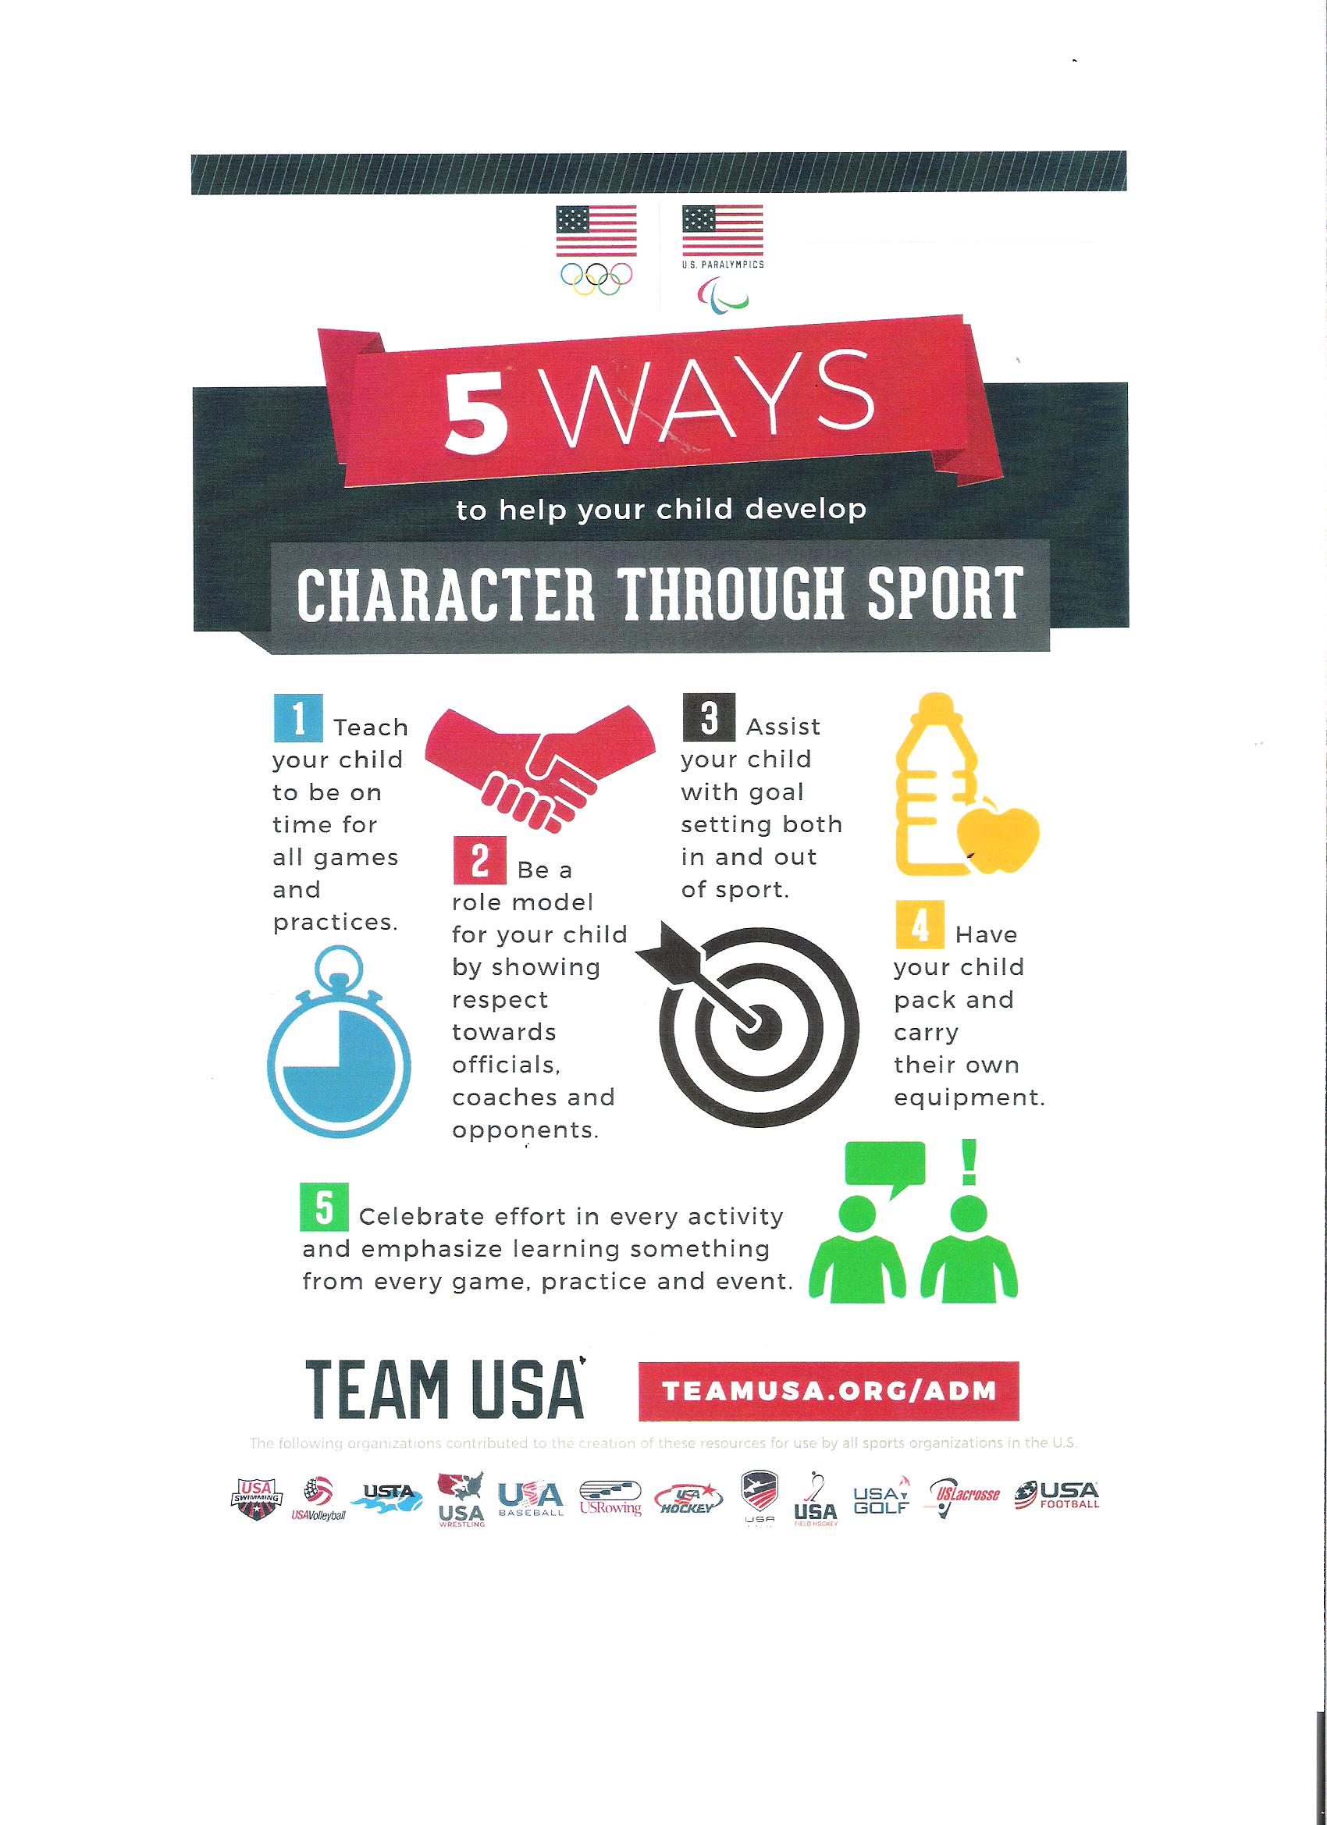  FAST 500 Invitational and THT Summer Steam  Swim Meet recap  PCA Families,  Can you believe that we are just weeks away from our championship meets?! This long course season is flying by! In the past 6 weeks, we have competed in Fishers’ FAST 500 Invitational and Terre Haute’s THT Summer Steam. We have had many athletes continue to have breakout swims, earn Divisional cuts, earn State cuts, and set many new club records. We were also represented by Ms. Elle Gilkerson at the Councilman Classic! Great job representing PCA, Elle! PCA coaches are so proud of our athlete’s hard work so far this season, and we know that we are nowhere near done!  Congratulations to these athletes who earned State Cuts!  Peyton Clark- 50 Breaststroke 47.88  Rayah Rugenstein- 50 Breaststroke 47.33  Averie Keating- 100 Freestyle 110.67  Julia Baker- 50 Back 40.96  Special Congratulations to Jaxon Russell for, once again, earning the High Point Award for 8 and Under Boys at the THT Summer Steam and for setting 4 new meet records!  Also, a Special Congratulations to ALL PCA participants in the THT Summer Steam meet, as we were the combined over-all WINNERS of the meet! We brought home a nice trophy that I’m sure will be accompanied by many others in the not too distant future!  Over-all, great work was done by all of our swimmers! PCA coaches are excited to see what our athletes accomplish at the JAGS meet this coming weekend, and we will continue to work towards earning more cuts for our upcoming Divisional and State Championship meets! Let’s Go PCA!

