- Upcoming Short Course events  October 5-6  ACST Fall Classic  October 14-19  Fall Break  October 25-27  THT Meet  November 8-10  PCA Swim Meet | 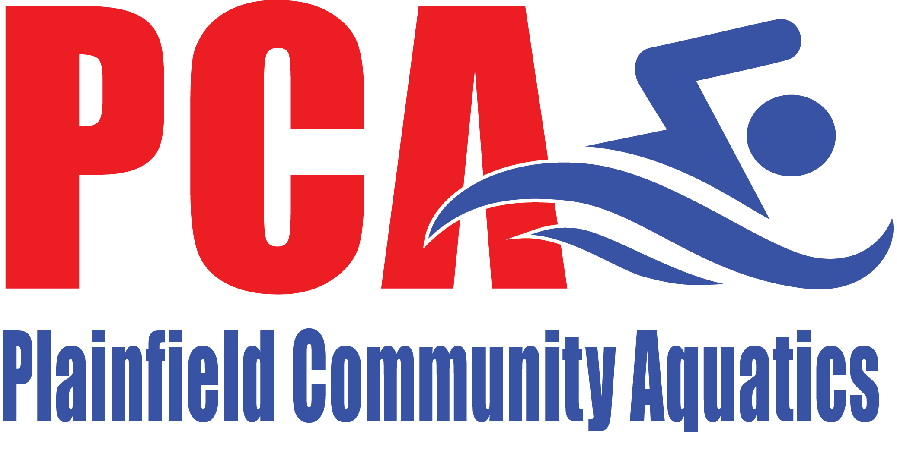  September 2019 edition  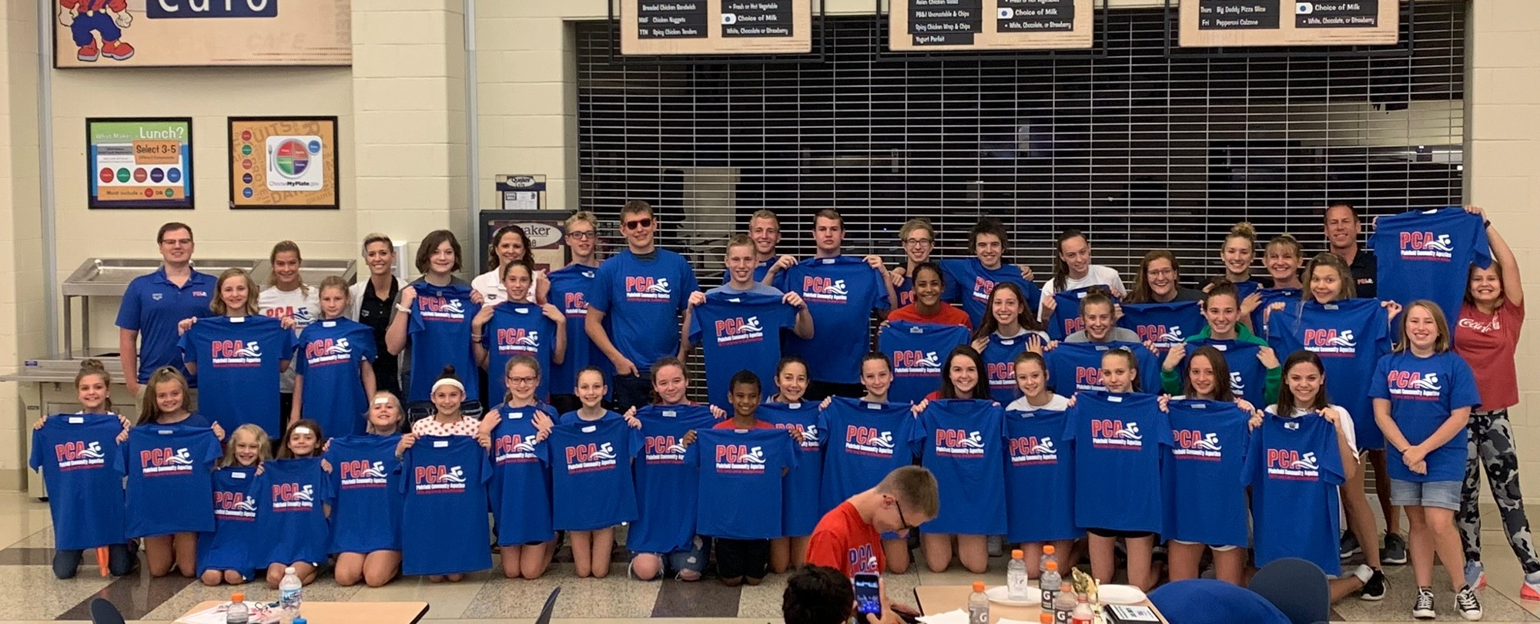  Photo of PCA Divisional and State athletes  Note from the Board of Directors  Well another Long Course season has ended and another Short Course season has begun. We had a very successful End of Season Banquet full of athlete recognition! Lots and lots of awards were given out showing what a great job our athletes did during Long Course.  We also voted on new Board members. As we always hate to say goodbye to board members, we love to welcome new ones. Please welcome Scott Market and Kari Ponders to our board! We are happy to see them bring their knowledge and talents to our club.  We have a lot going on this season. New blocks will be installed in October and we are all excited to see that! We host our second meet in November, which is always a lot of work but really shows what a great club we are. We are still looking for Sponsors for our meet, so please help us get the word out.  On the Lessons and Development side, we had an extremely successful registration week. This was our first time to be completely full in lessons! Word is really getting out about our program. The board and coaches continue to look into other ways we can provide lessons for the demand out there, but we won’t sacrifice the quality of our program.  Angela Maar -PCA Board President
- Contact Us  Plainfield Community Aquatics – PCA  Mail:  PO BOX 774  Plainfield, IN 46168  E-mail:  pcaswim@gmail.com  Website:  www.teamunify.com/team/inpca/page/home | PCA Sponsorship Opportunities  PCA is seeking sponsorships for the upcoming invitational. With our growing club, I'm certain we have individuals who have connections and/or contacts with local business owners, or perhaps you own your own business.  As a Title or Gold Sponsor, a 3x3 professional color logo sign will be prominently displayed on the pool deck, opposite the spectator seating area. These banners will not only hang during the Invitational, but all through the PHS swim season, at PHS swim meets, and at PCA lessons. These banners get a lot of visibility!  If someone has contact with a local HVAC company, pool shop, electrician, home builder, plumber, massage therapist, car dealership, restaurant, financial services company...the list could go on...PLEASE make contact with the business and give them our info. Please email me at finneyam@gmail.com and let me know who you have reached out to. Thank you for your help! It takes a village!  -Amanda Finney PCA Sponsorship Chairperson  PCA Team Activity –Quacker Day Parade  PCA athletes, coaches and parents walked in the Quaker Day parade. The kids had a great time participating in this event!  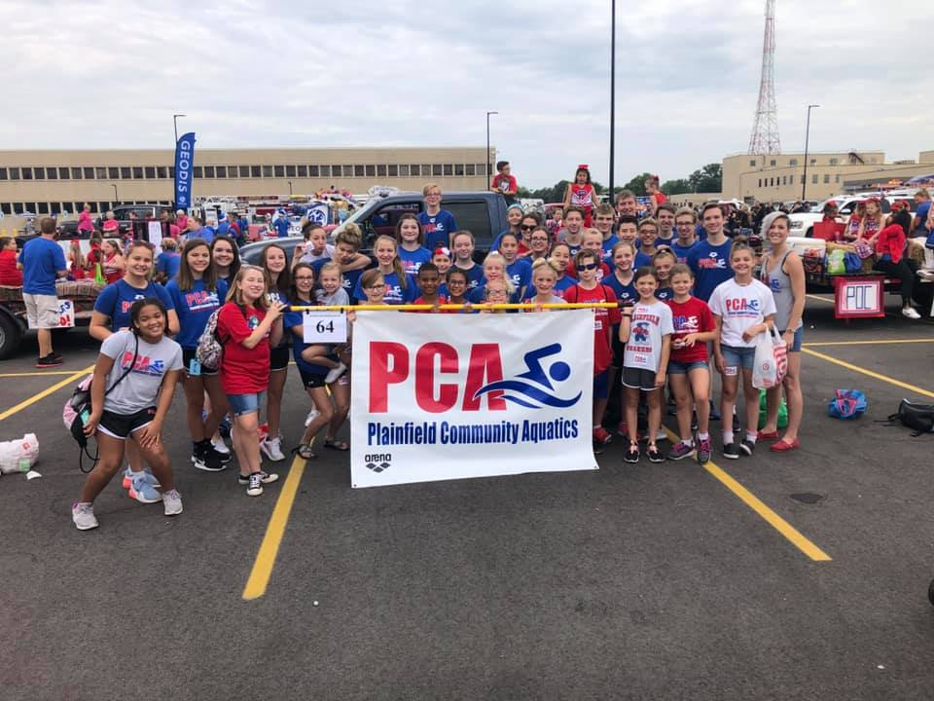
- Contact Us  Plainfield Community Aquatics – PCA  Mail:  PO BOX 774  Plainfield, IN 46168  E-mail:  pcaswim@gmail.com  Website:  www.teamunify.com/team/inpca/page/home | From the Coach’s Desk  PCA Age Group Families,  Our Age Group athletes have had a wonderful start to our 2019/2020 Short Course Season. We have many new faces joining our ranks and it has been a pleasure watching them grow and progress over the past several weeks. Since the start of the season, all of our groups have dedicated the majority of our practice time to stroke development and technique. At this time in the season, it is important for our athletes to build a solid technical foundation in their strokes and begin building up their endurance. Our coaches will always emphasize the importance of stroke efficiency and power, both on and below the surface. Swimming under the water is just as important as swimming on the surface! Over the next few weeks, we will be leading our athletes through workouts that will help build up their aerobic base in preparation for our first official meet, October 5th and 6th at Avon High School, hosted by ACST. We hope to see many PCA athletes compete and show off the new skills they have learned and improved!  Coach Liz Woodruff  Greetings PCA family,  This first month has flown by! It has been a great opening to our short course season with our LARGE group of swimmers. Our primary focus throughout this first phase of our training is aerobic base development. In this phase we work to build a conditioning platform that will be our foundation for our next training phase which will introduce our first real anaerobic and speed development work. The swimmers have done well with staying focused through what some would consider to be "routine" workouts. Even more important, we have been working to improve our team atmosphere and culture. I have challenged the kids to make being a good teammate their highest priority and so far they seem to be responding well. I am looking forward to what the next month holds, as we near our competition season!  Coach Johnson  Parent’s Corner  In this section we want to pass along great information for parents of swimmers. Did you know that on the USA Swimming website there’s a tab just for Parent’s with all kind of helpful articles and videos? Here’s the link to access those https://www.usaswimming.org/for-you/parents  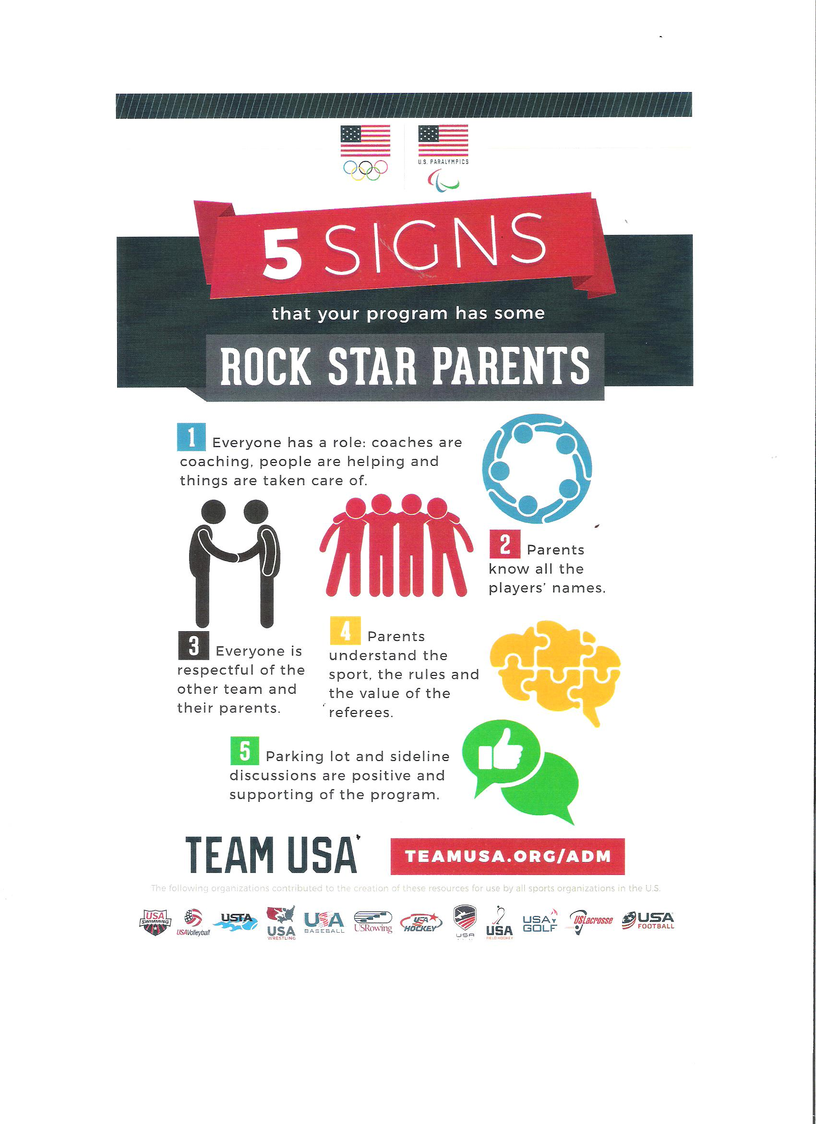  The topic for this edition of Parent’s Corner is “Rock Star Parents”

