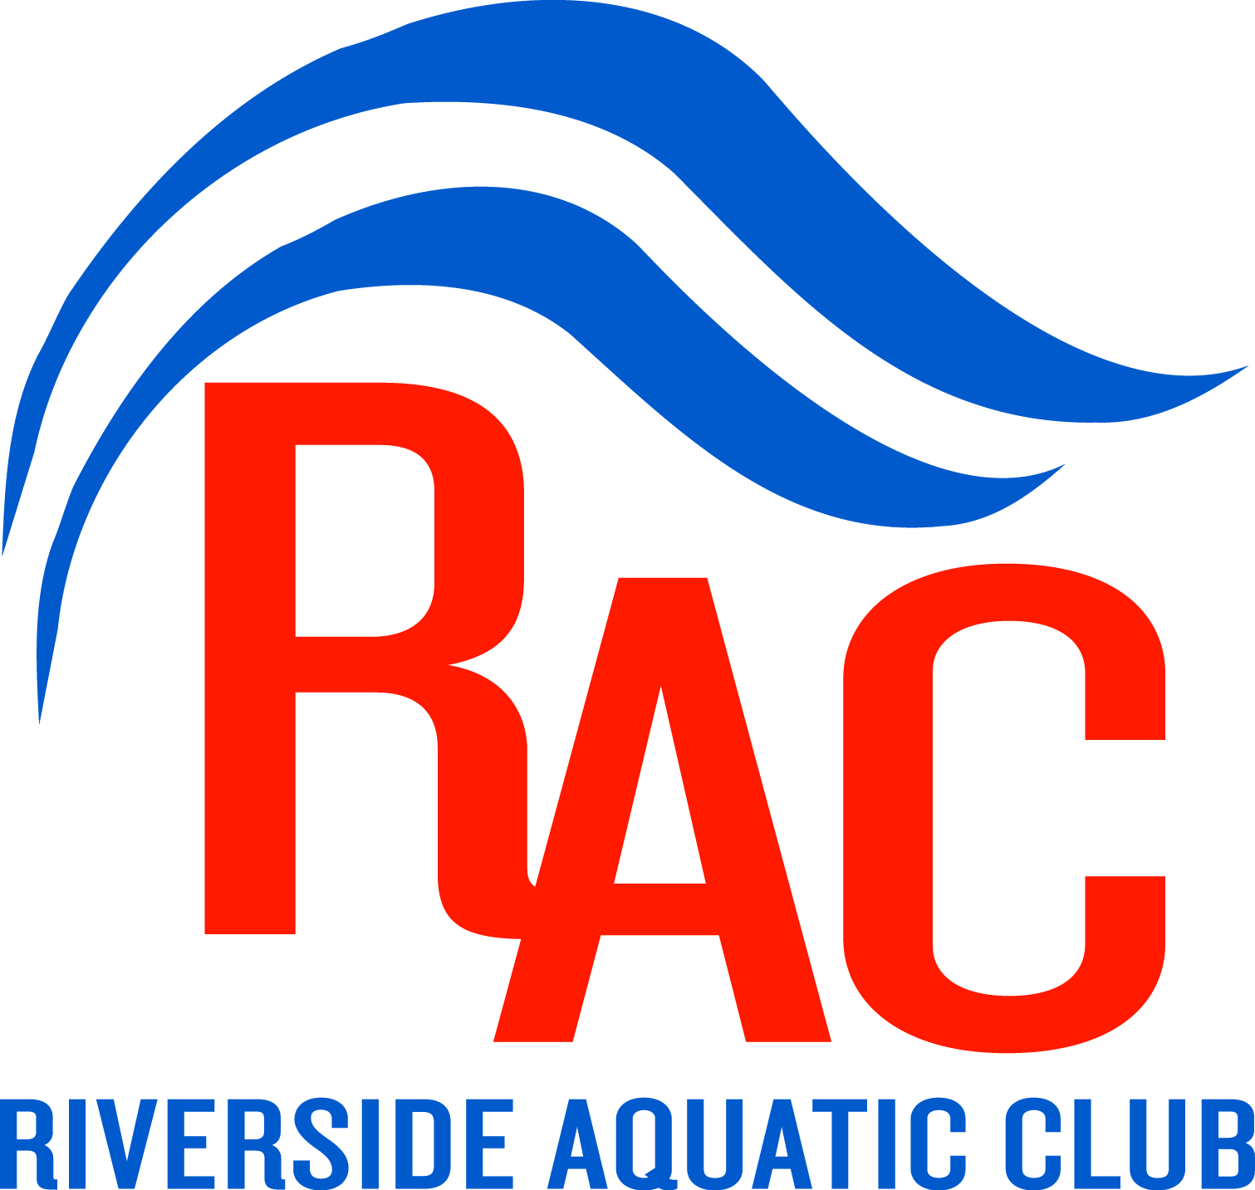

Sponsor Riverside Aquatics Club
and Support Competitive Swimming for Youth

Riverside Aquatics Club (RAC), a chartered club of United States Swimming, is located in Floyd County and is a year-round competitive swim team with over 200 athletes ranging in age from five to nineteen. It is the oldest swim team in the Southern Indiana area and one of the oldest in the Kentuckiana region. Riverside hosts two meets per year at NAFC School Corporation pools that draw over 600 swimmers from the Louisville and Southern Indiana areas. In November we will be hosting the Turkey Classic and in February we will be hosting the RAC Winter Invitational. These are large meets drawing 400 swimmers to our area. We also host a one day meet in May with over 200 swimmers.

Our goal is to provide a competitive swimming experience to children of all skill levels; to allow athletes to strengthen pride and develop character through disciplined effort; and to help children develop physically, socially and emotionally in a healthy, fun atmosphere. You can help us achieve these goals by becoming a “winning medal” sponsor. Please consider one of the levels listed below.

Platinum Medal Sponsorship Level - $2,000.00.
Same as Gold plus;.
Team Title Sponsor
Logo on championship shirt and own banner placed in pool area.

Gold Medal Sponsorship Level - $1,000.00.
Opportunity for company supplied table/banner at swim meets
Name and logo on “welcome” banner at meet
Full page ad in Team Banquet Book
Listed as team sponsor on team website and link to sponsor site

Silver Medal Sponsorship Level - $500.00
Name and logo on “welcome” banner at meet
1/2 page ad in Team Banquet Book
Listed as team sponsor on team website and link to sponsor site

Bronze Medal Sponsorship Level - $250.00
1/4 page ad in Team Banquet Book
Listed as team sponsor on team website and link to sponsor site

Riverside Aquatics Club is a 501c(3) non-profit, and all donations are tax-deductible.
Business Mgr: Elizabeth Mueller, 812-968-5148, riversideaquaticclub@gmail.com

