Updated: September 8, 2021 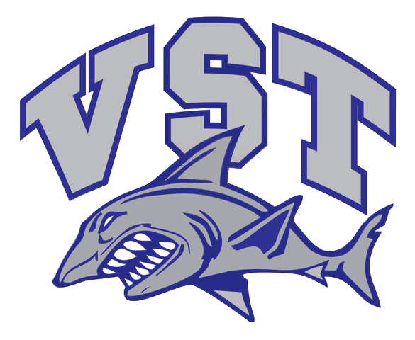
Subject: VINCENNES SWIM TEAM COVID-19 PROTOCOL:
The purpose of the COVID protocol is to establish the expectation for athletes and coaches to help prevent the spread of COVID 19.
- Face masks will be required to be worn by all athletes and coaches while in the locker rooms and while on deck at the YMCA and as required at all meets and VST events.
- Designated areas for the swimmer’s personal belongings will be marked in the pool area. Sharing equipment is prohibited.
- Athletes should shower and change clothes at home, but this is at the parent’s discretion.
- If an athlete or coach feels ill in any way, specially having any of the symptoms listed below, they should not attend practice or participate in meets or other VST-related events.
- Athletes and coaches must be seen by a physician/provider and be cleared to return to practice after being diagnosed with COVID 19 or any other communicable disease/ illness.
- There is no penalty for missing practice. If the athlete/coach or a family member feels ill, they must stay home. If missing practice please let your coach or the VST President know as soon as possible.
- If a positive COVID-19 case is reported to the President, the close contact(s) will be notified and given instructions on if they need to quarantine or not.
  - Must quarantine if with the positive person for more than 15 minutes without masking and monitor for any symptoms.
  - Must quarantine if experiencing symptoms after being in close contact and be tested for COVID-19.
  - If the swimmer has received the COVID-19 vaccine, he/she does not need to quarantine per CDC recommendations but must continue to mask and follow social distancing guidelines.

- Signs and Symptoms of COVID 19 per the CDC
- Fever or chills
- Cough
- Shortness of breath or difficulty breathing
- Fatigue
- Muscle or body aches
- Headache
- New loss of taste or smell
- Sore throat
- Congestion or runny nose
- Nausea or vomiting
- Diarrhea

