Swim Team Levels
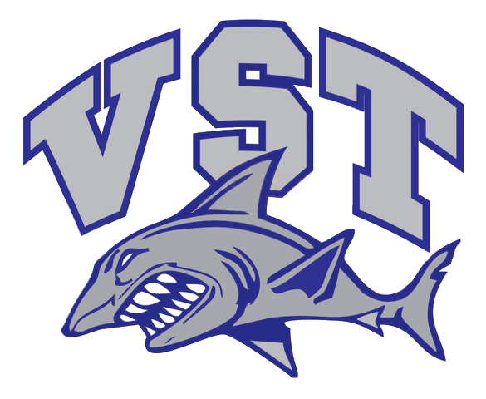
Requirements to join team/White Group:
- Must be able to swim 25 yards unassisted without stopping using freestyle and backstroke.
- Needs to be comfortable in water and in the deep end.
- Have the ability/maturity to learn and pay attention.
- Will need to have their own goggles, kick board, flippers and pull buoy.
Requirements to advance to Purple Group:
- Must swim with face in the water.
- Have good rotational breathing while performing the freestyle stroke.
- Must know freestyle and backstroke well and attempting breast stroke and butterfly.
- Know how to dive into the pool either off the edge or off the blocks.
- Working on flip turns and starts.
- Will need to have their own goggles, kick board, flippers and pull buoy.
- Working on how to read the pace clock
Requirements to advance to Red Group:
- Has to swim a 5X100 freestyle from a push start in 2:45(2 minutes 45 seconds)
- Must be able to perform flip turns and starts off of the blocks
- Must be able to perform all 4 strokes (freestyle, backstroke, breaststroke and butterfly) and be able to swim a 50 using each stroke.
- Should be able to legally swim 3 of the 4 strokes
- Must be able to repeat intervals with limited supervision
- Must know how to read the pace clock.
- Have good streamlines.
- Will need to have their own goggles, kick board, flippers, pull buoy and hand paddles.
Requirements to advance to Blue Group:
- Has to swim a 5 X 100 Freestyle from a push start in 1:45 (1 minute 45 seconds)
- Must be able to swim all 4 strokes well.
- Should be able to legally swim all 4 strokes.
- Must be a self-starter and be able to complete workouts with limited supervision.
- Will need to have their own goggles, kick board, flippers, pull buoy, hand paddles and snorkel

