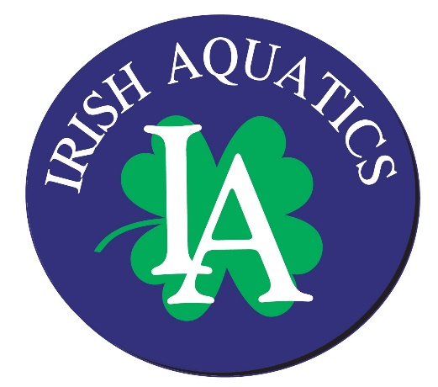

Irish Aquatics
Swim. Fight. Win! Go Irish!

IA Weekly News

Week of July 1, 2018
Open Water State Meet Recap
This past Wednesday, 22 IA swimmers trekked to College Corner, OH for the 2018 IN Swimming Open Water State Championship. This meet was held in conjunction with the Open Water Championships for Ohio Swimming, Lake Erie Swimming, Michigan Swimming, Kentucky Swimming, and Allegheny Mountain Swimming. Among the Indiana teams present, IA had the second largest group competing. We had a great time at the event and everyone did a great job. Overall, 21 teams participated, and IA finished in second place! Below is a listing of the places for our athletes:
15 & Over Boys 4k
Johnny Bossler – 5th
Beck Brurok – 11th
Anders Brurok – 12th
Alex Krygowski – 20th
Trevor Heintzberger – 23rd
Relay – Johnny, Beck and Anders – 3rd

15 & Over Girls 4k
Mary Cate Pruitt – 1st
Lauren Kilgore – 10th
Emma Feltzer – 12th
Lauren Pieniazkiewicz – 14th
Aislinn Walsh – 25th
Caroline Marks – 26th
Sami Weaver – 31st
Sophia Korfmacher – 3rd (swam in the MI Swimming division of the meet as she had not been transferred to IA before the meet with IN Swimming)
Relay – Mary Cate, Lauren K, Emma – 2nd
Relay - Lauren P, Aislinn, Caroline – 5th

13-14 Boys 3k

Sam Tullis – 7th

13-14 Girls 3k

Andie Drew – 1st
Abie Wiencek – 7th
Jane Lloyd – 9th
Peyton Racht – 10th
Cece Farrell – 11th
Relay – Andie, Abie, and Jane – 1st

11-12 Girls 2k
Lee Erdman – 8th
10 & Under Boys
Jack Erdman – 7th
10 & Under Girls
Anna Pruitt – 5th
IA Summer Spectacular
Volunteer Jobs: Please be sure you have signed up for your volunteer slots for the meet. Each family is required to fill 3 volunteer jobs over the course of the weekend.
Hospitality donations: The link for donations for the coach, official and volunteer hospitality room and table is live. Please consider signing up to donate something for the meet. http://bit.ly/summermeet18
Meet set up: Meet setup will take place on Thursday, July 5, from 3:30-7:30 pm. Please consider coming in and helping if you can to get the facility ready for the event.

Upcoming Billing
Autopay will be processed on Monday, July 2 as the 1st fell on Sunday. Please log on and check your invoice and make a payment if you are not set up on autopay.
2nd Annual IA Golf Outing
The 2nd annual IA Golf outing will be held at Orchard Hills Country Club on Saturday, August 25. If you would like to enter a team or are interested in more information on the event either as a participant or a sponsor, please contact Christie Hannewyk.
Meet Directors in Training
We are looking for our next great meet directors! In our current model, one person has served as meet director for all of our meets, but going forward, we are looking to train 3 or more individuals on what being a meet director entails so that each of our team hosted meets has a different meet director. Meet directors need to have good management and interpersonal communication skills, an ability to make quick decisions in pressure situations, and a desire to put forth a product (a swim meet in this case) that he/she is proud of. If you want more information on what being a meet director entails, please contact Coach Matt or Christie Hannewyk for more information. We are hoping to have someone shadow Christie during the Summer Spectacular in July to be able to take the reigns for the Tim Welsh Invitational in January.
Safe Sport – Locker Room Monitoring
As was mentioned in the last two newsletters, in our continued efforts to create a safe and fun environment for all of our swimmers, we are looking for a hallway monitor to sit outside the entrance to the pool deck from the hallway outside the locker rooms each night at practice between the hours of 6:00 and 8:00. There are multiple entrances to this hallway (although only one of them is supposed to be open which is the main entrance to the pool at Door 5), and the entire hallway cannot be seen from the front desk, thus we are stationing a volunteer in the hall to have a set of eyes in an otherwise blind zone. The link for signing up for this position can be found here.
Team Store at SwimOutlet.com
If you are new to the team or your returning swimmers have changed groups or outgrown their equipment, we have a team store set up at SwimOutlet.com with the recommended equipment for each group listed. There are also customized team apparel items available through the team store. Visit www.swimoutlet.com/irishaquatics or click the Team Store command button from the home page of our website (next to the picture) to access our team store. Also, whenever you make a purchase through Swim Outlet, be sure to start in the team store as we receive a credit from all purchases on most items. We use this credit to buy training items for the team’s use.
Upcoming Deadlines
- Monday, July 9 – Registration deadline for Senior State
- Monday, July 16 – Registration deadline for Age Group State
- Monday, July 23 – Registration deadline for Summer Divisional

Upcoming Meets and Team Events
- Friday, July 6-Sunday, July 8: IA Summer Spectacular
- Thursday, July 19 - Sunday, July 22: Senior State Championship
- Friday, July 27 - Sunday, July 29: Age Group State
- Tuesday, July 31 - Saturday, August 4: NCSA Summer Championship
- Saturday, August 4 - Sunday, August 5: Summer Divisional

Practice Schedule

Group | Monday  7/2 | Tuesday  7/3 | Wednesday  7/4 | Thursday  7/5 | Friday  7/6 | Saturday  7/7 | Sunday  7/8
Gold | 6:00-8:30 AM  4:00-5:00 PM  @ Beacon  5:30-7:30 PM | 6:00-8:30 AM  5:30-7:30 PM | 6:00-8:30 AM | 6:00-8:30 AM  5:30-7:30 PM | No Practice | No Practice | No Practice
Silver | 6:00-8:30 AM  5:30-7:30 PM | 5:30-7:30 PM  Dryland | 6:00-8:30 AM | 5:30-7:30 PM  Dryland | No Practice | No Practice | No Practice
Bronze | 6:00-7:30 PM  Dryland | 6:00-7:30 PM  Dryland | No Practice | 6:00-7:30 PM  Dryland | No Practice | No Practice | No Practice
Green | 6:00-7:00 PM | 6:00-7:00 PM | No Practice | 6:00-7:00 PM | No Practice | No Practice | No Practice

*Beacon workouts are provided for all swimmers registered in the Gold group and any swimmer registered in the Silver group who will be at least 11 years old by the Age Group State Meet (July 27, 2018)

