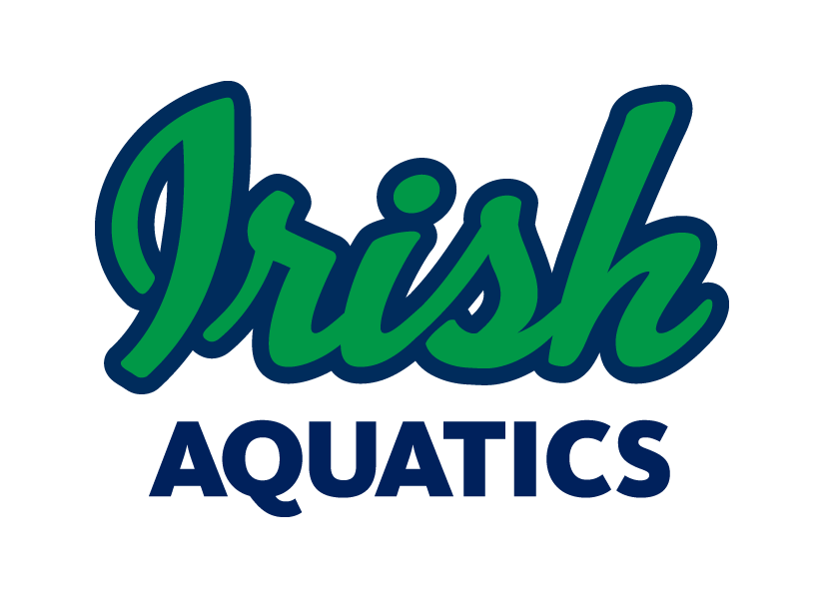
Irish Aquatics
Swim. Fight. Win! Go Irish!

IA Weekly News

February 16, 2020

Group Updates

There will be no practice for any group in Bremen on Thursday this week.

The Shamrock 3 and Senior group practices in South Bend will start getting shorter and will most likely not last all the way until 8:30. The exact end time may vary from day to day depending on the specifics of the workout, but please be prepared to pick swimmers up a little earlier from this point on.

Basketball Games This Week at Notre Dame

There is a home basketball game for the men’s team this Monday, February 17, at 7:00 PM against UNC. There is also a women’s basketball game on Thursday, February 20, at 8:00 PM vs VT. Please be prepared for increased traffic on campus those days.

Parent Education

Each week, Coach Ben will be putting out an article for the parents in our Parent Education series. Many of these articles will be specific to swimming while others may be about parenting in youth sports in general. All of the articles are meant to give us as parents a look into how we can be a positive contributor to our children’s athletic experience.

This week’s article comes from the Swim Swam and is titled “Should Parents Talk About Performance?”

This article has some great suggestions for how parents should address their swimmer’s performance after a meet.

The article will be posted on the team Facebook page on Tuesday morning, but you can get to it now here.

NCISC Winter Championship

Congrats to all swimmers who participated in the 2020 NCISC Winter Championship on Saturday at Riley HS. We had some amazing swims and new cuts made! At the end of the day, IA walked away with the trophy for the team championship for the second year in a row!

Girls HS State Championships

This past Friday and Saturday, a number of our high school girls from St. Joseph HS trekked to Indianapolis for the 2020 IHSAA Girls State Championship. St. Joe had at least 1 swimmer in each swimming event, and they had someone score points in many of them. See below for a summary of the swims.

Andie Drew: 200 IM (22nd), 500 Free (13th)
Olivia Elston: 200 Medley Relay (12th), 200 Free Relay (7th)
Emma Feltzer: 200 Free (13th), 100 Free (11th), 200 Free Relay (7th), 400 Free Relay (9th)
Jane Lloyd: 200 Medley Relay (12th), 100 Back (27th), 400 Free Relay (9th)
Lauren Pieniazkiewicz: 200 Medley Relay (12th), 50 Free (17th), 200 Free Relay (7th), 100 Breast (17th)
Mary Cate Pruitt: 200 Free (3rd), 500 Free (1st), 200 Free Relay (7th), 400 Free Relay (9th)

Congrats to everyone on a great high school season. We are looking forward to having you back in the water with IA!

Boys HS Sectional Championships

This coming Thursday and Saturday is the 2020 Boys HS Sectional Championship. We have swimmers from Bremen HS, Mishawaka HS, Penn HS, and St. Joseph HS competing at the Mishawaka sectional, a swimmer from Michigan City competing at the Valparaiso sectional, and a swimmer from Culver Academy competing at the Warsaw sectional. Good luck boys!

Meet Shirts and Caps

For all meets, swimmers are to wear either the new silver team swim cap or the purple Swim for Tim team swim cap. The pink, green, blue and black caps with the old team logo are only to be worn at practice.

Each swimmer gets 1 cap with their initial registration with the team, either latex or silicone. Any additional caps must be purchased. Swimmers are reminded to keep track of their own cap and make sure that it is in his/her swim bag after every practice and meet. Any old team caps can be worn in practice, but only the new silver Arena team caps may be worn at meets (no exceptions). Additional and new silver caps can be purchased from Coach Matt for $12 for silicone and $5 for latex. The purple Swim for Tim caps are $10 apiece. You can pay cash on the spot or it can be billed to your account.

If your swimmer has not received his/her new gray Swim. Fight. Win! t-shirt, Coach Matt can supply that at practice as well. These shirts are to be worn on deck at swim meets as part of the team uniform.

The old logo caps are still available for purchase and can be worn at practices. The silicone caps are available in pink, green, blue and black (championship team caps, swimmers must have qualified for the level of meet the cap is for) for $5 each. Latex caps are available for $1 each in blue only. We also have a stock of old t-shirts available for purchase.

Short Course Banquet

Our annual team banquet will be held at Knollwood Country Club on Tuesday, March 24 at 6:00 PM. Please mark your calendars and plan to join us for an evening of celebration of our individual and team accomplishments this year! More information will be available soon as well as an RSVP system to reserve your spot.

MAAPP Waivers

Each family needs to sign the MAAPP acknowledgement form every year. This form is located on the website under the Safe Sport section. Please return the signed waiver (one per family) to Coach Matt at practice. All families must sign this waiver each year.

SwimOutlet.com Team Store
New custom items are available now on the team store!
We have a team store set up at SwimOutlet.com with the gear for each group as well as custom team items available. Visit www.swimoutlet.com/irishaquatics or through the “Team Store” command button on the homepage of our website to access our team specific store. Be sure to always order from Swim Outlet by first starting at our team store (you should see a banner at the top of the page stating “You are shopping through the Irish Aquatics Team Store Affiliate account.” When shopping through the team store, IA gets a percentage of the amount spent back for use by the team, which allows us to provide things to the swimmers such as championship caps or training aids for team use. Also, as an Arena sponsored team, we get 35% of the money spent on Arena gear back for team use on Arena gear the following calendar year, but only if the gear is ordered through our team store on Swim Outlet.
If there are custom items you would like to see in the store, just let Coach Matt know and he will work on getting something added!
On Deck Smartphone App
Team Unify offers a smartphone app that allows easy access to your account information, meet entries, and much more called On Deck. It is recommended that all families have this app installed on their phone. This is a great way to check your account balance, register your swimmers for meets or check their events for an upcoming meet, or even time a race. The app is free in the App Store on Apple devices and the Google Play store for Android devices. Your login information for the app is the same as it is for the website.
Birth Certificate Requirement
If your swimmer is new to the program and has not competed for another team within IN Swimming before, we will need a copy of his/her birth certificate or passport. This can be sent via email, text, or by a physical copy sent into practice to Coach Matt mdorsch@gmail.com, (248) 321-7845. This is a requirement of IN Swimming for a 1-time verification of the swimmer’s date of birth. Any swimmer not supplying the document and competing in a meet will be assessed a $100 fine by IN Swimming though the club.
This Photo by Unknown Author is licensed under CC BY-NC-ND
Upcoming Meets & Deadlines
The registration deadline CON Last Chance Showdown has passed. If you need to register your swimmer still, our final update will be sent in Monday evening. Please contact Coach Ben before practice on Monday to get your swimmer into the meet.
The CON Leisure Pools Last Chance Showdown is the last non-championship meet for the short course season. This meet is good for all swimmers in all groups, but for those who are not qualified for the Divisional or higher meets, this meet would serve as his/her championship meet.
The Divisional, Senior State, Age Group State, and Speedo Sectional Championships all require time standard achievements to be eligible for the meet. It is expected that all who qualify, including on relays, attend the championship meet.
- February 24 – Divisional Championship
- March 2 – Senior State Championship
- March 9 – Age Group State Championship

Upcoming Events
- February 28-March 1 – CON Leisure Pools Last Chance Showdown, Concord HS
- March 6-8 – IN Swimming NW Divisional, Lake Central HS
- March 13-15 – IN Swimming Short Course Senior Championship, IU Natatorium
- March 20-22 – IN Swimming Short Course Age Group Championship, IU Natatorium
- March 26-29 – Speedo Sectional Championship, Elkhart Aquatic Center

Practice Schedule

Group | Monday  2/17 | Tuesday  2/18 | Wednesday  2/19 | Thursday  2/20 | Friday  2/21 | Saturday  2/22 | Sunday  2/23
Little Leprechauns | 6:00-7:00 PM  @ Rolfs | 6:00-7:00 PM  @ Rolfs | 6:00-7:00 PM  @ Rolfs | 6:00-7:00 PM  @ Rolfs | No Practice | No Practice | No Practice
Shamrock 1 SB | 6:00-7:30 PM  @ Rolfs | 6:00-7:30 PM  @ Rolfs | 6:00-7:30 PM  @ Rolfs | 6:00-7:30 PM  @ Rolfs | No Practice | No Practice | No Practice
Shamrock 2 SB | 6:00-8:00 PM  @ Rolfs | 6:00-8:00 PM  @ Rolfs  Dryland | 6:00-8:00 PM  @ Rolfs | 6:00-8:00 PM  @ Rolfs  Dryland | 6:00-8:00 PM  @ Rolfs | No Practice | No Practice
Shamrock 3 SB | 6:00-8:30 PM  @ Rolfs  Dryland | 6:00-8:30 PM  @ Rolfs | 6:00-8:30 PM  @ Rolfs  Dryland | 6:00-8:30 PM  @ Rolfs | 6:00-8:00 PM  @ Rolfs | No Practice | No Practice
Senior  SB | 6:00-8:30 PM  @ Rolfs  Dryland | 6:00-8:30 PM  @ Rolfs | 6:00-8:30 PM  @ Rolfs  Dryland | 6:00-8:30 PM  @ Rolfs | 6:00-8:00 PM  @ Rolfs | No Practice | No Practice
Shamrock 1  Bremen | 6:00-7:30 PM  @ Bremen HS | 6:00-7:30 PM  @ Bremen HS | 6:00-7:30 PM  @ Bremen HS | No Practice | No Practice | No Practice | No Practice
Shamrock 2  Bremen | 6:00-8:00 PM  @ Bremen HS | 6:00-8:00 PM  @ Bremen HS | 6:00-8:00 PM  @ Bremen HS | No Practice | 6:00-8:00 PM  @ Bremen HS | No Practice | No Practice
Shamrock 3  Bremen | 6:00-8:00 PM  @ Bremen HS | 6:00-8:00 PM  @ Bremen HS | 6:00-8:00 PM  @ Bremen HS | No Practice | 6:00-8:00 PM  @ Bremen HS | No Practice | No Practice

