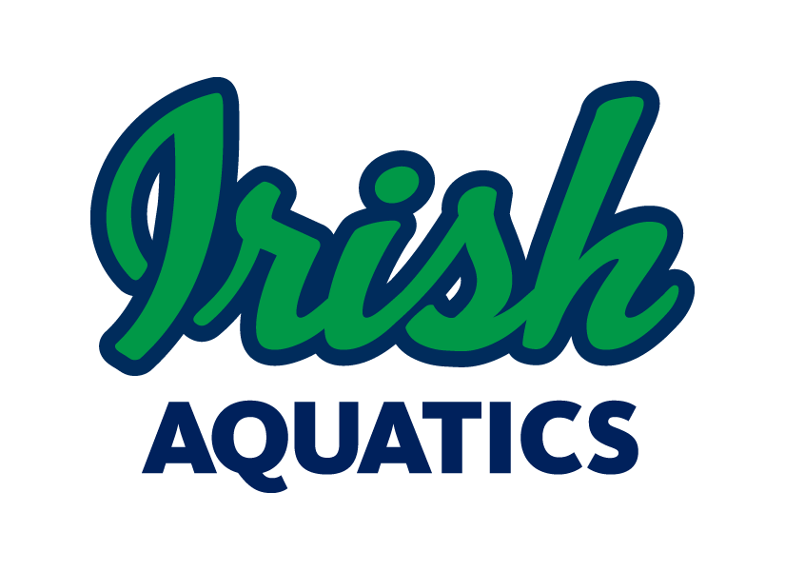
Swim. Fight. Win! Go Irish!

IA Weekly News

March 15, 2020

In the last week, everything in our lives has been thrown into turmoil with increased spread of the coronavirus and the closing of schools and workplaces. This has greatly affected the swimming world as a whole, not just locally, regionally, or nationally, but across the globe. Swimmers at every level from the learn-to-swim student to the Olympic hopefuls and professional swimmers are left without a place to train or a team to train with. In the coming weeks, I am confident that more and more facilities will close their doors to everyone to help fight the spread of this virus.
At this point, there are no facilities that I know of that are allowing groups to come in and train. And if there was a facility that was willing to let a group in, I do not feel that it would be the responsible choice for us as a team to do so. This is an unprecedented time and as a group, we need to do our part for the greater good, which is the overall public health. From this point on, Irish Aquatics is shutting down all programming, including swim practices, swim lessons and the team banquet. At this point, I do not know how long we will be shut down for, but it is safe to assume that our normal programming will not resume until April 13 at the absolute earliest, but it is likely that date will be pushed back. The coaches and the board will monitor the state of everything and decide when we feel it is safe and appropriate to resume practices. We will also look at options for rescheduling the banquet.
Go Irish!
Coach Matt

Parent/Swimmer Education

With no team practices available for the foreseeable future, we will be offering some alternatives for swimmers to work out. There have been many outlets that have waived their membership fees for their services so that during this time when swimmers are out of the water and some parents may be out of work, people can still access materials that will help them stay fit.

Today, we will focus on swimming specific yoga. Jeff Grace is a certified yoga instructor who has put together many routines specifically for swimmers. His content has been made free through May 31 and can be accesses here. The workouts range from 25 to 45 minutes. Yoga is a great way to work on range of motion, flexibility, and coordinated strength while putting yourself in a calm and relaxed state of mind.

Long Course Transition

In the last newsletter, the process for transitioning to the long course season was laid out, but due to the fact the we are out of the water, this process will be changing. We will not be billing account on April 1 for the long course season. We will wait until we are able to start and then will figure out a prorated fee based on when we get back in the pool.

If your swimmer(s) will not continue with the program in the spring/summer, please send Coach Matt an email letting him know so that he can deactivate him/her in the system.

Please contact Coach Matt with any additional questions you may have about the long course season or billing.

Spring Fundraiser

We are moving our annual Nelson’s Chicken Sale Fundraiser to the spring from our historical fall date starting this year. We have the sale set for Friday, April 24 at the Marathon gas station at the corner of Grape Rd and Edison Rd in Mishawaka. We will be covering both lunch and dinner, with the event running from 11:30-7:00. We will be looking for help from those that may be available during the day for the lunch time rush and we will be expecting our 13 & Over swimmers to participate after school. More information will be available on this soon, so watch your email for information on pre-sales and volunteering.

Long Course Schedule

The meets for the summer long course season are all listed on the team website under Team Events. Please check the list and mark your calendars!

Parent and Athlete Safe Sport Training

In our efforts to become a Safe Sport Recognized Club with USA Swimming, we are requesting that all parents complete the free Safe Sport Training for Parents course offered by USA Swimming, which can be found here. We are also asking that swimmers aged 12-17 complete the free Safe Sport Training for Athletes course, which can be found here. We have to have a minimum percentage of parents and swimmers take the courses to qualify for the Safe Sport Recognized Club program, but instead of reaching the minimum threshold, our goal is 100% participation. If you have questions about anything Safe Sport, please do not hesitate to reach out to Coach Matt, Michelle Horvath (our team Safe Sport Coordinator), or one of our board members.

Meet Shirts and Caps

The remaining championship t-shirts that were not available for pickup at the championship dinner due to an ordering error are in. Once we are able to resume team activities, these will be distributed.

MAAPP Waivers

Each family needs to sign the MAAPP acknowledgement form every year. This form is located on the website under the Safe Sport section. Please return the signed waiver (one per family) to Coach Matt at practice. All families must sign this waiver each year.

SwimOutlet.com Team Store
New custom items are available now on the team store!
We have a team store set up at SwimOutlet.com with the gear for each group as well as custom team items available. Visit www.swimoutlet.com/irishaquatics or through the “Team Store” command button on the homepage of our website to access our team specific store. Be sure to always order from Swim Outlet by first starting at our team store (you should see a banner at the top of the page stating “You are shopping through the Irish Aquatics Team Store Affiliate account.” When shopping through the team store, IA gets a percentage of the amount spent back for use by the team, which allows us to provide things to the swimmers such as championship caps or training aids for team use. Also, as an Arena sponsored team, we get 35% of the money spent on Arena gear back for team use on Arena gear the following calendar year, but only if the gear is ordered through our team store on Swim Outlet.
If there are custom items you would like to see in the store, just let Coach Matt know and he will work on getting something added!
On Deck Smartphone App
Team Unify offers a smartphone app that allows easy access to your account information, meet entries, and much more called On Deck. It is recommended that all families have this app installed on their phone. This is a great way to check your account balance, register your swimmers for meets or check their events for an upcoming meet, or even time a race. The app is free in the App Store on Apple devices and the Google Play store for Android devices. Your login information for the app is the same as it is for the website.
Birth Certificate Requirement
If your swimmer is new to the program and has not competed for another team within IN Swimming before, we will need a copy of his/her birth certificate or passport. This can be sent via email, text, or by a physical copy sent into practice to Coach Matt mdorsch@gmail.com, (248) 321-7845. This is a requirement of IN Swimming for a 1-time verification of the swimmer’s date of birth. Any swimmer not supplying the document and competing in a meet will be assessed a $100 fine by IN Swimming though the club.
This Photo by Unknown Author is licensed under CC BY-NC-ND

Practice Schedule

There are no practices scheduled at any location until further notice due to the community efforts to minimize the spread of COVID-19.

