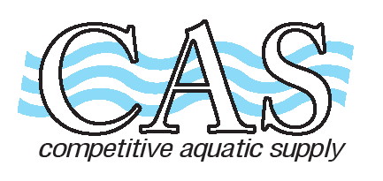
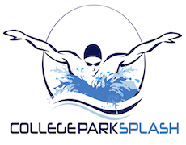
COMPETITIVE AQUATIC SUPPLY
15661 Container Lane Huntington Beach, CA. 92649
(714) 898-2655 (800) 421-5192 Fax: (714) 898-4988
Email: casswim@aol.com Website: www.casswimshop.com

COLLEGE PARK SPLASH TEAM ORDER FORM

Name________________________________________________Date_____________________________
Address _________________________________________________Phone __________________________
City/Zip ______________________________________________Email______________________________
Item QTY SIZE PRICE TOTAL

TEAM SUIT TYR PHOENIX SPLICE Navy /White

FEMALE:
Thick Strap MPX 408 Size 22 – 40 ____ ____ $48.00 ________
Thin Strap DPX 408 Size 22 – 40 ____ ____ $48.00 ________

MALE:
Jammer SPX 408 Size 22-38 ____ ____ $32.00 ________
Brief RPX 408 Size 22-38 ____ ____ $25.60 ________

SUBTOTAL ________
TAX 7.75% ________
TOTAL ________
REC # ________

To place your order: go to www.casswimshop.com,
Choose: Team Store (at top), then College Park Splash
Team code is CPS (all caps)

When choosing shipping method, options are:
“Will Call H B” - 15661 Container Lane, HB 92649 “Will Call Irvine” - 3972 Barranca Pkwy, Irvine 92606
“Ship” For an additional charge orders can be shipped to your home

PAYMENT: CASH or CHECK# _____
Credit Card: (VISA MC AMEX) _______________________________ EXP: _______CVV: ______

