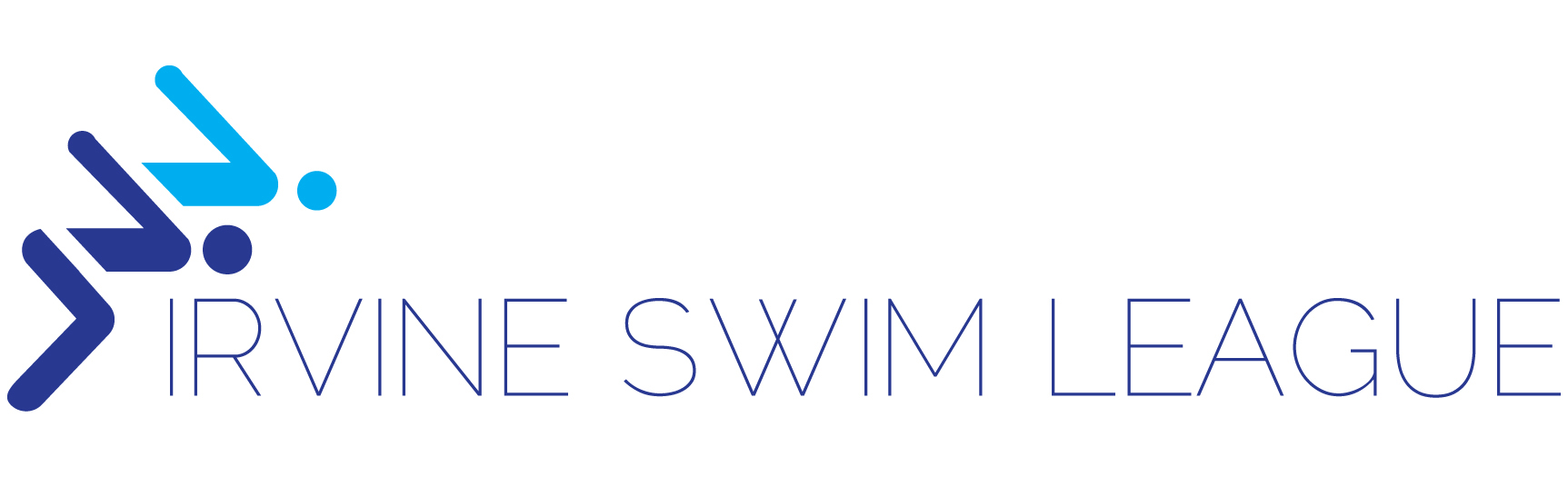
Parent Code of Conduct
- I will not engage in unsportsmanlike conduct with any coach, parent, swimmer, participant,
official or any other attendee.
- I will not encourage my child, or any other person, to engage in unsportsmanlike conduct with
any coach, parent, swimmer, participant, official or any other attendee.
- I will not engage in any behavior which would endanger the health, safety or well-being of any
coach, parent, swimmer, participant, official or any other attendee.
- I will not encourage my child, or any other person, to engage in any behavior which would
endanger the health, safety or wellbeing of any coach, parent, swimmer, participant, official or
any other attendee.
- I will not use drugs or alcohol while at a youth sports event and will not attend, coach, officiate or
participate in a youth sports event while under the influence of drugs or alcohol.
- I will not permit my child, or encourage any other person, to use drugs or alcohol at a youth
sports event and will not permit my child, or encourage any other person, to attend, coach,
officiate or participate in a youth sports event while under the influence of drugs or alcohol.
- I will not engage in the use of profanity.
- I will not encourage my child, or any other person, to engage in the use of profanity.
- I will treat any coach, parent, swimmer, participant, official or any other attendee with respect
regardless of race, creed, color, national origin, sex, sexual orientation or ability.
- I will encourage my child to treat any coach, parent, swimmer, participant, official or any other
attendee with respect regardless of race, creed, color, national origin, sex, sexual orientation or
ability.
- I will not engage in verbal or physical threats or abuse aimed at any coach, parent, swimmer,
participant, official or any other attendee.
- I will not encourage my child, or any other person, to engage in verbal or physical threats or
abuse aimed at any coach, parent, swimmer, participant, official or any other attendee.
- I will not initiate a fight or scuffle with any coach, parent, swimmer, participant, official or any
other attendee.
- I will not encourage my child, or any other person, to initiate a fight or scuffle with any coach,
parent, swimmer, participant, official or any other attendee.
- I will not engage in, or permit, bullying of a coach, parent, swimmer, participant, official or an
other member. Bullying includes severe or repeated use by one or more persons of an oral, written, or electronic nature, or a physical act or gesture that can cause physical or emotional harm.
- I will not engage in any sexual, or otherwise inappropriate, conduct or advance (whether oral, written, visual, physical, or otherwise), towards a swimmer, coach or any person under the age of eighteen (18) years old.
- I will not engage in any act of harassment, including, without limitation, unwelcome sexual advances, requests for sexual favors, and/or other inappropriate oral, written, visual or physical conduct of a sexual, or otherwise inappropriate, nature in connection with any swimmer, coach, parent, or member.

I understand and agree that ISL reserves the right to reject any participant application or to suspend or expel any participant, including swimmer, coach, parent, or otherwise, upon either (1) a determination by ISL in its sole discretion that a violation of any of the above provisions has taken place, or (2) for any other reason it deems appropriate and to the extent permitted by applicable state and federal law.

