NEW TRIER AQUATICS
WRITTEN PERMISSION FOR A LICENSED MASSAGE THERAPIST OR OTHER CERTIFIED PROFESSIONAL OR HEALTH CARE PROVIDER TO TREAT A MINOR ATHLETE

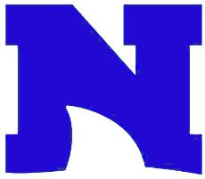

I, , legal guardian of , a minor athlete, give express written permission, and grant an exception to the Minor Athlete Abuse Prevention Policy for (massage therapist or other certified professional) to provide a massage, rubdown and/or athletic training modality on
(minor athlete) on (date)
at (location). The massage, rubdown or athletic training modality must be done with at least one other adult present in the room and must never be done with only (minor athlete) and (massage therapist or other certified professional) in the room. I acknowledge that I have the right to observe the massage, rubdown or athletic training modality. I further acknowledge that this written permission is valid only for the dates and location specified herein.

Legal Guardian Signature:
Date:

