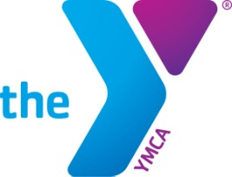
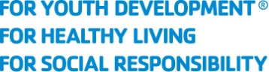

Iowa YMCA Competitive Swimming
All Star Team Nomination

All Star Team candidates should be committed to YOUTH DEVELOPMENT – positive role model, HEALTHY LIVING – taking an active role in a lifelong sport and SOCIAL RESPONSIBILITY – giving back and supporting others in their community. They should show dedication to YMCA Swimming and great sportsmanship to all those around them. Please submit a paragraph or two on how this swimmer demonstrates these traits. This information will be printed in the all-star booklet and posted on the wall at the State Swim Meet. Please also include a brief summary of your candidate that we can use to announce them when they receive their award.

Each YMCA may nominate one (1) male and (1) female. This information including a photo of each should be submitted no later than FEB 20, 2017

Information to be included:

YMCA Name: Team Name:

Person(s) Nominating:

Candidate Name: Age: Gender: Years on Team:

Wall/Print Write Up: (between 200 – 300 words):

Presentation Announcement at Meet (50 words):

Submit via email to iowayswimming@gmail.com by FEB 18, 2019

