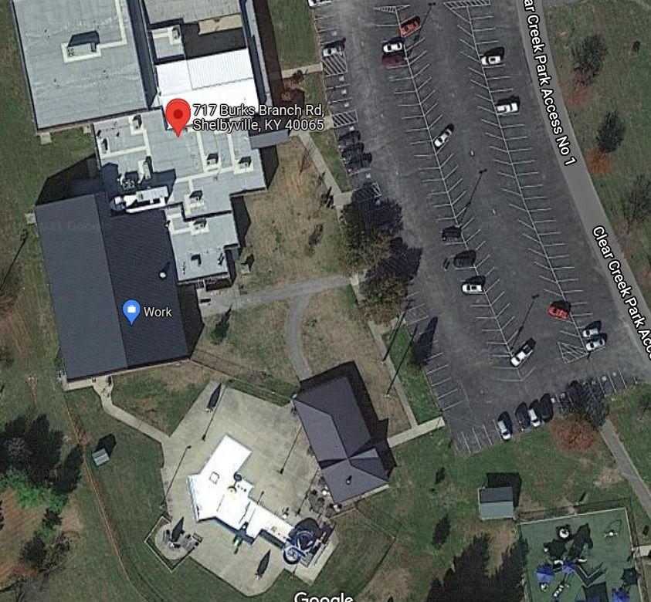

+Spectators may sit outside

Bus Parking

Pool Entrance for Athletes and Officials

Pool Entrance for Spectators

Entrance for Spectators