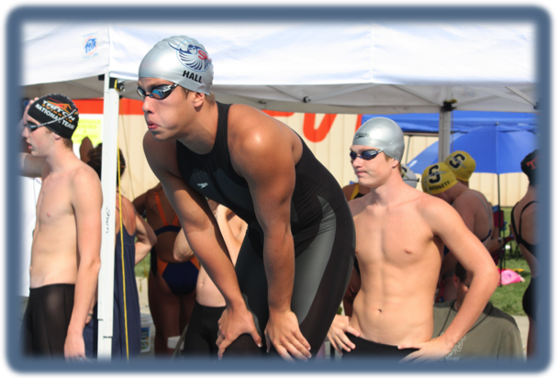

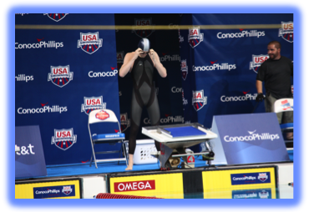
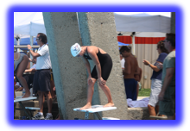
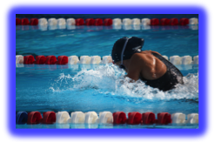
able to earn runner-up
honors in individual events.
Garrett Strickler, Hannah
Walker, Sara Wood, and
Ryan Metzger placed in the
top 8 in their individual
events. Rudy Edelen, Lauren
Walker, and Emily Wood had to 16 finishes in their individual events
SKY Swimming

SKY SHINES AT STATE

Corey Hall State Champion 100 meter Fly
Corey Hall lead the SKY Swim Team at the KYLSC State Championships with an individual 1st place in the men’s 100 meter fly. The team finished in 7th place out of 24 teams in the state championships. Jake Thomas, Jonathan Hindman, Emily Eaves, and Paige Fields were able to earn runner-up honors in individual events. Garrett Strickler, Hannah Walker, Sara Wood, and Ryan Metzger placed in the top 8 in their individual events. Rudy Edelen, Lauren Walker, and Emily Wood had to 16 finishes in their individual events

Tyler Reed finishes 19th at World Trials

August, 09

Up Coming Events

Zone Team Members
Registration will be August 10th – 14th at BGHS Swimming Pool. The registration time is 3:30 to 5:00pm. On-line registration will be available .
Russellville SKY Swimming will hold their registration on August 10th – 14th at BGHS swimming pool . Practice will begin September 1st at the Carpenter Center
Paige Fields and Lauren Walker represented KY Swimming in the Southern Zone Championships held in Orlando, Florida. Great Job Girls!!
Tyler Reed swimming finished in 19th place at Senior Nationals World Trials held in Indianapolis> Tyler swam a life time best time of 1:50.5 in the 200 meter freestyle. Tyler will be entering his Jr year at the University of Kentucky. Great Job Tyler!!

