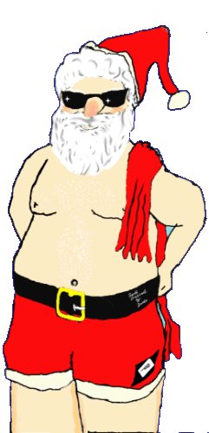SKY Christmas Practice Schedule
Group | 12/19 | 12/20 | 12/21 | 12/22 | 12/23 | 12/24 | 12/25 | 12/26 | 12/27 | 12/28 | 12/29 | 12/30 | 12/31 | 1/1 | 01/02 | 1/3
Senior  BGHS | 8 to 10  4 to 6 | 1 to 3 | 8 to 10  4 to 6 | 8 to 10  weights  4 to 6 | 8 to 10  4 to 6  XMAS  PARTY | 8 to 10  weights  OFF | OFF | 8 to 10  4 to 6 | 1 to 3  Dee’s  BDAY | 8 to 10  4 to 6 | 8 to 10  Weights  4 to 6 | 8 to 10  4 to 6 | 8 to 10  Weights  OFF | OFF | 8 to 10 | OFF
Blue | 8 to 10  4 to 6 | 1 to 3 | 8 to 10  4 to 6 | 8 to 10  4 to 6 | 8 to 10  4 to 6  XMAS  Party | 8 to 10  OFF | OFF | 8 to 10  4 to 6 | 1 to 3  Dee’s  BDAY | 8 to 10  4 to 6 | 8 to 10  4 to 6 | 8 to 10  4 to 6 | 8 to 10  4 to 6 | OFF | 8 to 10 | OFF
White | OFF | 1:45 to 3 | 10:45  To  Noon | 10:45  To  Noon | 4:00  To  5:30  XMAS  PARTY | OFF | OFF | OFF | 1:45  To  3:00 | 10:45  To  Noon | 10:45  To  Noon | 10:45  To  Noon | 10:45  To  Noon | OFF | OFF | 1:00  To  2:30
Red 2  Red 3 | OFF | 1 to 1:45 | 10:00  To  10:45 | 10:00  To  10:45 | 5:15  To  6:00  XMAS  PARTY | OFF | OFF | OFF | 1:00  to  1:45 | 10:00  To  10:45 | 10:00  To  10:45 | 10:00  To  10:45 | 10:00  To  10:45 | OFF | OFF | 1:00  To  1:45
Red 1 | OFF | 1 to 1:30 | 10:00  To  10:45 | 10:00  To  10:45 | 5:15  To  6:00  XMAS  PARTY | OFF | OFF | OFF | 1:00  to  1:45 | 10:00  To  10:45 | 10:00  To  10:45 | 10:00  To  10:45 | 10:00  To  10:45 | OFF | OFF | 1:00  To  1:45
Christmas Party will be after practice on December, 23rd. Please bring a gift ($5 max) same gender. Pizza, desserts, chips, and drinks will be served.

