ACKNOWLEDGEMENT OF USA SWIMMING MAAPP POLICY

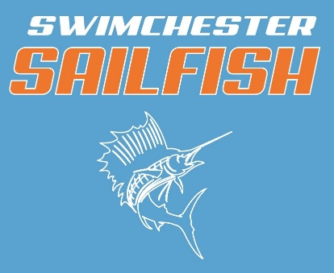

I acknowledge that I have received, read and understood the Minor Athlete Abuse Prevention Policy (MAAPP) and/or that the Policy has been explained to me or my family. I further acknowledge and understand that agreeing to comply with the contents of this Policy is a condition of my membership with (USA Swimming member club).

Name:
Signature:
Date:

