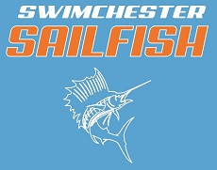
2020-2021 Team Sponsor Form

Sponsor Name ______________________________________________________

Sponsor Address ____________________________________________________

Sponsor Contact______________________________Phone #_________________

_____Gold Corporate Sponsor $1,000
Logo on the website, team T-shirts (larger print than blue/orange sponsors), team banner that will be hung in the pool area and any other advertising

_____Silver Sponsor $500
Logo on the website, team T-shirts (larger than blue/orange sponsors), team banner that will be hung in the pool area

_____Blue Sponsor $250
Logo on team T-shirts

_____Orange Sponsor $250
Logo on team website

_____White Sponsor $250
Logo on team banner

_____Friend of the Team Sponsor $________ ($50 minimum)

Thank you for your support!
Please send the form to (check payable to Swimchester Sailfish):
Swimchester Sailfish
2052 Rebel Road
Lexington, KY 40503

