Nu Wave Swim Club Team Sponsorship 2019- 20

Taking Louisiana Swimming to the National level!

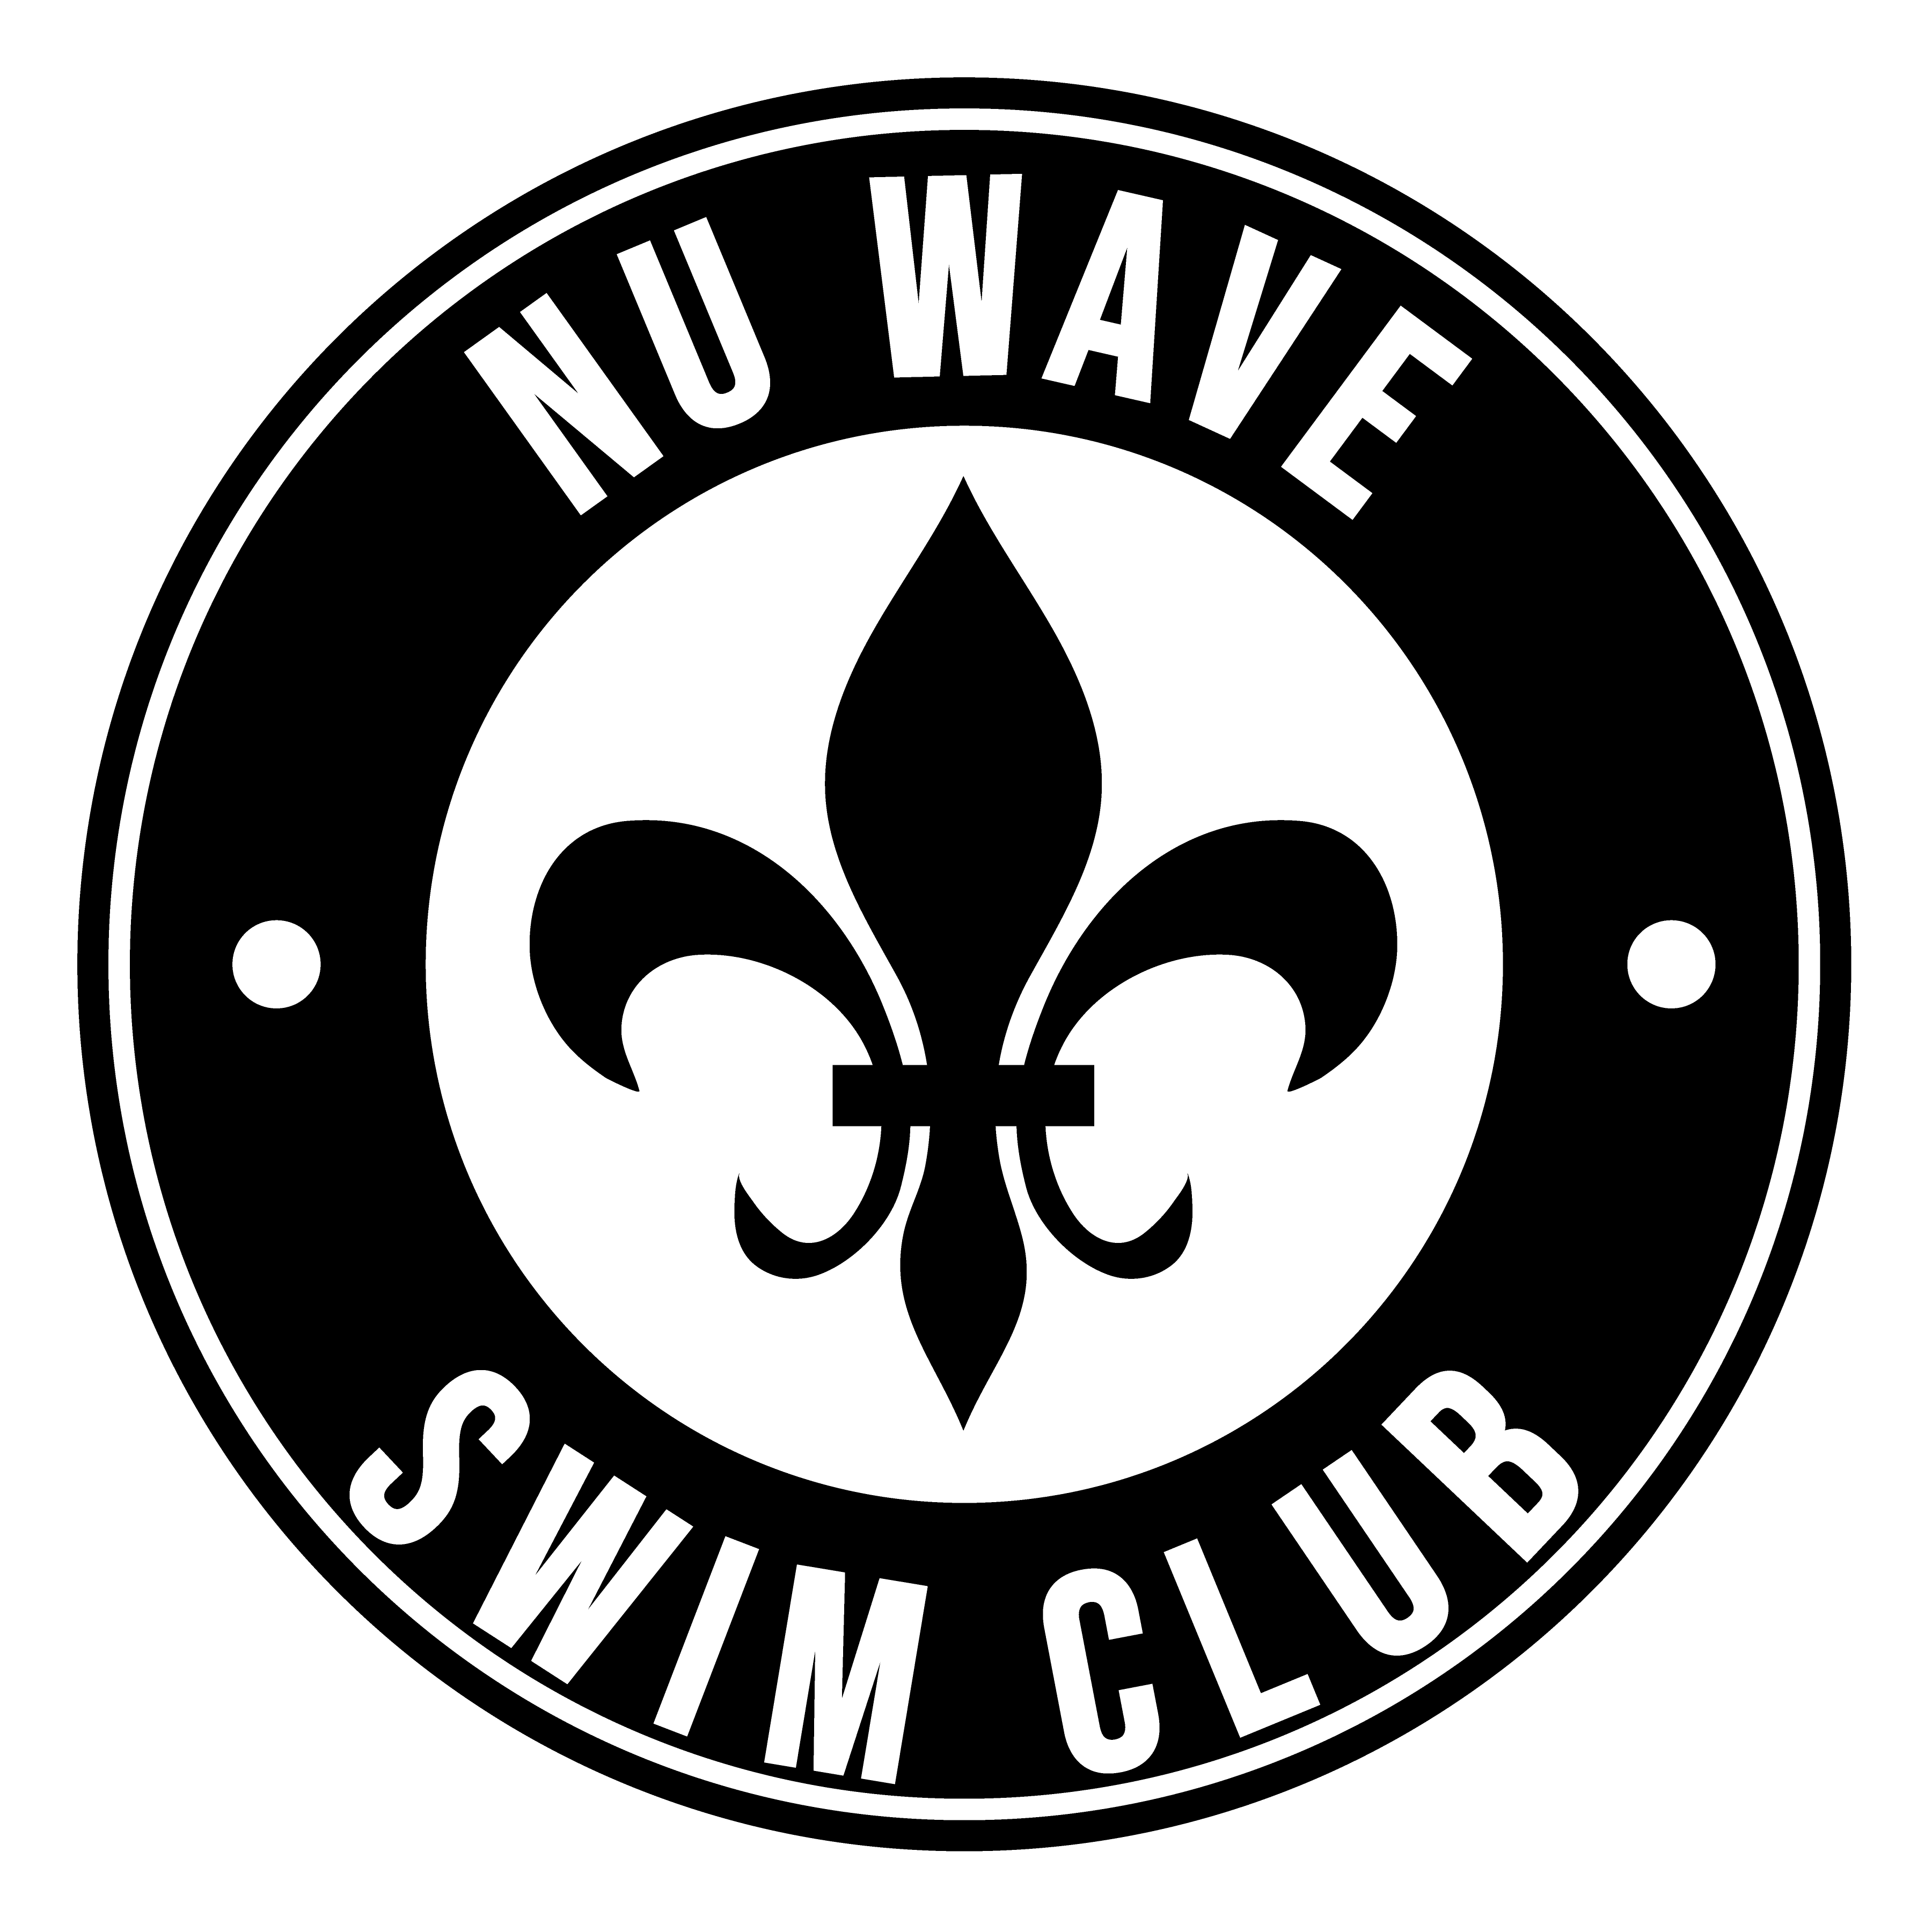

Dear Nu Wave Supporter:

Please join us in supporting Nu Wave Swim Club, a non-profit 501(c)(3) organization to promote youth swimming. You and your business can reach over 3,000 people by becoming a sponsor for Nu Wave Swim Club.

Our yearly membership dues do not cover the costs of operations. Our deficit is funded through team supporters like you. Donations directly support our pool rental fees, equipment purchases, and the best coaching staff in the city.

Above all, your donation helps to keep our swim club’s dues low, which enables more kids to participate in our program.

Please send your tax-deductible donation today to enable Nu Wave swimming to continue its success in training local children to compete at the National level!

Every sponsor at every level gives each child The Nu Wave Edge!

Thank you,

Swim New Orleans d/b/a Nu Wave Swim Club

Premier New Orleans Swim Club
Five of the last Seven Consecutive Years of Top 3 Finishes at the Louisiana State Championships!
Over 160 United States Swimming members
Over 125 Learn to Swim Participants
Over 25 United States Master Swimmers
USA Swimming Level 4 Club Recognition Program- recognizes Business & Organizational Success, Parent & Volunteer Development, Coach Development & Education, and Athlete Development & Performance

Promoting Health and Fitness
Encouraging kids to be healthy and active
Helping to reverse the trend of childhood obesity

Building Confidence
Teaching children how to establish and meet goals at a young age, creating a pathway for a successful future

Leadership Development
Competing at the highest level

Promoting Water Safety
Providing year-round swim instruction to hundreds of children

2018-19 Team Accomplishments
2019 Bronze Medal Club in USA Swimming's Club Excellence Program
Host for the 2020 Louisiana Senior State Championships (July 2020)
2018-19 Male 12&U Swimmer of the Year Runner-up
4 Collegiate student-athletes (3 at D1 schools)
57 New Team Records
1 New State Record
5 Individual HS State Champions, 12 additional Top 3 finishes
17 Individual Club Champions, 51 additional Top 3 finishes
2018 Winter Junior National Finalists (2 Finalists)
7 Swimmers attending the NCSA Championship (4 Finalists)
6 Swimmers attending the Age Group Sectionals (1 Finalist)
3 Swimmers attending the Senior Zone Championship (1 Finalist)

Nu Wave Swim Club Sponsorship Levels:

Platinum Level_________________________________________________________$4,000

Placement of your Company name/logo on the home page of our Nu Wave website with a link to your company website and logo placed on the front page of our bi-monthly newsletters.

Your Company name/logo displayed on a Platinum level banner to be hung at three or more team hosted meets.

Your Company name/logo displayed on our Program Brochure.

Logo on the Footer on all Nu Wave digital meet programs for all team-hosted meets and sessions.

Company name displayed at our concessions for all meet hosted meets.

Company name displayed in the Louisiana State Championship Meet Program as an Event Sponsor for three events.

Gold Level $1,000

Placement of your Company name/logo on the home page of our Nu Wave website with a link to your company website and logo placed on the front page of our bi-monthly newsletters.

Your Company name/logo displayed on a banner to be hung at three or more team hosted meets (recognized as Gold Level sponsor).

Your Company name/logo displayed on our Program Brochure.

Logo on the Footer on all Nu Wave digital meet programs for all team-hosted meets and sessions.

Company name displayed at our concessions for all meet hosted meets.

Company name displayed in the Louisiana State Championship Meet Program as an Event Sponsor for two events.

Silver Level $500

Placement of your Company name/logo on the home page of our Nu Wave website and the front page of our bi-monthly newsletters.

Your Company name/logo displayed on a banner to be hung at three team hosted meets (recognized as Silver Level sponsor).

Your Company name/logo displayed on our Program Brochure.

Logo on the Footer on Nu Wave digital meet programs for three home swim meets.

Company name displayed at our concessions for all meet hosted meets.

Company name displayed in the Louisiana State Championship Meet Program as an Event Sponsor for one event.

Bronze Level $250

Placement of your Company name/logo on the home page of our Nu Wave website.

Your Company name/logo displayed on a banner to be hung at three team hosted meets (recognized as Bronze Level sponsor).

Logo on the Footer on Nu Wave digital meet programs for two home swim meets.

Company name displayed at our concessions for all meet hosted meets.

Louisiana State Championship Meet Event Sponsor______________$100

Company name displayed in the Louisiana State Championship Meet Program as an Event Sponsor for three events.

Swim New Orleans (dba Nu Wave Swim Club) Sponsor Application

Name of Business or Sponsor: _______________________________________________________

Name of Representative/Owner: ___________________________________________________

Mailing address: ______________________________________________________________________

Telephone: _______________________________ Fax: ______________________________________

E-mail address: ______________________________________________________________________

Service/Product/Trade: ____________________________________________________________

Sponsorship Level: _________________________________

Please attach the appropriate artwork or e-mail your logo or image files to athionville@cox.net. All sponsors will receive an e-mail when your application has been received.

Please make checks payable to Swim New Orleans and address all forms to Angele Thionville, 109 Glenwood Avenue, Harahan, LA 70123.

High resolution JPG or Vector files are preferred for use in banner and ad designs.

Thank you,

Swim New Orleans
d/b/a Nu Wave Swim Club

ALL APPLICATIONS ARE DUE BY October 20, 2019, IF YOU WANT TO BE GUARANTEED A SPOT ON THE TEAM BANNER AND MEET PROGRAM FOR OUR FIRST MEET AND TEAM BROUCHURE.

