Erie
Name: Mitchell Myers

HB White

Name: Khian Kirkland

HB Red
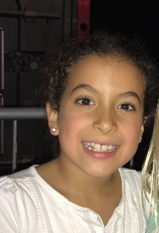
Name: Valeria Dominguez
Age: 9 years
Swim Group: Red
Hobbies: Volleyball
Role Model: Myself
Favorite Stroke: freestyle
Famous Person I'd like to meet: Carlos Vives
Favorite Movie: The Greatest Showman
Favorite Book: The Land of Stories
Favorite part about swimming on LESD: Swim
I want to be: A swimmer

HB Blue
Name: Theo Jones
HB Bronze
Name: Riva Kogan

HB Silver
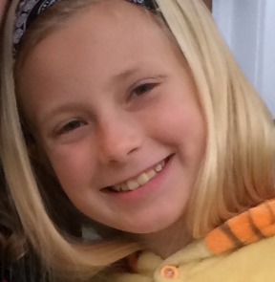
Name: Sydney Golovan
Age: 12
Swim Group: HB Silver
Hobbies: Baking, Arts and Crafts
Role Model: Mom and Dad
Favorite Stroke: Breast
Famous Person I'd like to meet:
Favorite Movie:
Favorite Book: H2O
Favorite part about swimming on LESD: Friends on my Team
I want to be: Something in the Sciences

HB Gold
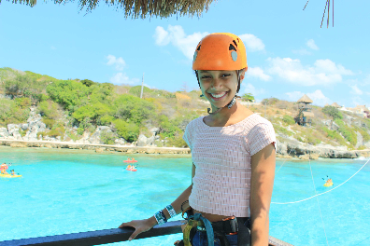
Name: Kali Mclin
Age: 14
Swim Group: Gold (HB)
Hobbies: Golf, Collecting stickers, organizing
Role Model: Michael Phelps, Cody Miller
Favorite Stroke: Breaststroke
Famous Person I'd like to meet: Michael Phelps
Favorite Movie: Jumanji
Favorite Book: Don’t like books
Favorite part about swimming on LESD: teammates and practice, coaches
I want to be: a Doctor

Hawken Lower White
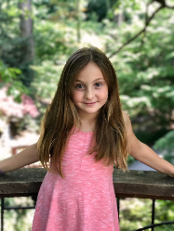

Name: Adriana Friedman
Age: 9
Swim Group: White
Hobbies: swimming, piano, horseback riding, tennis
Role Model: My mom
Favorite Stroke: freestyle
Famous Person I'd like to meet: Lebron James
Favorite Movie: Mousehunt
Favorite Book: Sisters
Favorite part about swimming on LESD: meets
I want to be: a travel writer

Hawken Lower Red
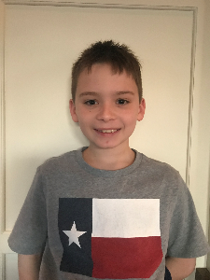
Name: frank Hobbs
I’m 10
I’m in red group
Some of my hobbies are gaming coding reading science technical stuff and of course swimming.
My role model is my uncle David he died in car accident
My favorite strokes are backstroke and breaststroke.
a famous person that I would like to meet is Chris Martin
my favorite movie series of Star Wars
my favorite book is Charlie and the great glass elevator
my favorite part about lesd is swimming meets because I can be with my friends
what I want to be when I grow up is a person who works at Mission control

Hawken Lower Red

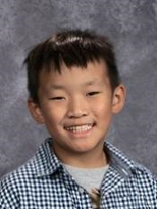

Name: Ethan Dong
Age: 10
Swim Group: Red
Hobbies: crafting
Role Model: Ellie Dong, my sister. She is brave and competitive.
Favorite Stroke: free-style
Famous Person I'd like to meet:J.R.R Tolkiens
Favorite Movie: what is your name? (Japanese movie)
Favorite Book: Hobbit
Favorite part about swimming on LESD: I can make a lot of new friends.
I want to be: an author

Hawken Lower Blue
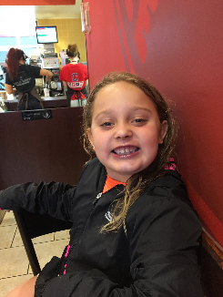

Name: Quincey Smith
Age: 8
Swim Group: Blue
Hobbies:Soccer, Swimming
Role Model: Mom and Dad
Favorite Stroke: Backstroke
Famous Person I'd like to meet:Katie Ledecky
Favorite Movie: Wonder
Favorite Book: Hello Universe
Favorite part about swimming on LESD: Swimming with friends
I want to be: Teacher and Olympic Swimmer

Hawken Lower Bronze
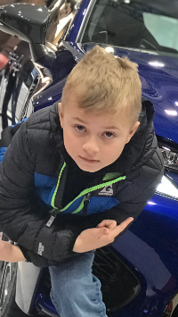

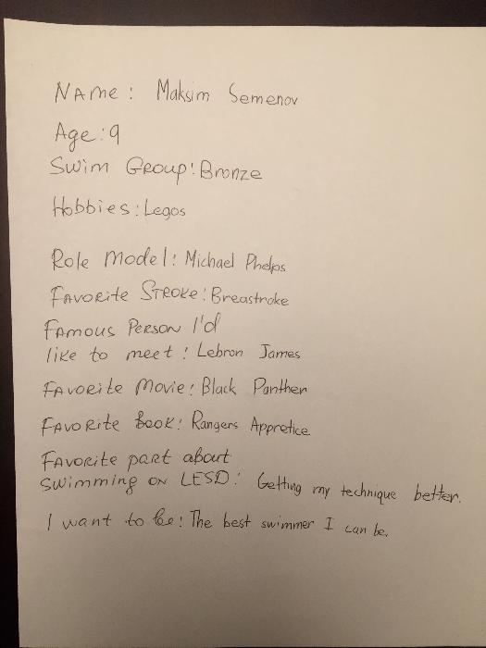
Hawken Lower Student
Name: Lucas Greenberg

Hawken Lower Gold

Name: Julia Kiefer
Age: 16
Swim Group: Gold
Hobbies: Reading
Role Model: My parents
Favorite Stroke: Backstroke
Famous Person I'd like to meet: Jane Goodall
Favorite Movie: Spirit
Favorite Book: The Child Thief
Favorite part about swimming on LESD: The sense of community
I want to be: A scientific researcher

Hawken Upper White

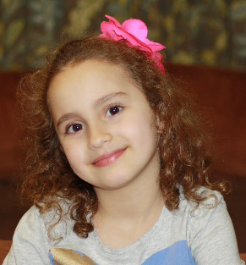

Name: Elizabeth Matsievich
Age: 6
Swim Group: White Hawken Upper
Hobbies: Swimming, Figure skating, Reading, Nature walks
Role Model: My older sister
Favorite Stroke: Front crawl
Famous Person I'd like to meet: The Maccabeats and a tooth fairy
Favorite Movie: The BFG
Favorite Book: The Jewel Fairies series
Favorite part about swimming on LESD: Diving and racing
I want to be: Writer and a president

Hawken Upper Red/Blue

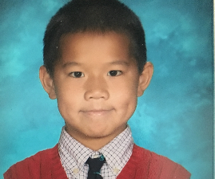

Leo Shi and I am 10 years old.
I am a swimmer in red group and my hobbies
Collecting, reading, playing on my phone and computer
And drawing. My role model to look up to is Thomas
Edison. He stands out to me and for me is a symbol
for never giving up and that your first try is not always
right. My favorite stroke is breaststroke. My favorite
person that I want to meet is Lebron James. My
favorite movie is Jumangi and my favorite book
Is the Cupcake Club. My favorite part about swimming
is that I can see other people that I don't normally see.
I want to be a chef when I grow up. What I mean by
chef though is a baker.

Hawken Upper Bronze

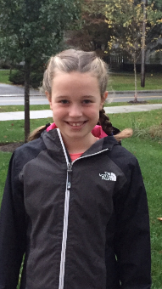

Name: Addy Pruce
Age: 10
Swim Group: Bronze
Hobbies: Swim, basketball, lacrosse, arts & crafts
Role Model: Mom and Dad
Favorite Stroke: Butterfly
Famous Person I'd like to meet:Zendaya
Favorite Movie: The Greatest Showman
Favorite Book: The War that Saved my Life
Favorite part about swimming on LESD: Having fun with friends and getting better at swimming
I want to be: Idk

Hawken Upper Silver

Name: Will Dietz

Hawken Upper Silver

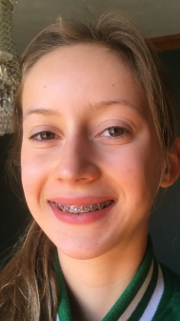

Name: Charlotte Hantus
Age: 15
Swim Group: Silver upper hawken
Hobbies: swimming, running, biking, violin, reading.
Role Model:
Favorite Stroke: Free
Famous Person I'd like to meet:
Favorite Movie: anything with magic
Favorite Book: anything with magic
Favorite part about swimming on LESD: swimming with friends
I want to be: microbiologist

Hawken Upper Gold

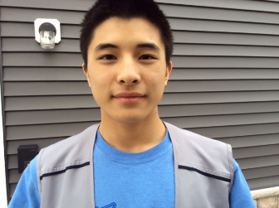

Name : Kenneth Yang
Age: 15
Swim Group: Gold
Hobby: coding
Role Model : father
Favorite stroke : Free stroke
Famous person like to meet: Johnny Ive
Favorite movie : Gladiator
Favorite book: What If
Favorite part about swim on LESD : swim with teammates
I like to be: tech entrepreneur

