CSC
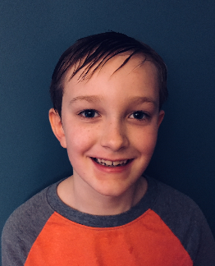

Name: Eli Baker

Erie
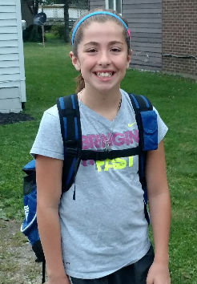
Name: Riley Amory
Hobbies: Swimming, Baking and making Crafts
Role Model: Katie Ledecky
Favorite Stroke: Backstroke
Famous Person I'd like to meet: Imagine Dragons
Favorite Movie: Coco
Favorite Book: The hunger games
Favorite part about swimming on LESD: My favorite part about swimming with LESD is swimming with my friends at meets and Practice. I also love to train with my coaches.
I want to be: A chemist

HB Red

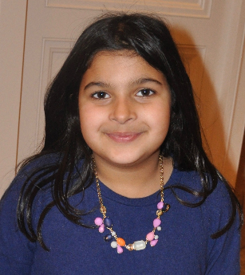
Raina Sethi
Age 9
Red Group
Hobbies: math, art, reading, tennis, squash, golf and swimming
Role model: Her teacher, Mrs. Kline
Favorite stroke: Breast stroke
Famous person she'd like to meet: Serena Williams
Favorite movie: The Last Jedi and Moana
Favorite book: Wonder
Favorite part about swimming on LESD: All the fun things they add to practices
I want to be:an artist and a singer

HB Blue
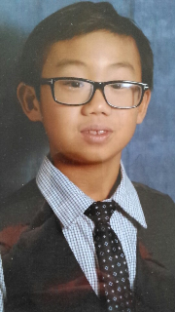
Name: JAMES YAN
Age: 8 YEARS OLD
Swim Group: BLUE
Hobbies Ice hockey, swimming and dancing。
Role Model: Phelps
Favorite Stroke: freestyle
Famous Person I'd like to meet george washington
Favorite Movie;sing
Favorite Book:captain underpant
Favorite part about swimming on LESD:
I want to be:scientist

HB Bronze
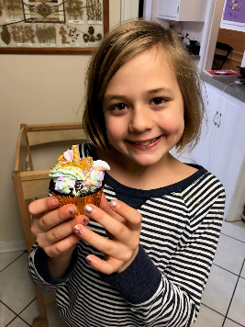
Name: Livia Cremer
Age: 8
Swim Group: Bronze
Hobbies: cross stitch, shopping, arts and crafts, piano
Role Model: Emma Watson and Katie Ledecky
Favorite Stroke: breaststroke and butterfly
Famous Person I'd like to meet: Emma Watson
Favorite Movie: Leap
Favorite Book: All Harry Potter
Favorite part about swimming on LESD: everything
I want to be: actress

HB Silver
Name: Sydney Golovan
Age: 12
Swim Group: HB Silver
Hobbies: Baking, Arts and Crafts
Role Model: Mom and Dad
Favorite Stroke: Breast
Famous Person I'd like to meet:
Favorite Movie:
Favorite Book: H2O
Favorite part about swimming on LESD: Friends on my Team
I want to be: Something in the Sciences

HB Gold
Name: Madison Miluk

Hawken Lower White

Name: Maddox
age 5
white team
hobbies are riding his bike and video games
favorite stroke is free style
wants to meet Micheal Phelps
favorite movie is Moana
he wants to be an inventor when he grows up
favorite part of swim team is the green bucket challenge.

Hawken Lower Red
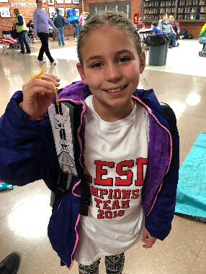
Name: Lily Bay White
Age: 9
Swim Group: red
Hobbies: swimming, drawing, making slime, playing Xbox right my tablet, reading,
Role Model: my Aunt Kate
Favorite Stroke: breast stroke
Famous Person I'd like to meet: Taylor Swift
Favorite Movie: The Emoji Movie
Favorite Book: Tale of Despereaux
Favorite part about swimming on LESD: making new friends and becoming a better swimmer
I want to be: an Olympic swimmer

Hawken Lower Red
Name: Reese Ungier
Hawken Lower Blue

Name: Brian Spahiu

Hawken Lower Bronze
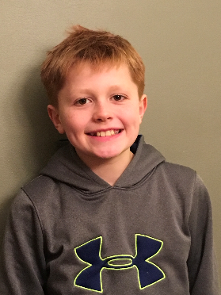
Name: Owen O’Malley
Age: 12
Swim Group: Bronze
Hobbies: Swimming, technology, hanging out with family,playing with my dog
Role Model: Steve Jobs
Favorite Stroke: Breaststroke
Famous Person I'd like to meet: Elon Musk
Favorite Movie: Ocean’s 11, Dark Knight Trilogy
Favorite Book: Holes
Favorite part about swimming on LESD: New friends and being in the pool
I want to be: Car Designer

Hawken Lower Silver
Name: Preston Wooley
Hawken Lower Silver
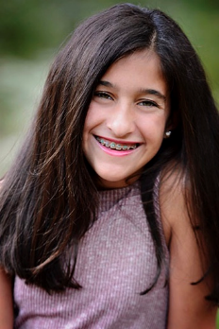
Name: anjali jawa
Age: 12
Swim Group: HL Silver
Hobbies: Tennis, Skiing, Golfing and Singing
Role Model: my mom
Favorite Stroke: Free
Famous Person I'd like to meet: Katie Ledecky
Favorite Movie: Star Wars
Favorite Book: Harry Potter
Favorite part about swimming on LESD: my friends
I want to be: a better swimmer

Hawken Upper White

Name: Winston Yu

Hawken Upper Red/Blue

Name: Ben Azok
Age: 8
Swim Group: Blue (Hawken Upper)
Hobbies: basketball, baseball, tennis, going to Cedar Point
Role Model: Katie Ledecky
Favorite Stroke: breast
Famous Person I'd like to meet: Michael Phelps
Favorite Movie: Star Wars
Favorite Book: Diary of a Wimpy Kid
Favorite part about swimming on LESD: the races and winning awards
I want to be: an Olympic swimmer

Hawken Upper Red/Blue

Name: Calvin Dietz
Age:8
Swim Group: blue
Hobbies: Play sports and ride my ATV
Role Model: My family
Favorite Stroke: Breastroke
Famous Person I'd like to meet: LeBron James
Favorite Movie: LEGO Batman Movie
Favorite Book: Harry Potter
Favorite part about swimming on LESD: Going to meets
I want to be: A famous basketball player

Hawken Upper Bronze

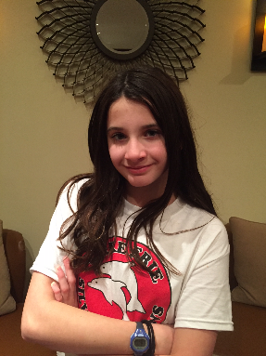

Name: Alexis Laven
Age: 11
Swim Group: Hawken Upper Bronze
Hobbies : Minecraft, playing trumpet
Role Model: Taylor Swift
Favorite Stroke: Backstroke
Famous Person I'd like to meet: Taylor Swift
Favorite Movie: Princess Bride
Favorite Book: Wonder
Favorite part about swimming on LESD: Coaches and the people I meet
I want to be: math teacher

Hawken Upper Silver

Name: Sarah Pophal
Age: 12
Swim Group: Silver
Hobbies: Making Slime
Role Model: Chloe Katz and my sister, Claire
Favorite Stroke: Free
Famous Person I'd like to meet: Sacagawea and Louis and Clark
Favorite Movie: Dumbo and
Favorite Book:
Favorite part about swimming on LESD:
I want to be:

Hawken Upper Silver

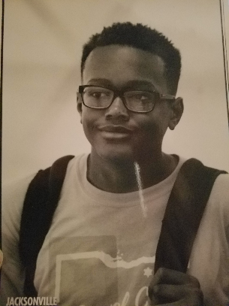

Name: James Huff lll
Age: 14
Swim Group: Silver
Hobbies: Video games and vacations
Role Model: My Dad
Favorite Stroke: Breast Stroke
Famous person I want to meet: LeBron James
Favorite Movie: Swindle
Favorite Book: Itachi's Story Daylight
Favorite part about swimming on LESD: being with friends, swimming on relays, and beating my times
I want to be: Math professor or mathematician

