Erie
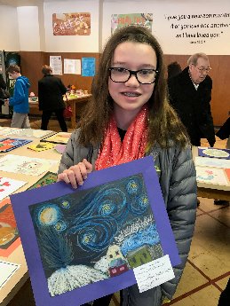
Name: Ellie Brugger
Age: 12
Group: Gold
Hobbies: Swimming, Running, Drawing and Reading
Role Models: parents
Stroke: Breast Stroke
Famous Person: Elle Fanning
Favorite Movie: Jaws
Favorite Book: Cinder
Favorite part of LESD: making new friends and the great coaches
I want to be: an Orthodontist

HB Blue
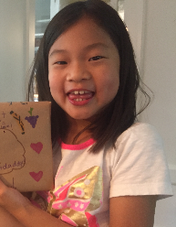

Name: Vivian Morgan
Age:8
Swim Group: Blue
Hobbies: Piano, Science, Reading, and Cooking
Role Model: my dad
Favorite Stroke: butterfly
Famous Person I'd like to meet: Lin-Manuel Miranda
Favorite Movie: Parent Trap
Favorite Book: Harry Potter
Favorite part about swimming on LESD: warm ups
I want to be: a chef

HB Bronze
Name: Ivy Berlin
HB Silver

Name: Colt Simonelli

HB Gold
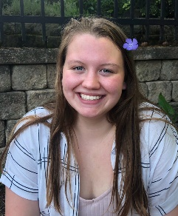

Name: Victoria Hagen
Age: 15
Group: Gold
Role Model: Katie Ledecky
Favorite Stroke: Freestyle
A famous person I’d like to meet: Nathan Adrian
Favorite Movie: Mrs. Doubtfire
Favorite book: The Things We Carry
Favorite part about swimming on LESD: I love the people on LESD. We always have fun during practices and meets no matter what.
I want to be: A doctor or a Chemist

Hawken Lower White/Red
Name: Gabby Saffore

Hawken Lower Blue
Name: Flora Fan

Hawken Lower Bronze
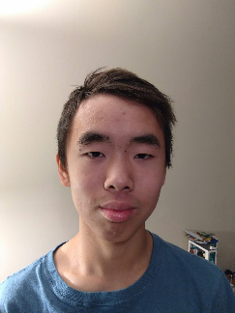

Name: Christian Wu
Age: 14
Swim Group: Bronze
Hobbies: I like to play some video-games, not a wide variety, also recently I’ve been going out to play tennis with some friends a lot more. I also like to read a few magazines, mainly ones from National Geographic.
Role Model: Elon Musk
Favorite Stroke: Breaststroke
Famous Person I'd like to meet: Bill Gates
Favorite Movie: Interstellar
Favorite Book: 1984 by George Orwell
Favorite part about swimming on LESD: Just being able to make and talk to friends.
I want to be: Something in the STEM field. Probably some kind of engineer
Hawken Lower Silver
Name: Noah Beaver
Hawken Upper White

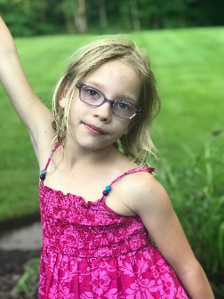

Name: Ellery Losch
Age: 7
Swim Group: white
Hobbies: gymnastics
Role Model: Victoria (a past gymnastics coach)
Favorite Stroke: breaststroke
Famous Person I'd like to meet: don’t know
Favorite Movie: The Incredibles
Favorite Book: Pinkalicious
Favorite part about swimming on LESD: swimming
I want to be: a gymnast

Hawken Upper Red/Blue

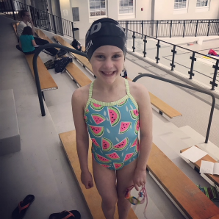

Name: Emery Horvath
Age: 6
Swim Group: red/blue
Hobbies: swimming, playing, coloring
Role Model: Michael Phelps
Favorite Stroke: butterfly
Famous Person I'd like to meet: Michael Phelps
Favorite Movie: Hotel Transylvania 2
Favorite Book: Magic Fairies
Favorite part about swimming on LESD: it’s fun and everyone is super nice
I want to be: famous swimmer

Hawken Upper Bronze

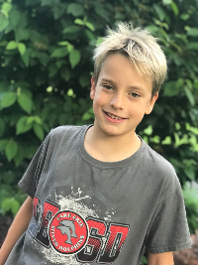

Name: Everett Losch
Age: 8
Swim Group: bronze
Hobbies: building legos
Role Model: Michael Phelps
Favorite Stroke: backstroke
Famous Person I'd like to meet: Michael Phelps
Favorite Movie: Star Wars
Favorite Book: The 39 Story Treehouse
Favorite part about swimming on LESD: meeting friends
I want to be: a swimmer

Hawken Upper Silver

Name: Reese Hill

Hawken Upper Gold

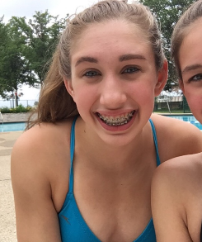

Lauren Musbach
Age 15
Hawken Upper Gold
Hobbies: drawing, reading
Role Model : Mom and Dad
Fav stroke : Butterfly
Fav person like to meet : Laurie Hernandez
Fav movie: The Miracle Season
Fav book: Every Day
Fav part Swimming of swimming on LESD: Coaches
I want to be an Engineer

