CSC
Name: Ethan Scheer

Erie
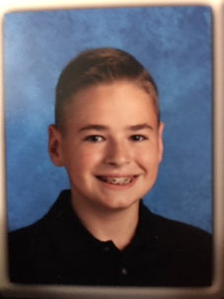
Name: Aidan Levis
Age: 12
Swim Group: Gold
Hobbies: Swimming, Sailing, Skiing, Water Polo
Role Model: My Dad And Coach Gregg Sarbak
Favorite Stroke: Freestyle
Famous Person I'd like to meet: Michael Phelps
Favorite Movie: Star Wars
Favorite Book: The Maze Runner
Favorite part about swimming on LESD: Swimming with all of my friends and training with great coaches
I want to be: Engineer

HB White

Name: Ella Cremer
Age: 6
Swim Group: HB White
Hobbies: piano, soccer, ice skating
Role Model: Livia (big sister in bronze)
Favorite Stroke: Breaststroke
Famous Person I'd like to meet: Jojo Siwa
Favorite Movie: Coco
Favorite Book: The Little Prince
Favorite part about swimming on LESD: That you learn how to swim better

HB Blue
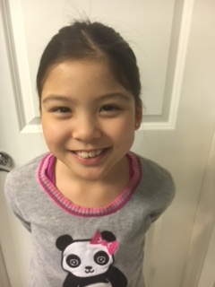

Name: Abigail Wee
Age: 9
Swim group: Blue
Hobbies: Volleyball, swimming, tennis
Role Model: Michael Phelps
Famous Person I’d like to meet: Michael Phelps
Favorite Movie: The Last Jedi
Favorite Book: Little House in the Big Woods
Favorite Part About Swimmig in LESD: Having fun
I want be an: Orthodontist and swimmer

Hawken Lower White
Name: Christina Jun

Hawken Lower Red

Name: Flora Fan
Age: 7
Swim Group: Red
Hobbies: gymnastics and swimming
Role Model: Michael Phelps
Favorite Stroke: breast
Famous Person I'd like to meet: Simone Biles
Favorite Movie: Emoji Movie
Favorite Book: Dork Diaries
Favorite part about swimming on LESD: 100 choice at the beginning of practice
I want to be: a professional swimmer

Hawken Lower Red
Name- Toni Opelami
Age- 8
Swim group- Red
Hobbies- Riding my bike and go cart, performing magic tricks
Role model- My dad
Favorite stroke- Breast stroke
Famous person I’ll like to meet- Kristaps Porzingis
Favorite movie- Black Panther
Favorite book-Big Nate series/ Wonder
Favorite part about swimming in LESD- I get to work on my swimming technique
I’ll like to be- Inventor/ Actor

Hawken Lower Bronze
Name: Benji Beaver

Hawken Lower Student
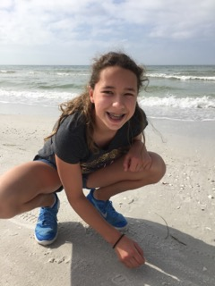

Name: Zoey Cosgrove
Age: 12
Swim Group: Silver
Hobbies: volleyball, photography, reading, movies, baking
Role Model: my Grandma
Favorite Stroke: Breaststroke
Famous person I’d like to meet: Octavia Spencer
Favorite Movie: The Help
Favorite Book: The Genius Files
Favorite part about swimming on LESD: Coach and teammates
I want to be: an interior designer

Hawken Lower Silver

Name: Lilian Li
Age: 10
Swim Group: Silver
Hobbies: reading, drawing
Role Model: My big sister Vivian
Favorite Stroke: Breaststroke
Famous Person I'd like to meet:
Favorite Movie: Coraline
Favorite Book: Harry Potter and Percy Jackson series
Favorite part about swimming on LESD: great coaches and friends
I want to be: Computer Engineer

Hawken Lower Silver
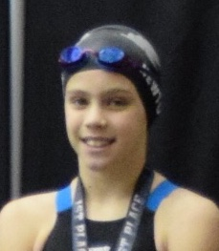

Name: Nina Newton
Age: 10
Swim Group: Silver
Hobbies: Reading
Role Model: Mom & Dad
Favorite Stroke: Butterfly
Famous Person I'd like to meet:
Favorite Movie: Coco
Favorite Book: Wonder
Favorite part about swimming on LESD: swimming
I want to be: Swim coach

Hawken Upper White

Name: Katie Azok
Age: 5
Swim Group: White (Hawken Upper)
Hobbies: gymnastics, playing with dolls, swinging on a swing
Role Model: my big brother, Ben
Favorite Stroke: Freestyle
Famous Person I'd like to meet: Santa Claus
Favorite Movie: Captain Underpants
Favorite Book: Diary of a Wimpy Kid
Favorite part about swimming on LESD: my friends and coaches

Hawken Upper Red/Blue

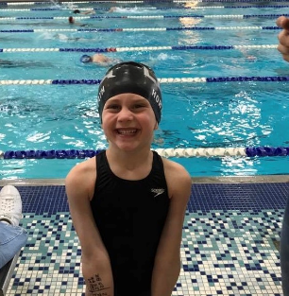

Name: Emery Horvath
Age: 6
Swim Group: Red
Hobbies: swimming, reading, dancing
Role Model: A good swimmer
Favorite Stroke: Backstroke
Famous Person I'd like to meet: Michael Phelps
Favorite Movie: Alice in Wonderland
Favorite Book: Princess in Black
Favorite part about swimming on LESD: Doing cheers at meets and being with my friends
I want to be: a vet

Hawken Upper Bronze

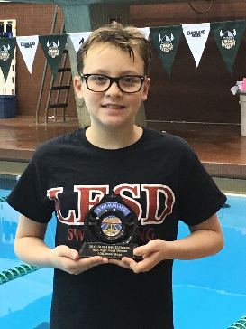

Name: Mac Clark
Age: 10
Swim Group: HU Bronze
Hobbies: Swimming and Traveling
Role Model: Katie Ledecky
Favorite Stroke: Distance Freestyle
Famous Person I'd like to meet: Ryan Murphy and Katie Ledecky
Favorite Movie: Star Wars Return of the Jedi
Favorite Book: 1776
Favorite part about swimming on LESD: There are lots of people on the club
I want to be: An Olympic Gold Medalist

Hawken Upper Bronze

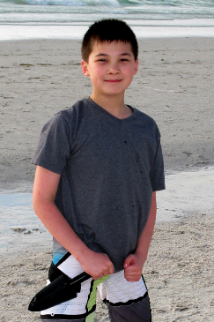

Name: Julian Wolke
Age: 10
Swim Group: Hawken Upper Bronze
Hobbies: Snowboarding
Role Model: Shaun White
Favorite Stroke: Breaststroke
Famous Person I'd like to meet: Shaun White
Favorite Movie: Harry Potter and The Sorcerer's Stone
Favorite Book: Harry Potter and The Goblet of Fire
Favorite part about swimming on LESD: Going to swim meets
I want to be: a Video Game Designer

Hawken Upper Gold

Name: Sylvia Stewart-Bates

