Erie
Name: Evan Kemp

HB Red
Julia Turner
age 8
swims at HB
her hobbies are crafting and riding her bike.
Her role model is Coach Aroney
she wants to meet Michael Phelp
her favorite stroke is backstroke
She loves the movie Hidden Figures
book Wonder.

HB Blue
Name: Ivy Berlin
HB Bronze
Name: Sofia Jiminez
HB Bronze
Name: Thor Johannessen
HB Silver
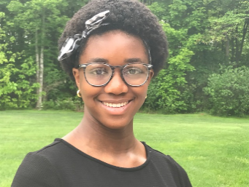
Name: Munachimso (Muna) Janet Agwa
Age: 13
Swim Group: Silver
Hobbies: Reading, journaling, and watching Netflix
Role Model: Michelle Obama
Favorite Stroke: Breaststroke
Famous Person I’d like meet: Ellen DeGeneres
Favorite Movie: Black Panther
Favorite Book: Divergent by Veronica Roth
Favorite part about swimming on LESD: Making connections with my teammates and coach.
I want to be: A surgeon

HB Silver
Name: Colt Simonelli
HB Gold
Name: Kali McClin

Hawken Lower White

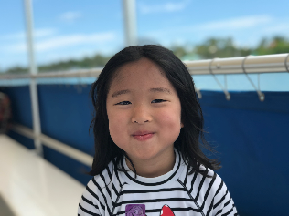

Name: Christina Jun
Age: 6
Swim Group: White at Hawken Lower
Hobbies:playing a piano
Role Model: chris- my brother
Favorite Stroke: back stroke
Famous Person I'd like to meet: Michael Phelps
Favorite Movie: Boss Baby
Favorite Book: Pigeon Books
Favorite part about swimming on LESD: green bucket challenge
I want to be: swim coach

Hawken Lower Red
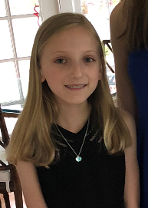
Name: Samantha DeMinico
Age: 9
Swim Group: Blue Team (as of 6/4/18)
Hobbies: swimming, tennis, piano, crafts
Role Model: My family
Favorite Stroke: Freestyle
Famous Person I'd like to meet: Queen of England
Favorite Movie: Wonder
Favorite Book: Nancy Drew
Favorite part about swimming on LESD: Learning how to dive
I want to be: A swimmer

Hawken Lower Blue
Name: Isabelle Flowers

Hawken Lower Bronze
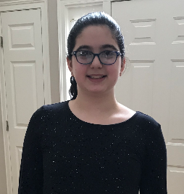

Name: Orli Peleg
Age: 12
Swim Group: Bronze
Hobbies: Swimming, playing piano
Role Model: My Sister
Favorite Stroke: Bufferfly
Famous Person I'd like to meet: Katie Ladekey
Favorite Movie: Z-O-M-B-I-E-S
Favorite Book: Long Way Down
Favorite part about swimming on LESD: Everything
I want to be: An Olympic Swimmer, and a doctor

Hawken Lower Gold
Name: Carys Edgar
Hawken Upper White

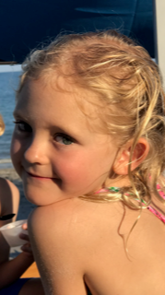

Name: Giulia Isabella Mattes
Age: 7
Swim Group: White
Hobbies: jumping on my Trampoline and drawing
Role Model: ?
Favorite Stroke: Dolphin kick
Famous Person I'd like to meet: Katy Perry
Favorite Movie: „ The greatest Showman“
Favorite Book: Puppy Princess
Favorite part about swimming on LESD:
having fun and being in the water
I want to be: a champion swimmer

Hawken Upper Red/Blue

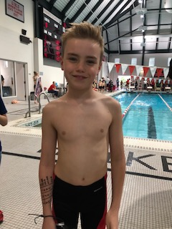

Name: Nick Carcelli
Age: 11
Swim Group: Blue/Bronze
Hobbies: swim, run, golf, play video games and jump on trampoline
Role Model: my grandpa cause he was a hard worker
Favorite Stroke: back stroke
Famous Person I'd like to meet: Billy Joel
Favorite Movie: Zoolander
Favorite Book: Bones Series
Favorite part about swimming on LESD: relays
I want to be: a PGA tour golfer 🏌️ or an Olympic swimmer 🏊

Hawken Upper Bronze

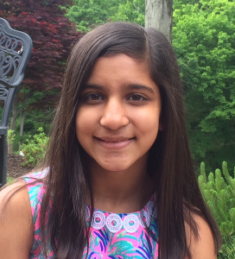

Name: Alisha Vasavada
Age: 12
Swim Group: bronze
Hobbies: swimming and running
Role Model: my parents
Favorite Stroke: breaststroke
Famous Person I'd like to meet: Katie Ledecky
Favorite Movie: Wonder
Favorite Book: The Land of Stories
Favorite part about swimming on LESD: swim meets and getting better at swimming
I want to be: a doctor

Hawken Upper Silver

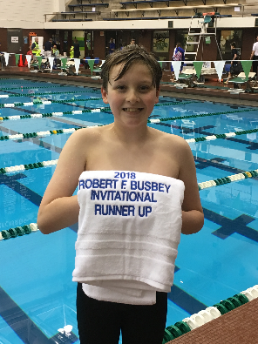

Name: Mac Clark​
Age: 11​
Swim Group: Hawken Upper Silver​
Hobbies​: Swimming, Playing cards​
Role Model: Ryan Murphy​
Favorite Stroke: Freestyle​
Famous Person I'd like to meet: Ryan Murphy, Katie Ledecky​
Favorite Movie: Avengers Infinity War​
Favorite Book: 1776​
Favorite part about swimming on LESD: Teammates and Coaches​
I want to be: Olympic swimmer​

Hawken Upper Silver

Name: Marley Hill

Hawken Upper Gold

Name: Julia Johnson

