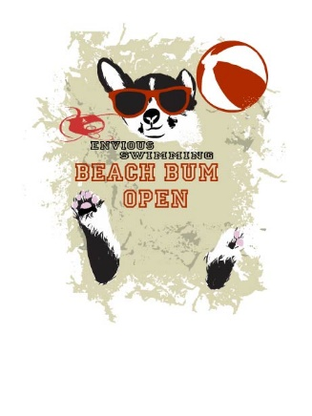
Beach Bum Open
McDermott Pool
975 Sandy Lane, Warwick RI

Session 1 Saturday Morning
Warm-up @ 8:00am |  | Meet starts @ 9:10am
Girls |  | Boys
1 | 12&U 200 IM |  | 2
3 | 12&U 50 FLY |  | 4
5 | 12&U 50 FR |  | 6
7 | 12&U 100 BK |  | 8
9 | 11-12 200 FLY |  | 10
11 | 12&U 100 BR |  | 12

Session Distance
Warm-up @ 1:00 pm |  | Meet starts @ 1:25pm
Girls |  | Boys
 | Mixed 11&O 800 FR (Fast to Slow) Limit of 4 heats

Session 3 Saturday Afternoon
Warm-up @ 2:30pm |  | Meet starts @ 3:40pm
Girls |  | Boys
15 | 13&O 200 BR |  | 16
17 | 13&O 100 BK |  | 18
19 | 13&O 50 FR |  | 20
21 | 13&O 50 BR |  | 22
23 | 13&O 200 FLY |  | 24
25 | 13&O 200 FR |  | 26

Session 4 Sunday Morning
Warm-up @ 8:00am |  | Meet starts @ 9:10am
Girls |  | Boys
27 | 11-12 200 BR |  | 28
29 | 12&U 100 FR |  | 30
31 | 12&U 50 BK |  | 32
33 | 12&U 50 BR |  | 34
35 | 11-12 200 BK |  | 36
37 | 12&U 100 FLY |  | 38
39 | 12&U 200 FR |  | 40

Session Distance
Warm-up @ 1:00 pm |  | Meet starts @ 1:25pm
Girls |  | Boys
 | MIXED 11&O 1500 FR (Slow to Fast) Limit 3heats

Session 6 Sunday Afternoon
Warm-up @ 2:10pm |  | Meet starts @ 3:20pm
Girls |  | Boys
43 | 13&O 200 IM |  | 44
45 | 13&O 50 FLY |  | 46
47 | 13&O 50 BK |  | 48
49 | 13&O 100 BR |  | 50
51 | 13&O 100 FLY |  | 52
53 | 13&O 200 BK |  | 54
55 | 13&O 100 FR |  | 56

