Athlete Protection Training Course
Coaches Advantage Training
Link & Tips:

The Coaches Advantage Training (CAT) and Athlete Protection Training (APT) courses are required and must be renewed on a yearly basis.

The APT is required for all new and existing members, including coaches, officials, chaperones, meet directors, and adult athletes 18 and over. The CAT is for coaches only.

You must be a USA Swimming member to access the courses.

Your first step is to click on this Link to your LEARN account. This link will take you to the USA Swimming website’s LEARN home page.

Scroll down to the middle of the page until you see this:

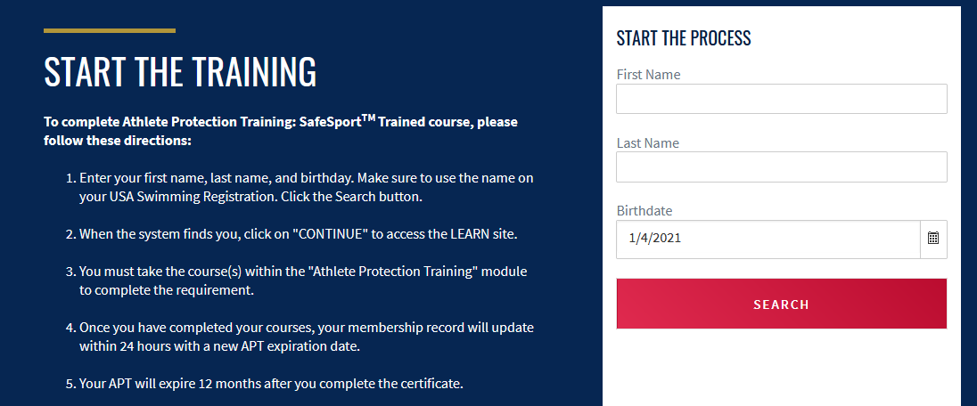

Insert your first name, last name and DOB and then hit the red SEARCH button.

Your name should come up below the SEARCH button as seen below.

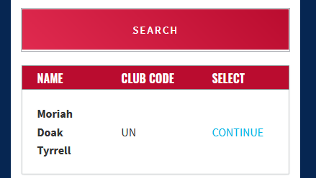

Click Continue

Then click GO TO LEARN.

The page will look like this:
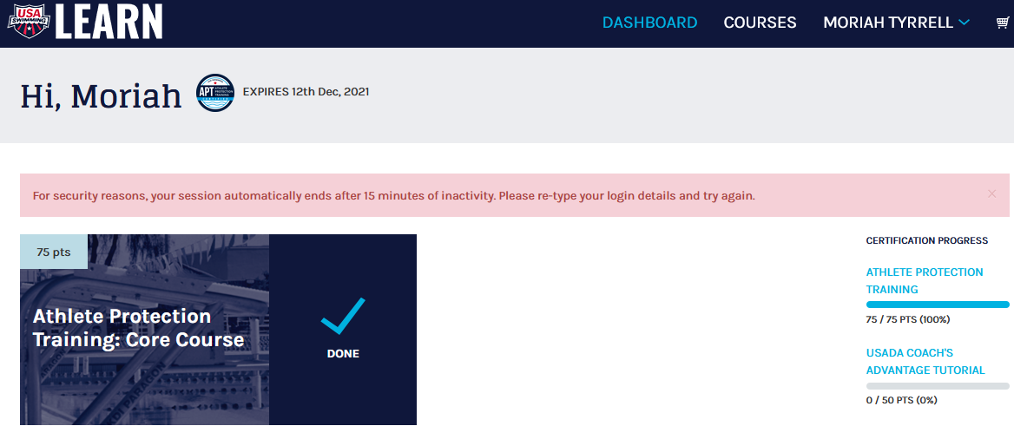

CAT
If the class is not on the home page click on COURSES in the top menu bar and select the Coaches Advantage Training class.

APT Tips:

First Year Taking the Couse
You must take the Athlete Protection Training Core Course. This should be on your Dashboard page when you first log into your LEARN account.

If you do not see it here on the main page then at the top of the page click on COURSES

The class will look like this: Click on LEARN MORE and follow the steps to complete the course. Once the course is complete it will upload and clear to your deck pass.

Second Year Taking the Couse

Follow the instructions above to get back into your LEARN account. Click on COURSE in the top menu bar.

Select the Refresher 1 Course: If you are on the right course it will say Add Course.
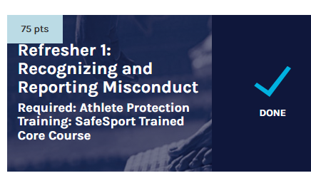
Once you have completed the class it will automatically update to your deck pass.

Third Year Taking the Couse

Repeat the above steps to enter your LEARN account. Click on COURSES in the top menu bar.
Select the Refresher 2 Course:
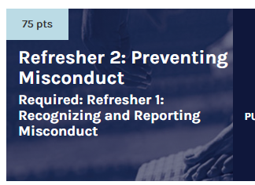

Fourth Year Taking the Couse

Repeat the above steps to enter your LEARN account. Click on COURSES in the top menu bar.
Select the Refresher 3 Course:

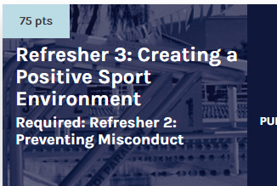

Only the class that you need to take will be available for you to click on. All other courses will say “Purchase Disabled.”

If you still have questions about your APT, or any of your required certifications, please email Moriah at registrarnes@gmail.com.

