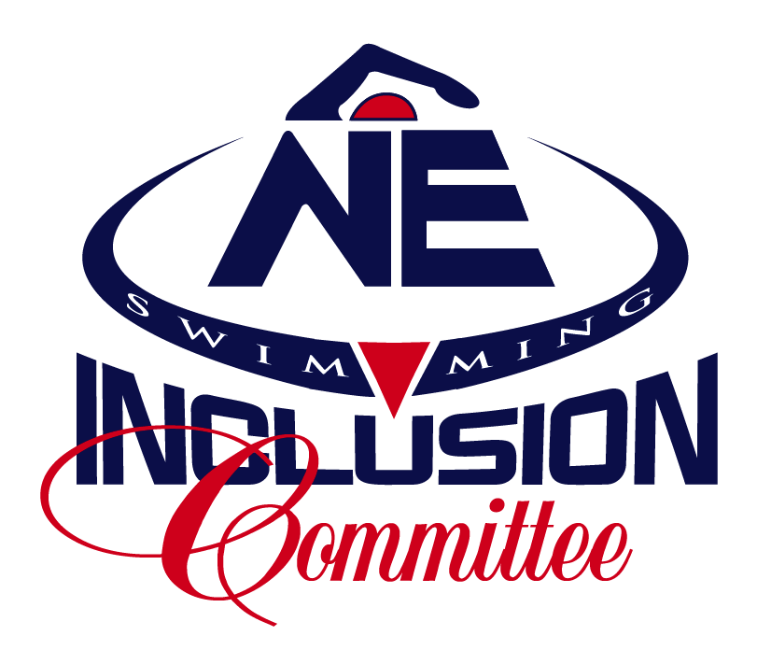
New England Swimming: Diversity, Equity & Inclusion Committee Meeting Agenda
Saturday, February 20, 2021
8:00pm via Zoom

Welcome

Recent Events
- Feb NES Board Meeting
- Pinkmantaray Presentation by Schuylar Bailar
- Diversity in Aquatics Annual Convention

Action Points
- Pronouns on virtual platforms
- Hashtags on social media
- Image descriptions

Check-Ins
- Sam, Eva, & Diya - Athlete Subcommittee
- Mike - Para-athlete inclusion in champs
- Laura - NES forms

DEI Education in NES
- Consulting with Truclusion
- Teach Me Tuesday on IG -- thoughts on switching days in order to not take away from the athlete Take Over Tuesday
- Schuyler Presentation --
  - Looking at possibility of April, after champs season
  - When would allow for the greatest participation?
- What formats for education appeal most to you?

New Items/Items Needing Attention
- LEAP Strategic Plan
  - NES goals for integrating DEI into “fabric of LSC”
- Clinic with AEC
  - Location
  - Coaches to assist
- Coaches Committee looking for DEI representation at meetings
- Priscilla Project
- Minutes for Meetings
- “Complaint Jar”
  - Reporting DEI incidents
  - Wording
  - Where do form submissions go to?

Open floor for thoughts and ideas

March Meeting: March 20th (Sat) or 21st (Sun), Are evenings best?

