October 6, 2021
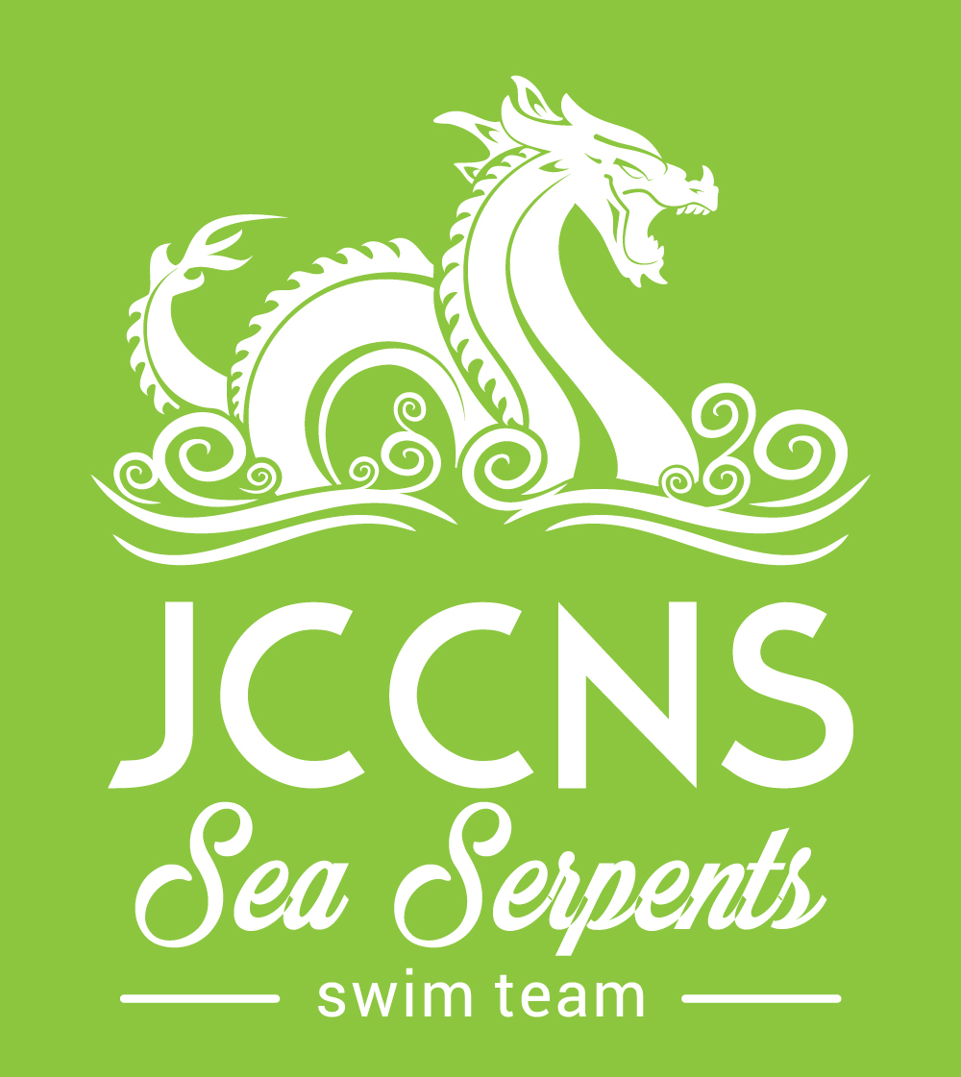
Job Title: Head Age Group Swim Coach Marblehead, MA.
Hours: Part Time or Full Time Hours available for the right candidate
Supervisor: Head Swim Coach

FLSA status: Non exempt

Rate: $18.00 - $25.00 per hour
Job Description
General Information
The JCCNS Sea Serpents is a young, fast growing year-round USA Swim team with approximately 120 swimmers, which includes a Pre-Team, Special Olympics Practice Group, and a summer league team. These past few seasons we had multiple top ten swimmers, three zone qualifiers, and two Sectional Qualifiers.
Position qualifications:
- Experience as a competitive swimmer, preferably at a collegiate level
- Experience working with kids ranging in age from 5 to 18
- Knowledge of proper stroke technique and progressions
- USA Swimming Coach Certification or willing to obtain before first swim meet
- Prior experience coaching and/or teaching swimming
- Willing to train the right candidate
This position will be responsible for overseeing in conjunction with the Head Coach our 13&under Age Group practice groups as well as assisting with our Pre Senior and Senior Groups. Planning practices and attending weekend swim meets when assigned.

• Write and plan practices in conjunction with the Head Coach
• Alongside the Head Coach assist our Developmental Coaches with practice planning
• Act as Lead Coach for two practice groups and assist with the Senior Groups
• Assist Head Coach with Swim Team Admin.
• Act as a role model with professionalism and integrity at all times
• Continue to improve teaching and coaching skills
• Attend weekend swim meets home and away when assigned
• Attend travel trips acting as both coach and chaperone with assignments such as managing food and transportation
About our Organization

The Jewish Community Center of the North Shore is committed to being the central gathering place for Jewish life, learning and culture, offering enriching experiences to strengthen Jewish identity. It strives to enhance all members’ social, physical, educational and spiritual lives. The JCCNS is an essential resource dedicated to participating in and contributing to the welfare of the whole community.

Most recently, the JCCNS has been named Business of the Year by the Marblehead Chamber of Commerce and also voted the region’s #1 Health Club and Gold Medal Winner for Summer Camp!

Come join a great group of people to work with.

Contact Information

Please forward your resume to Head Coach, Ashley Vieira, at avieira@jccns.com or via mail to:
Attn: Human Resources
JCCNS
4 Community Road
Marblehead, MA 01945
781.631.8330
www.jccns.com

