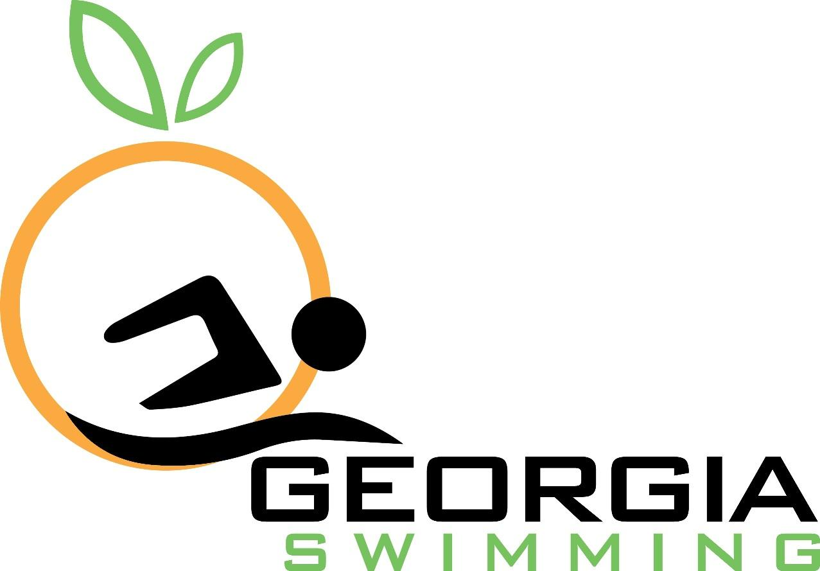

2017 Betsy Dunbar Award Nomination

Nomination Period Opens: January 1, 2018
Nomination Deadline: March 15, 2018

An award of $1,000 will be presented every year to a Georgia swimmer who is currently in their fourth year of collegiate swimming. The Georgia Swimming Board of Directors will evaluate all nominees for this award on the basis of leadership, performance and academic achievement. To be nominated, the swimmer must have represented the Georgia LSC for their entire senior year prior to college and also every summer during their college career.

Three letters of recommendation from the following must also be submitted along with this application. Applications without these attachments will not be considered.
● Nominee’s Collegiate swimming coach
● A faculty member from nominee’s college
● A teammate from nominee’s college swim team

Please complete this form and return to Jessica Cooper at jessica@gaswim.org.

Nominator Contact Information
Full Name
Phone
Email

Nominee Contact Information
Nominee Full Name
USAS Club
USAS Registration Number
Birthdate
Phone
Coach
Coach’s Email

To be eligible for this award, the swimmer must have represented the Georgia Swimming LSC for their entire senior year prior to college and also every summer during their college career.

Please list at least one sanctioned SC and LC meet in which the swimmer represented Georgia Swimming in during the nominee’s senior year in high school. Include the name, date, location of the meet, event swum and the time obtained. These items are available from the SWIMS database on the USA Swimming website.

Please list at least one meet in which the swimmer represented Georgia Swimming during the summers of the nominee’s college career. Include the name, date, location of the meet, event swum and the time obtained. These items are available from the SWIMS database on the USA Swimming website.

Three letters of recommendation are required for nomination. One each from the nominee’s collegiate swimming coach, a faculty member from the nominee’s college and a teammate from the nominee’s swim team. Please provide the contact information for each below.

Collegiate Swim Coach
Name
College
Phone
Email

Collegiate Faculty Member
Name
Position
Phone
Email

Collegiate Teammate
Name
Phone
Email

Letters may be emailed to Jessica Cooper at jessica@gaswim.org.

