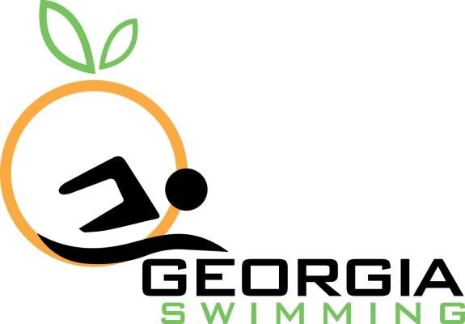
Georgia Swimming Inc. Application for Observation

Send completed application to all below:

Sanctions Chair: Eric Pingel, sanctions@gaswim.org
Admin Vice Chair: Lucas Ferreira, vicechair@gaswim.org
Senior Chair: Hugh Convery, senior@gaswim.org
Age Group Chair: Sydney Pepper, agegroup@gaswim.org
Officials Chair: Ed Saltzman, swimsalt@bellsouth.net
Sr. Athlete Representative: Rachel Todebush, seniorrep1@gaswim.org

USA SWIMMING REQUEST FOR OBSERVATION –
NON-SEASON CULMINATING CHAMPIONSHIP MEET
Form A

Meets requiring authorization by the USA Swimming staff leader or National NTV designee require 10-day advance application. Such meets include High School, Masters’ or other meets that are not season-culminating championship meets. This completed form and a copy of the meet information must be sent at least 10 days prior to the event to the LSC NTV official for review. The LSC official will send this completed form to the National NTV designee for approval. The request must include a reason & explanation for the request.
Acceptance of verification requests from the meet is subject to proof that conditions at the meet were in conformance with the required procedures and pertinent USA Swimming Rules and Regulations.

Name: Click or tap here to enter text. Email Address: Click or tap here to enter text.
Phone Number: Click or tap here to enter text.

Name of Meet: Click or tap here to enter text.
Date(s) of Meet: Click or tap here to enter text. Facility: Click or tap here to enter text.

Meet Director’s Email Address: Click or tap here to enter text.
Meet Director’s Phone Number: Click or tap here to enter text.

Is this meet on the regular, published calendar? [☐] Yes [☐] No
Type of Meet: [☐] High School | [☐ ] Masters | [☐ | ] Other
Course: [☐] Long Course Meters | [☐] Short Course Yards | [☐ | ] Short Course Meters
Approx. number of teams participating Click or tap here to enter text.
Approx. number of swimmers participating Click or tap here to enter text.
[☐ ] | Timing systems will conform to the conditions specified in 102.24 USA Swimming Rules & Regulations.
[☐ ] | The number of Association officials must meet the minimum requirements. There must be a referee, starter and two stroke and turn officials as provided in Article 102.10 – USA Swimming Rules & Regulations. A minimum of two additional USA Swimming Certified stroke & turn officials shall be assigned as observers for the purpose of verifying conformance with USA Swimming technical rules. Observers shall be permitted access to the pool deck. If at least two of the association meet officials  are dually certified by USA Swimming, additional observers are not necessary. Where the technical

 | rules listed in Article 101 are the same as the host organization, the judgment of the organization officials shall be sufficient.
[ ☐ ] | USA-S disqualifications from observed meets shall be reported to the LSC NTV Officer
[ ☐ ] | The meet referee, or LSC designee, will provide swimmers and coaches with information about the observation program and the procedures to be used to request observation. Requests may be  submitted prior to the swim for which observation is desired, or all swims may be observed.
[☐ ] | A copy of the meet information is attached.
[☐ ] | The reason & explanation for this request is attached.

Names and phone numbers of USA Swimming officials who will serve as observers at this meet or the dually certified officials:
1) Click or tap here to enter text. 2) Click or tap here to enter text.

3) Click or tap here to enter text. 4) Click or tap here to enter text.
Name of Meet Referee: Click or tap here to enter text.
Meet Referee Email: Click or tap here to enter text.
This form must be submitted and accepted by the LSC NTV Official prior to submission to the Time s Committee NTV designee.

Accepted by: Click or tap here to enter text.
GA LSC Sanction Chair

Date: Click or tap here to enter text.

