BoD Minutes
November 9, 2022
This meeting began at 8:30pm via ZOOM

BoD members present
Steve Potter (DAQ) General Chair | Jason Swain (SMAC) Coaches Chair
Lucas Ferreira (GA) Admin Vice-Chair | Tommie Jackson (CAD) DE&I Chair
Nancy Harmon (SCAT) Secretary | Ed Saltzman (DYNA) Officials Chair
Hugh Convery (GA) Senior Vice-Chair | Rachel Todebush (SPAC) Senior Athlete Rep
Sydney Pepper (DYNA) Age Group Vice-Chair | Holly Mattson (HURR) Junior Athlete Rep

BoD members absent
Kevin Sullivan (OAC) Treasurer  Rob Copeland (SCAT) Finance Vice-Chair Matthew Grant (VAST) Tech Planning Chair | Grace Ann Byerly (TWS)- Senior Athlete at-large  Will Guichard (SA) Junior Athlete at-large

GASI Swimming staff present GASI Swimming staff absent
John Pepper, Business Manager | Veronica Burchill, Director of Social Media
Lora Thompson, Membership Coordinator

Others present
Karl Krug (SPAC) Governance Chair | Teresa Coan (CW) Disability Chair
Brook Kubik (SA) Operational Risk | Michael Groves (ASL)

Call to order, approval of minutes

S. Potter called the meeting to order at 8:34pm.
Mission and vision statement of Georgia Swimming (GASI) presented
Motion: E. Saltzman to approve BoD minutes from October 12, 2022 (T. Jackson2nd)
Discussion: no discussion
Vote: Unanimous approval
Resolution: October 12, 2022 minutes approved

Officer Reports
General Chair (S.Potter) no report submitted
- BoD members should have received the Annual Performance Review Summary of our Business Manager, J. Pepper. We have done this annually the past 5 years; the questions are the same to gauge variation in performance. We also ask how important each area is to GASI. J. Pepper is doing a good job. He scored 80%-90% in most areas. There was a bit of creep in fundraising, grant, and sponsorship solicitation. The BoD has put less emphasis on these areas in the past and he was merely asked to assist where he could. All in all, the BoD rated him very highly and we are moving forward with the budgeted pay raise for the 2022-2023 fiscal year. S. Potter felt that the board needs to get together and rethink various roles and duties and decide where emphasis should be placed. If something is not important, perhaps we do not need to be assessing.
- K. Krug (Governance) will be going over several things in his report, particularly, a vacancy in Safe Sport. This was left in his committee’s lap and S. Potter fully supports their recommendations but would like to bring it to the board for agreement.

Admin Vice-Chair (L. Ferreira) present, no report

Finance Committee (R. Copeland, K. Sullivan) not present, no report.
- Per S. Potter: Finance meeting was held last night. Things are transitioning nicely; still have a lingering issue with investment account. Discussion centered on Business Manager pay raise.

Senior Chair (H. Convery) present
- Working on LC State. Two bids received to replace GT, who has confirmed they will not be able to host. Voting is ongoing but currently, Columbus is leading.

Age Group Chair (S. Pepper) present, no report

Diversity (T. Jackson) present, report submitted

Secretary (N. Harmon) present

Registrar (L. Thompson) present, no report
- Launch of SWIM3.0 was a bit bumpy, it continues to improve, but doing the best she can to keep up with invoicing. Working on putting something together for the spring HoD for USA Swimming to collect all our fees, raising our fees accordingly. Current process is very time intensive. Big mess to be cleaned up; waiting on merging tool to get rid of duplicate accounts.
- L. Ferreira still having problems with APT platform; problem for athletes turning 18. He felt we should not be penalizing athletes. L. Thompson agreed but noted that it’s not really a SWIM3.0 issue, it is actually US Safe Sport having a problem with their platform and integrating it with all governing sports bodies. L. Ferreira stated he had contacted USA Swimming Safe Sport and did not get a response. L. Thompson will reach out to USAS. Both felt they need to reinstate the grace period if they can’t get this worked out. L. Ferreira went on to say he feels GASI should step in and not penalize our athletes. S. Potter says we cannot act on our own; this is federal law. He will contact other LSC’s to see if anything is being done and report back to the board. We have officials struggling with the same thing. He felt coaches were handling it the best that they can, having the athletes start early and having them swim exhibition until corrected.
- J. Swain, having APT issues as well. Spent 3 hrs. and still not updated. L. Thompson stated that if he did not take the refresher class, it will not update. J. Swaim indicated that he logged into the platform and clicked on the course provided. L. Thompson said that unfortunately USA Swimming no longer allows her access to individuals Dashboards, so she cannot open accounts and help resolve issues. She will contact USA Swimming on his behalf.
- K. Krug asked what they should do with athletes turning 18 before Senior State. L. Thompson suggested starting early. She also noted that there is an issue with the requirement not showing up in the athletes account until closer to their birthday. She is going to suggest to USA Swimming it be included sooner. She is not sure if this is a USA Swimming or US Safe Sport issue. J. Peppers stated he knows that USA Swimming is working with US Safe Sport trying to resolve these issues. K. Krug requested that they move the test to Safe Sport courses. He felt it is very confusing.
- L. Thompson suggested logging out and back in to check for dashboard updates. Another option is to refresh page using CTL Shift R. This will refresh page without cookies and sometimes helps.
- E. Saltzman noted that the magic number is 60 days. This is when the individual should be able to take the test. We are within that window for athletes affected for Senior State. L. Thompson will work with C. Loprinzo to monitor issues.
- S. Potter reiterated, it’s a new system, there are always issues, just hate that testing was when it went live.

Business Manager (J. Pepper) present, report submitted.

Coaches Chair (J. Swaim) present, no report
- Continuing to work on Coach of the Year award. Going to be talking with K. Krug (Governance) about possibly changing it to a Senior Staff Award, Age Group Staff Award. It seems the award has gotten stale, and this would make it more interesting and allow for better cohesion within clubs.
- Working with Visit Macon for the Coach’s Symposium; getting them some preliminary numbers so they can get us the right conference center with the right space and technology. Also working with some local hotels and restaurants to get us better deals.

Open Water (Meredith Green) not present, no report.

Governance (K. Krug) present
- Currently, finalizing survey (within the next week to 10 days) to be sent out before Senior State. New to the survey, we will be asking for concrete candidate information; specifically, why someone is qualified for a position, not just interest.
- Safe Sport Vacancy. The committee discussed and recommended CeCe Christy to step back in as interim Safe Sport Chair until April, when the HoD can properly vote on the position. The committee felt that Safe Sport Chair is not a position that should be left open. She was the previous chair and is experienced and willing to fill the slot until the spring.
  - S. Potter noted that the Safe Sport position is an appointed position, with the advice and consent of the board. He agrees with C. Christy’s interim appointment with Governance coming back in the next few months with a permanent recommendation. L. Ferreira noted that C. Christy has done this job for a long time, and she may not want to step in to do this indefinitely. The committee noted a new LSC chair will be in place as of April and will then be in the position to name the next Safe Sport chair. S. Potter agreed and asked the board if they agreed with the recommendation. All agreed, no one opposed.
- Admin Review Board vacancy. The committee recommends that they not fill vacancy as they currently meet the minimum requirements of athletes and members. They should go through an election cycle and then select odd/even years for serving.
  - Per S. Potter, no action is needed for Admin Board of Review based on Governance’s recommendations. We are legal on membership. K. Krug noted that it should be made clear at the HoD that elected members should immediately figure out odd/even terms, as Governance did when they were first created.

Safe Sport (vacant) no report

Operational Risk (B. Kubik) present, report submitted
- Files sent to J. Pepper for BoD to review. J. Pepper has posted them on the website and will send them out to board members, he did not want to send as .zip file.
- 2 more files are available, but they are stuck on a laptop in a building at UGA dealing with a copperhead infestation. She will forward to J. Pepper when they become available.

Athletes (R. Todebush) present
- Meeting held on Monday, discussed canned food drive starting next week. Committee will be emailing coaches asking them to put a line in their newsletters to promote the food drive. Working on next set of all-star towels, colors, and dates.
  - T. Coan asked if contacting the athlete reps for each team or just coaches? R. Todebush responded, just coaches.

Officials (E. Saltzman) present
- Neal McKinney’s family is hosting a Celebration of Life this Saturday, November 12, 2022, 11:00am. Officials’ newsletter went out with notification of the service.
- Working on Senior State, OQM approved with 22 officials signed up.
- Our recruiting season has gone well. ASL and ABSC have done a super job. They have a lot of new officials in the pipeline.
- K. Krug noted that Officials were looking into a cleaner process for scratches. He suggested they look at Swimcloud, talk to Scott Kitzman. It is a web-based meet management system that will solve a lot of our issues with scratches. It’s very user friendly, kids will see scratches live, results are posted within 30 minutes of an event, and it’s only $200 a year. It is being used for Pan American Games and YMCA Nationals. E. Saltzman stated he’d investigate. Currently they will be going with Jotform and a mailbox that will be updated.

Technical Planning (M. Grant) not present, no report

Disability (T. Coan) present
- The committee wants to say thank you for Georgia Swimming sponsoring and helping with “The Fred”. Eric Pingel was wonderful.
- Cumming Waves has stepped up and will be taking on the challenge of hosting next year.
- Disability committee has started working on next years’ meet.
- McKenzie Coan will be doing the clinic and has donated 100 books that she authored. Excited to already have swim swag coming in for the athletes.
- J. Pepper is working on getting the application online which allows athlete payments to go directly to Georgia Swimming.
Discussion: H. Convery noted that it was very difficult staffing meets that were held the same weekend as “The Fred”. He loves the enthusiasm but 60 plus officials at a meet of this size is too many. Per E. Saltzman there were not that many officials, maybe 20 from Georgia; most officials came from out of state. S. Potter stated this is not an uncommon problem and you need to have your MR be proactive, perhaps even reaching out to other Meet Referees asking them to share.

Old Business
None

New Business
None

Announcements
Next BoD meeting December 14, 2022
Discussion: historically, this meeting has been cancelled due to meet conflicts (holidays, Senior State, Nationals, Jrs).

Motion: H. Convery to cancel BoD minutes from December 14, 2022 (E. Saltzman 2nd)
Discussion: no discussion
Vote: Unanimous approval
Resolution: December 14, 2022 meeting cancelled, next BoD meeting, January 11, 2023

Adjournment
Motion: E. Saltzman to adjourn BoD November 11, 2022 BoD meeting(T. Jackson2nd)
Discussion: no discussion
Vote: Unanimous approval
Resolution: meeting adjourned 9:15pm

Respectfully submitted:

Nancy Harmon

GASI Secretary
November 15, 2022

Georgia Swimming DEI Meeting Minutes
October 13, 2022

l. Welcome: Coach Tommie Jackson welcomed the committee members to the meeting.
Attendance: Tommie Jackson (Diversity Chair), Mercedes Larkin (Official DAQ),
Reno Bashir (SFS), Marianne Countryman (CAD).

ll. Georgia Swimming DEI Mission: Reviewed.

lll. Georgia Swimming Diversity Swim Meet to be held Feb. 25, 2023.
Contract from Lanier Aquatics has been received and will be forwarded to the Georgia Swimming
Business office for approval.
During next month’s meeting, the committee will discuss the criteria for the awards which include
Diversity Coach of the Year and Diversity Swimmer of the Year (Male and Female).

lV. Georgia Diversity Swim Camp to be held April 22, 2023 at Frances Meadows Aquatic Center.
a. Contract from Lanier Aquatics has been received and will be forwarded to the Georgia Swimming
Business office for approval.
b. Speaker: Still working on confirming Maritza McClendon. Coach Jackson asked the committee for
input on the length of time we would like for her to commit to. We will have access to both the
water and the classroom simultaneously so we will have for flexibility. Four hours was agreed on.
Georgia Swimming will charge $10/athlete to help offset the cost of the speaker.
c. Athlete: John Pepper is looking into choosing an athlete.
d. Facility: Frances Meadows Aquatic Center
e. Pictures/Logo: Coach Brandon and Coach Reno are working on this.
f. Mercedes is exploring sponsorship possibilities.

V. Meeting Adjourned: Next meeting Nov. 10, 2022

Business Manager Report
November 2022
USA Swimming has accepted our Leap renewal and we are in good standing with our affiliation agreement.
The new Leap season will begin on January 1st, 2023
As we are now starting the new swim season, it is now time to review the goals and objectives that the LSC has come up with after the work session that was done in 2021.
We, as a board. need to look at what has been completed, started, or scratched.
Here is the goal and objectives sheet that we worked on in the last board assimilation meeting.
As an LSC, here is the goals we set forth on, Click here
Worksheet of ideas that came out of the homework that was done prior to our board assimilation.
I also asked each committee to come up with goals for themselves and only two committees submitted their goals. Below are their sheets.
Officials Committee
Tech Planning
We also need to review the Mission and Vision Statement. This is the check and balance that we need to make sure the boat has not steered away from them. We need to make sure that we are staying true to being athletes first.
Georgia Swimming Mission Statement: GA Swimming will increase opportunity, recognition, and growth in competitive swimming. We believe that swimming provides life-changing experiences for young people
Vision Statement: "Strong clubs, successful athletes, supported by GA Swimming"
Meeting minutes need to be submitted to the admin no later than 48 hours after the meeting is complete. These reports will then be posted in the monthly BoD meeting page and on the committee page.
Social Media Report - Veronica Burchill
- Podcast:
  - John’s interview comes out tomorrow
  - We’ve had a large increase in our overall plays per episode to 39 per episode
  - As always, let me know if you’d like me to interview anyone specifically

- Social Media:
  - Wellness Wednesday’s will be posted to stories twice a month to help our swimmers check-in with their mental health
  - I’m scheduling posts for our food drive to start next week
  - I’m scheduling posts for holidays, events, motivation mondays about 2 months ahead to make sure we have everything ready

Operational Risk Report:
Drowning Emergency

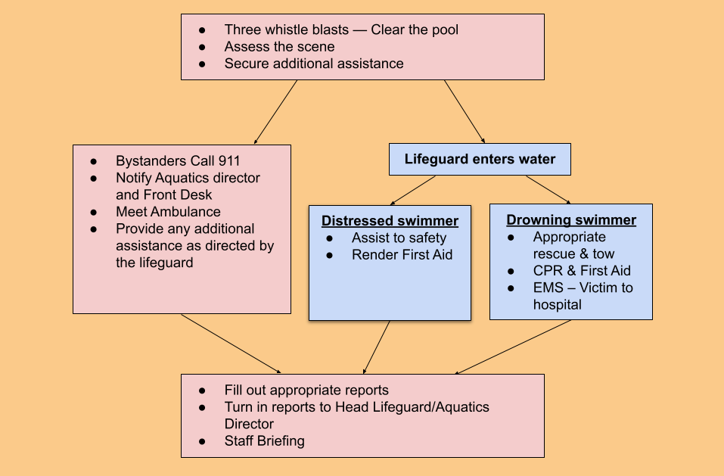

Hypoxic Training
What does Hypoxic Training mean?
The word “HYPOXIC” means… Hypoxic definition, having or caused by a very low level of oxygen.
During swim practice there is a training technique called “Hypoxic Training”. The term 'hypoxic training' refers to adapting to a reduced level of oxygen, in swimming terms, it refers to swimming more strokes without breathing. It was thought that by depriving your oxygen consumption you would slow the flow of oxygen (O₂) to the working muscles. ... Holding your breath increases Carbon dioxide (CO₂) in your system. If you were to hold your breath right now, your blood’s oxygen level would start to decrease and its carbon dioxide level would go up. Our bodies release carbon dioxide when we exhale, so as we hold our breath, it builds up and causes us to feel the urge to take another breath. However, this increase in carbon dioxide doesn’t always happen underwater.
Hypoxic swim sets have been used for decades to help swimmers reduce excessive breathing and simulate the challenge of maintaining a breathing pattern during a tough race.
Hypoxic blackout, also known as 'shallow water blackout', happens when loss of consciousness occurs underwater due to a lack of oxygen. This is often due to breath holding or purposeful hyperventilation before going underwater.
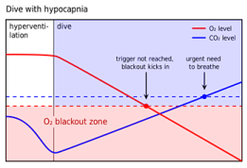
What is a Hypoxic Blackout?
Hypoxic blackout is a loss of consciousness caused by a reduced supply of oxygen to the brain. It is often related to hyperventilation, which is a series of long deep breaths designed to decrease the amount of carbon dioxide in the blood.
Hyperventilation is a dangerous technique often used by competitive swimmers and divers in order to hold their breath longer. Without the appropriate levels of carbon dioxide, the body fails to recognize the need for oxygen as it traditionally does. This condition is called hypocapnia. The table to the right illustrates how individuals who hyperventilate develop hypocapnia and reach the blackout zone before experiencing the normal urge to breathe.
Hypoxic blackouts are especially dangerous because an individual simply loses consciousness and can drown without any sign of a struggle. In some cases, an individual experiencing a hypoxic blackout will appear to be making coordinated movements because their body may continue to function temporarily. This phenomenon is particularly dangerous because a lifeguard may assume the individual is conscious.
Who is Affected by Hypoxic Blackout?
Hypoxic blackouts can affect anyone at anytime.
- Victims typically have no prior medical problems, are physically fit, and give no warning.
- It is usually associated with individuals who are either participating in breath holding contests or are performing underwater distance swimming.
Hypoxic Training and Hypoxic Blackout — Safety and Prevention Strategies
- Train Coaches, swimmers and parents on the dangers of hyperventilation and hypoxic blackout. Athletes should not hyperventilate (e.g., take multiple, deep breaths) prior to any underwater or other hypoxic efforts.
- If hypoxic training is utilized by coaches in the development of advanced competitive swimmers, it must be conducted only when following appropriate principles under the direct supervision of an experienced coach.
- Train Coaches and swimmers that a swimmer MUST never ignore the urge to breathe.
- Hypoxic training should involve progressive overload, in line with the athlete’s physical and skill development.
- Coaches should ensure adequate rest between hypoxic efforts to ensure full recovery.
- Inform parents and swimmers why teaching breathe control while swimming must be a supervised event.
- Understand that any strenuous exercise performed underwater drastically decreases the amount of time a swimmer can stay submerged.
- Never hesitate; if a swimmer is sitting motionless on the bottom of the pool pull them out immediately.
- Hypoxic training should not involve competitive effort, maximum duration or distance covered.
- Inform coaches that Hypoxic Training events have resulted in an athlete’s death.

Chloramines
Things coaches can do to help:
- Tell athletes not to urinate in the pool
- Ask athletes to shower before getting in the pool and explain what contributes to cholormine creation
- If notable level of chlorine in the air, ask facility to test and to open vents
- Raise awareness among athletes about cholomines, how they are created, the risks, and the signs of distress
- Raise awareness among coaching staff about cholomines, how they are created, the risks, and the signs of distress
Red flags that coaches can look for to identify that chloramines are too high:
- Coughing and shortness of breath
- Shoulders going up but lungs not inflating
- Flaring nostrils
- Cyanosis of the lips, tongue, fingernails (blue purple color when fingernails pressed)
- Major distress – quiver of the lips but unable to cough – notify lifeguards

What coaches should do if any swimmers are showing signs of respiratory distress:
- Notify lifeguard
- Get swimmers out of the water and into a foyer (place with fresh air)
- Hands above head
- Cool mist
- For a swimmer with known asthma, use inhaler
- Pools may have oxygen/pulmona (aerosol machines)

Facility Emergency Policy

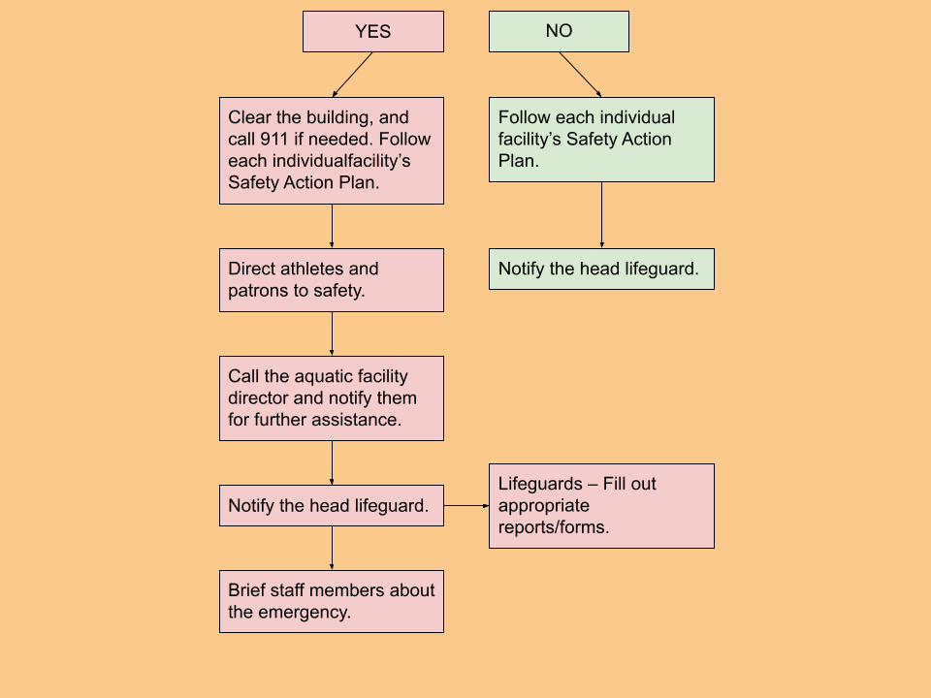

New team travel policy for Notifiable Diseases*
Steps to take when an athlete becomes symptomatic**/sick during a team travel trip:
- Immediately isolate the athlete.
- Notify the athlete’s parent/guardian and the zone team manager.
- Seek medical attention for the athlete (ER, urgent care, etc.). Have the athlete tested for suspected illnesses and obtain the test results.
- If the illness test result is positive, the athlete needs to leave the venue and return home as soon as it can be safely done. In the interim, the athlete should remain quarantined in a private room.
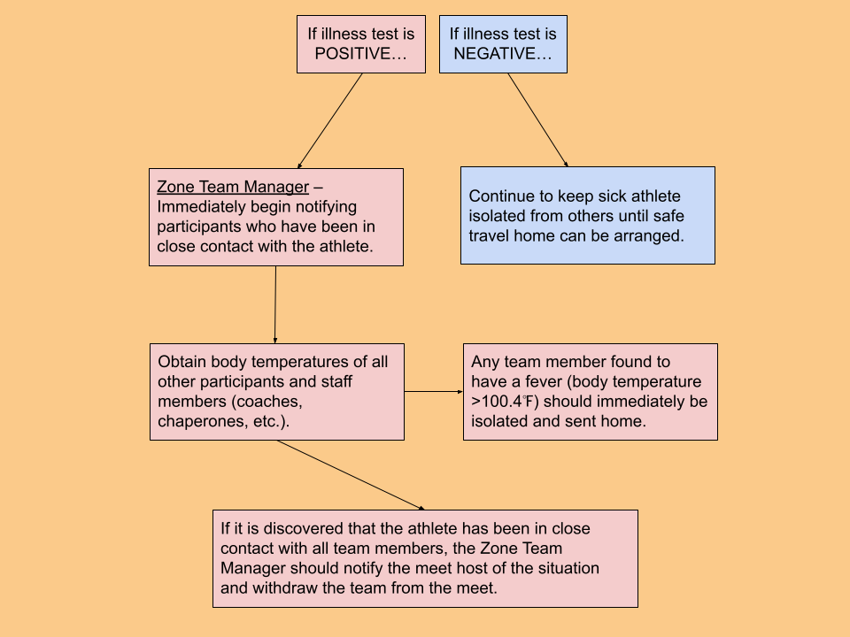

*Notifiable disease – Any disease required by law to be reported to government authorities. The following are identified as Notifiable Diseases by the Georgia Department of Public Health:
- Animal bites  - Botulism  - Diptheria  - E. Coli | - Influenza  - Measles  - Meningitis  - Novel respiratory viruses (i.e., COVID-19, SARS, MERS) | - Pertusis  - Staph infections  - Tuberculosis  - Legionnaires Disease
A complete list of Notifiable Diseases is available on their website.

**Symptomatic – When a participant begins to experience symptoms of any illness (i.e., COVID-19) while attending an overnight experience/trip.

Definitions:
Pool Chemicals
While it is the responsibility of the facility to maintain a proper chemical balance in the pool, USA adult members should be aware of the signs that there may be a chemical imbalance and not allow athletes in water that exhibits signs of chemical imbalance until it has been deemed safe through testing.
If a chemical imbalance is suspected, coaches should remove athletes from the water and ask a lifeguard on duty or facility manager to check the chemical levels in the water. Athletes should not be allowed to return to the water until the chemical levels have been shown to be safe by properly conducted tests by a professional.

Signs of chemical imbalance in water may include:
Cloudy, murky, or discolored water
Bubbles or foam on water
Living organisms in water (such as mosquito larvae, water beetles, or other small life forms), particularly in outdoor pools
An atypically strong or unusual odor
Water has a soapy feel
Swimmers complain of itchy skin, eye, or nasal irritation, or are coughing

