New team travel policy for Notifiable Diseases*
Steps to take when an athlete becomes symptomatic**/sick during a team travel trip:
- Immediately isolate the athlete.
- Notify the athlete’s parent/guardian and the zone team manager.
- Seek medical attention for the athlete (ER, urgent care, etc.). Have the athlete tested for suspected illnesses and obtain the test results.
- If the illness test result is positive, the athlete needs to leave the venue and return home as soon as it can be safely done. In the interim, the athlete should remain quarantined in a private room.
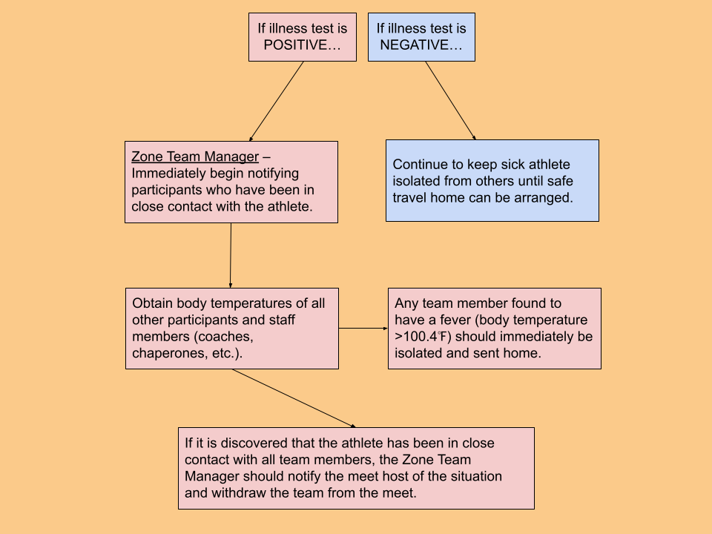

*Notifiable disease – Any disease required by law to be reported to government authorities. The following are identified as Notifiable Diseases by the Georgia Department of Public Health:
- Animal bites  - Botulism  - Diptheria  - E. Coli | - Influenza  - Measles  - Meningitis  - Novel respiratory viruses (i.e., COVID-19, SARS, MERS) | - Pertusis  - Staph infections  - Tuberculosis  - Legionnaires Disease
A complete list of Notifiable Diseases is available on their website.

**Symptomatic – When a participant begins to experience symptoms of any illness (i.e., COVID-19) while attending an overnight experience/trip.

