GEORGIA SWIMMING SAFE SPORT REPORT
AUGUST 28, 2020

SAFE SPORT RECOGNITION AS OF 7/31

GEORGIA ranked 6th with 18 clubs SSR

Brad Akins YMCA
Athens Bulldogs
Camden County Boomers
Blue Tide Swimming
Carrollton Bluefins
DeKalb Aquatics
Douglas County Stingrays
Dynamo
Gwinnett Aquatics
Lanier Aquatics
Stingrays
Southern Eagle
Summerhill Orcas
Spartan Aquatics
Summit Swimming
Three Rivers
US Aquatics
Warner Robins

TOP 5
1 Florida 49
2 NC 35
3 Maryland 32
4 PC 29
5 Potomac 19

12 GEORGIA CLUBS STARTED APPLICATION

Aiken Augusta
Chattahoochee Gold
Columbus Hurricanes
Lifetime
Marietta Marlins
Okefenokee
Swim Atlanta
Tara Tarpons
Georgia Coastal Aquatics
Savannah Swim Team
Valdosta Aquatics
Northwestern Aquatics

BECOME SAFE SPORT RECOGNIZED IN FOUR SIMPLE STEPS

1. Ensure the public main page of your website has a safe sport tab

2. Upload the required personalized documents provided to your club by Ceci

3. Schedule the required zoom education with Ceci or have athletes and parents complete the education on the USAS website

4. Go to USAS, enter your club portal, complete the safe sport recognized club application, and submit

If you would like assistance completing the application in your club portal, you may allow another person access only to the application. Please see the document below.

Access Club Portal

Step 1. Login to your DeckPass Step 2. In the top toolbar choose Safe Sport 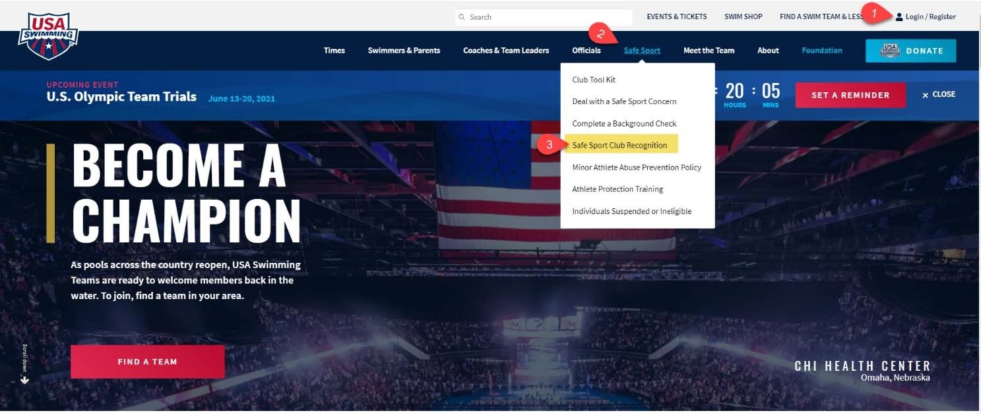Step 3.
In the drop down select Safe Sport Recognition Program

Step 4. Scroll down and select “Access Club Portal”
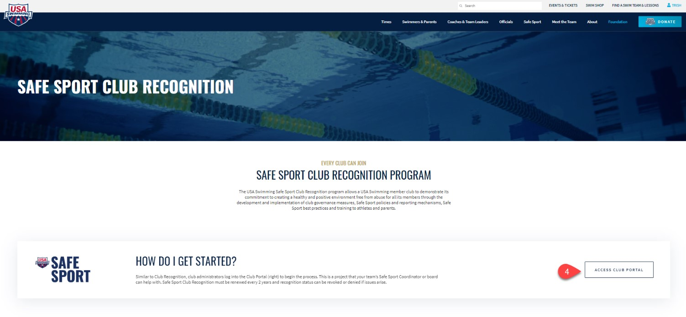

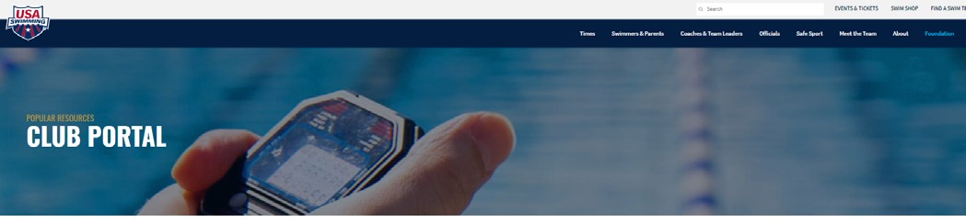
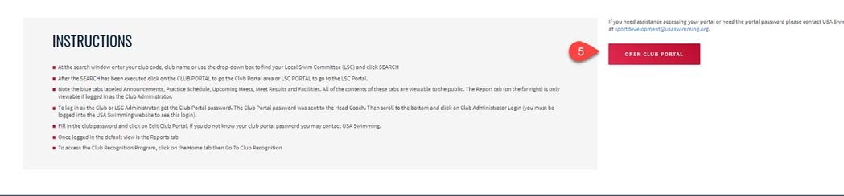
Step 5. Next page, click on “Open Club Portal”

Step 6. Type in your club name
Step 7. Click on search
Step 8. Select your club from the results and click on “Club Portal”
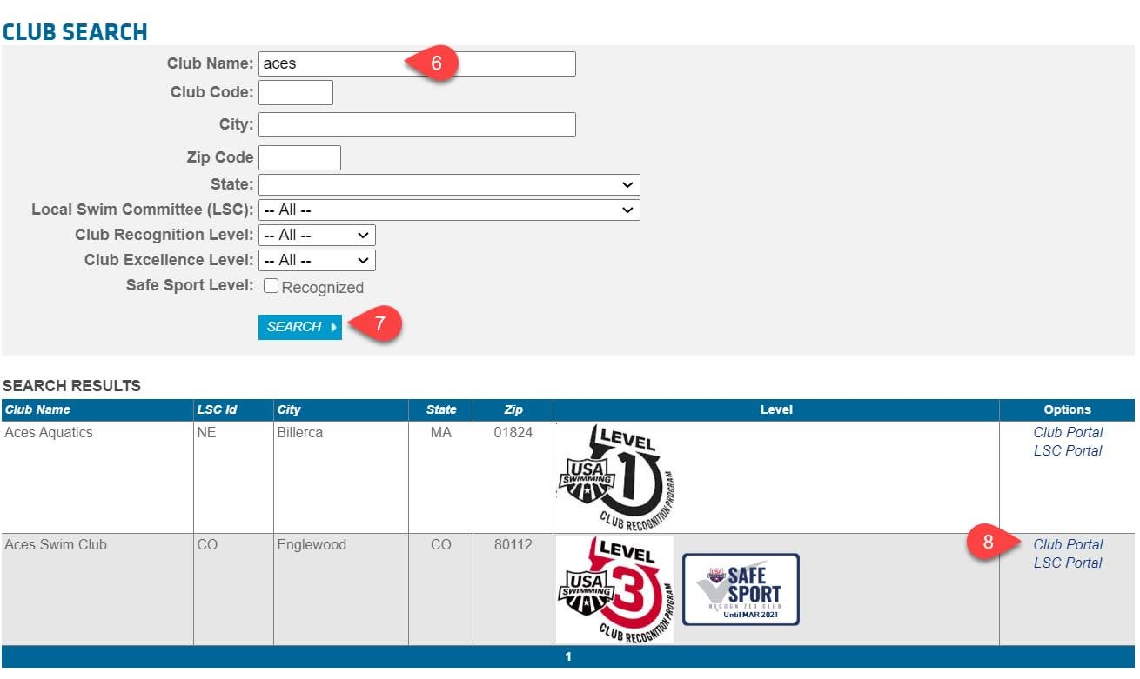

Step 9. Scroll to the bottom of the screen and click on “Club/Safe Sport Administrator Login”
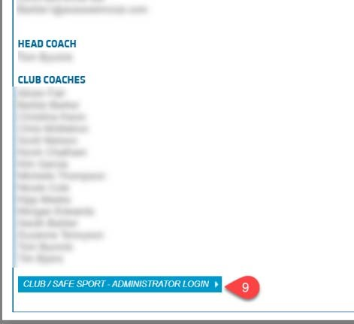
Step 10. Enter your email, phone number and the administrator password. Then click on “Edit Club Portal/Safe Sport Login”
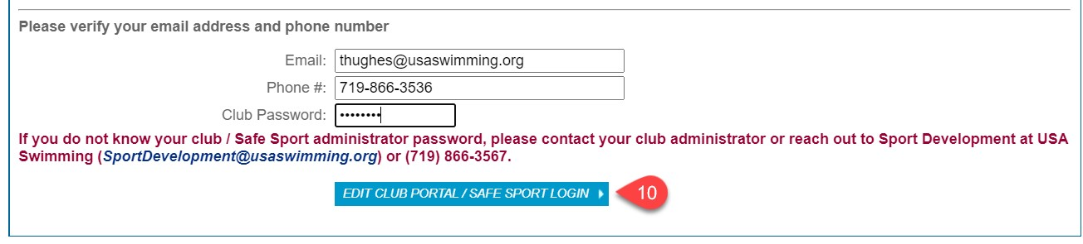

Club Portal Add Additional User Safe Sport Access

Step 11. In the Club Portal click on the “Users” tab
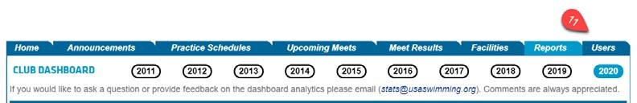Step 12. Click on “Add New Account”

Step 13. Enter in the user name and email address
- A password will be automatically generated, or you can choose to overwrite the password to one the user wants
- Do not assign the same password used for the administrator to another user. Either use the auto generated password or pick a different password for their use

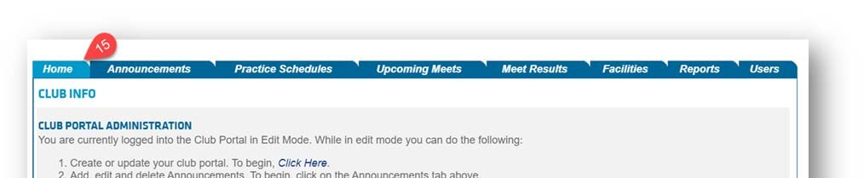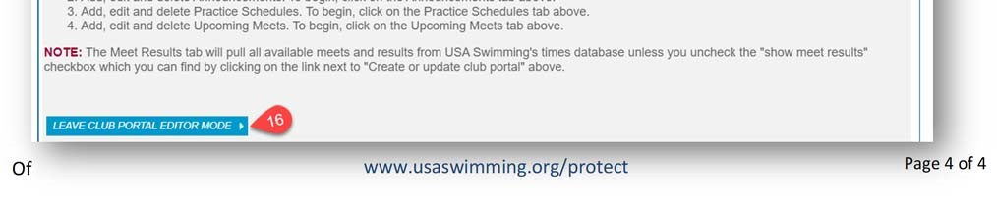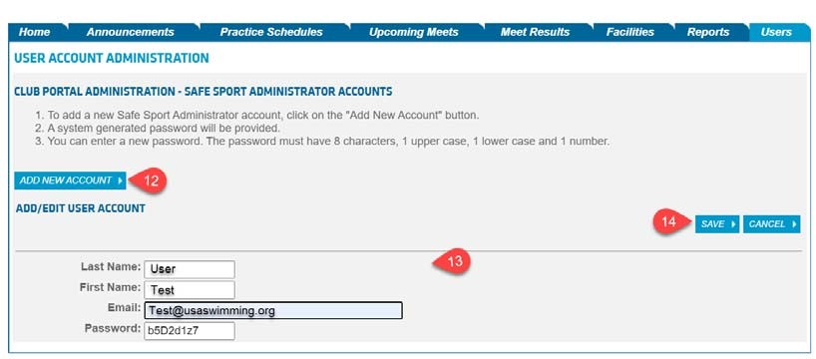
Step 14.

Click Save

Step 15.

Navigate back to the “Home” Tab
Step 16.

Make sure to log out of the club portal by clicking on “Leave Club Portal Editor Mode”

