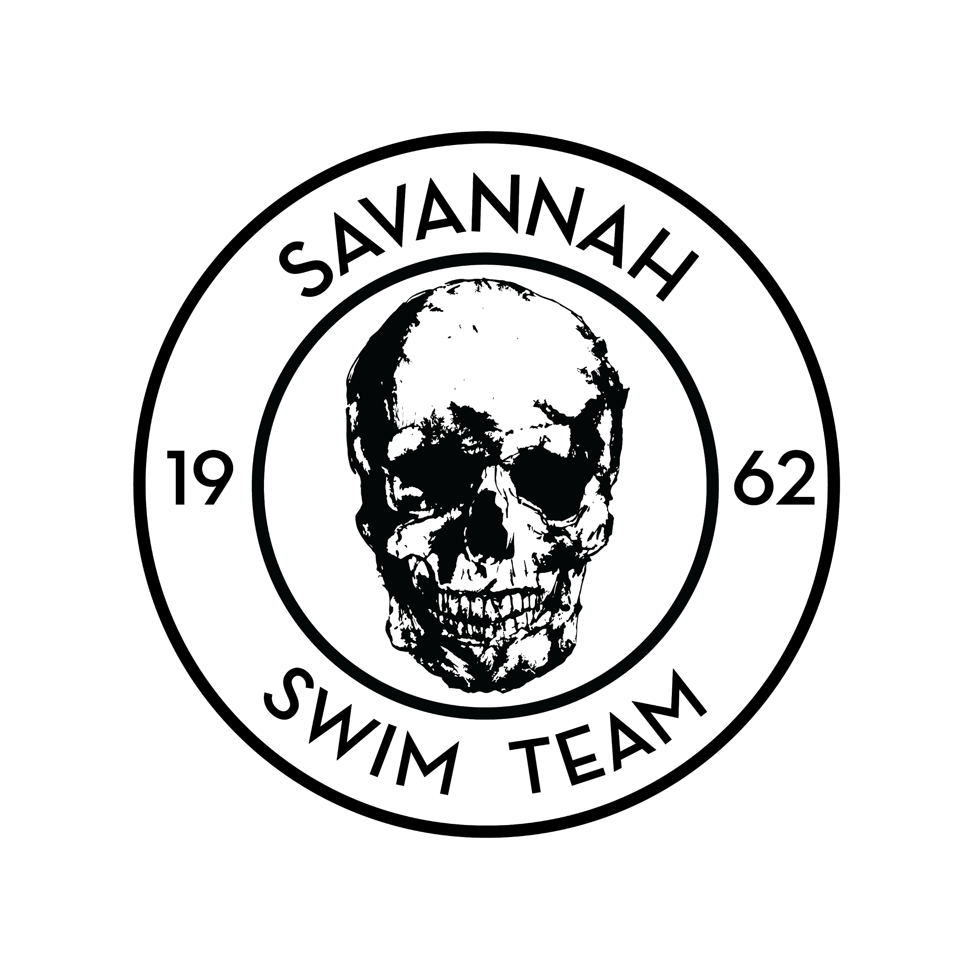
2020 Carey Hilliard’s Invitational
October 23-24, 2020
HOST | Savannah Swim Team – (SST)
SANCTION:  ATTESTATION: | Held under the sanction of USA Swimming, issued by Georgia Swimming Inc.,  Sanction #: GA20-088  - Article 202.4.3: Granted sanctions are non-transferrable to other organizations or clubs. Any such transferred sanction shall be void and the Sanction Committee shall deny any further sanctions to the organization or club violating this provision  - In applying for this sanctioned event, the Host, Savannah Swim Team agrees to comply and to enforce all health and safety mandates and guidelines of USA Swimming, Georgia LSC, the State of Georgia, and local jurisdiction.
MAAPP:  Minor Athlete Abuse Protection Policy  Effective June 23, 2019 | - A USA Swimming club that hosts a sanctioned USA Swimming swim meet indicates acknowledgement of USA Swimming’s Minor Athlete Abuse Prevention Policy (“MAAPP”).  - All USA Swimming members including athletes 18yrs and older and adults who are attending this swim meet and interact with minor athletes are expected to comply with the MAAPP policy.  - All chaperones, team managers, adult swimmers, meet directors, officials, and non-member parents and meet volunteers who are attending this swim meet are expected to understand and comply with MAAPP.  - As the host club, you are responsible for ensuring that these individuals know about and comply with MAAPP.
ELIGIBILITY FOR TIME RECOGNITION TO THE SWIMS DATABASE | Times achieved by an athlete member at a sanctioned competition who is 18 years of age (+30 day grace period) who have not completed the Athlete Protection Training OR (whose APT training had expired) by the date of the swim, WILL NOT be uploaded to the SWIMS database.
LIABILITY: | In granting this sanction it is understood and agreed that USA Swimming, Inc., Georgia Swimming, Inc., and Savannah Swim Team., shall be free and held harmless from any liabilities or claims for damages arising by reason of injuries to anyone during the conduct of the event.
MEET DIRECTOR: | Joe Witt / wittjoe@gmail.com
MEET REFEREE: | Keith Powell / kgp001@aol.com
STARTER: | Heather Harmon, Brendan Sheehan
STROKE AND TURN: | Autumn Shonk, Daniela Jones, Bill Pilczuk
ADMIN OFFICIAL: | Michele Smith – smith7278@bellsouth.net
SAFETY DIRECTOR: | Bill Pilczuk
FACILITY: | Camden Community Recreation Center, 1050 Wildcat Drive, Kingsland, GA 31548  This facilities competition pool is a 6 lane 25-yard pool with non-turbulent lane lines, depth varying between 5 and 9 feet, and conforms to USA Swimming rules and regulations for competition pools. The competition course has been certified in accordance with 104.2.2C(4). A copy of such certification is on file with USA Swimming and Georgia Swimming.
SCHEDULE: | Session 1: ALL Ages Warm up: 4:00pm Start: 5:00pm  Session 2: 11&U Warm up: 8:00am Start: 9:00am  Session 3: 13&O Warm up: 2pm Start: 3pm
MEET FORMAT: | - SCY  - Time Final Format (TF)  - ALL Events will be swam as MIXED Gender.
ENTRY FEES: | Flat FEE: $30.00  A $2.00 Ga travel surcharge applies to all non-Georgia LSC registered swimmers.  LATE ENTRIES: $30.00 +$10.00
ELIGIBILITY: | Open to all USA-registered swimmers and teams. SST will not allow unregistered swimmers, coaches, officials, or teams to participate in this meet. No swimmer will be permitted to compete unless the swimmer is a member in as provided in Article 302.
ENTRIES: | Swimmers may swim a maximum of 5 individual events per day.
CHECK-IN: | Deck entries can be made with the clerk of course up to 30 minutes before the start of the session.
ENTRY SUBMISSION: | ENTRY DEADLINE: Saturday, Oct 17, 2020 at 8:00pm.  Submit entries using Hy-Tek team manager. Entries must include the USA Swimming Club Code and each swimmer’s USA Swimming number, first and last name, age, and seeding time for each event entered.
RULES: | 102.8 SWIMWEAR  .1 Design  F. No Technical Suit may be worn by any 12 & Under USA Swimming athlete member in competition at any Sanctioned, Approved or Observed meet.  1) A Technical Suit is one that has the following components:  a. Any suit with any bonded or taped seams regardless of its fabric or silhouette; or  b. Any suit with woven fabric extending past the hips.  (Note: WOVEN FABRIC-A suit with woven fabric and sewn seams that does not extend below the hips is permitted.)  (Note: KNIT FABRIC-A suit with knit fabric and sewn seams not extending below the knees is permitted.)  This rule is in effect for all USA Swimming competitions in the United States, so any manufacturer or vendor selling a suit in the United States is subject to the above rule. No Technical Suits may be worn by any 12-Under USA Swimming athlete member in competition at any Sanctioned, Approved or Observed meet.  Current USA Swimming Rules, including the Minor Athlete Abuse Prevention Policy (“MAAPP”), will govern this meet.  Use of audio or visual recording devices, including a cell phone, is not permitted in changing areas, rest rooms or locker rooms.  Any swimmer entered in the meet, must be certified by a USA Swimming member-coach as being proficient in performing a racing start or must start each race from within the water. When unaccompanied by a member coach, it is the responsibility of the swimmer or the swimmer’s legal guardian to ensure compliance with this requirement.  Deck changes are prohibited. (Defined as changing, in whole or in part, into or out of a swimsuit when wearing just one suit in an area other than a permanent or temporary locker room, bathroom, changing room or other space designated for changing purposes). Swimmers participating in deck changing could be subject to removal from further competition in the meet.  On deck registrations will not be permitted during this event.  Operation of a drone, or any other flying apparatus, is prohibited over the venue (pools, athlete/coaches’ areas, spectator areas and open ceiling locker rooms) any time athletes, coaches, officials and /or spectators are present. Exceptions may be granted with prior written approval by the Program Operations Vice Chair, Program & Events Committee Chair, or designee.  Photos and videos may be taken of swimmers during the meet by parents or a professional photographer retained by the host club. All participants agree to be filmed or photographed by photographers designated by the meet host and to allow the meet host the right to use names, pictures, likenesses, and biographical information before, during, or after the period of participation in Georgia Swimming competitions to promote swimming and meets hosted by the meet organizer. If you do not wish to have your child(ren) photographed, you may withdraw your consent by informing the Meet Director before the start of the first day of the meet.  A swimmer must start and finish the race in the same lane.  Deck Pass is acceptable proof of USA Swimming membership.  Swimmers participating under the provisions of 202.9 or USA Swimming’s “open border” policy must be under the supervision of their own coach or a USA Swimming member coach. The Meet Director or Meet Referee may assist the swimmer in deciding for such supervision, but it is the swimmer’s responsibility to make such arrangements prior to the start of the meet.
COACHES: | Coaches will be required to sign in and show their USA Swimming coaches registration card or DECK PASS for verification that all certifications are current. Coaches meeting as needed.
OFFICIALS: | SST welcomes visiting officials and apprentices and will appreciate help in officiating this competition. There will be an official’s meeting (45 min) prior to the start of each session. The official’s uniform will consist of a white polo collared shirt, navy blue shorts, skirts or slacks with white socks and shoes. All officials must present at check in, their current LSC Officials Certification Card; OR a recently completed Apprentice Form; AND proof of current USA Swimming Non-Athlete membership. Credentials may be required for deck access and hospitality.
MEET COMMITTEE: | The Meet Committee shall be established during the coaching meeting or prior to the competition and shall consist of the Meet Director, Meet Referee, Coaches, and athlete members, as appropriate. As defined in the Official Glossary (2020 USA Swimming Rulebook)
AWARDS: | Ribbons for 10&U
CONCESSIONS: | NO Concessions.
GEORGIA WARM-UP POLICY: | The Georgia Swimming approved warm-up guidelines will be followed for this meet. Warm-up lane assignments will be posted at the pool. USA Swimming Certified Coaches must supervise in the vicinity of all warm-up activities.  Refer www.gaofficials.org > documents > Sanctions
GEORGIA SCRATCH RULE: | Refer www.gaofficials.org/documents > Sanctions
MISC. INFORMATION: | Prior to the meet warm-up, any team wanting water time must rent lanes from the CCAC. Lane availability is limited, and arrangements must be made in advance. Contact the facility directly at (912) 652-6793.
Covid Guidelines: | - There will be no spectators allowed on the pool deck. Parents will be able to watch through a cyclone fence.  - Athletes are strongly encouraged to wear masks between events.  - Locker room and restroom use must comply with all SafeSport guidelines.  - All non-competing persons i.e officials, coaches, timers, spectators, and meet administrators must comply with mandated social distancing and mass gathering rules.  - Seating for swimmers will be assigned by team, and swimmers will have a specific seat that they will take throughout the session.

Friday, October 23, 2020
Session 1
Warm-Up - 4:00pm
Meet Start - 5:00pm
Event Number | Age Group | Event
1 | Open | 100 Free
2 | Open | 200 Back
3 | 12&Under | 100 IM
4 | Open | 50 Fly
5 | Open | 100 Breast
6 | Open | 50 Back
7 | Open | 200 IM
8 | 11&Over | 500 Free*
*Deck-Seeded Event. Swam Fastest to Slowest. Swimmers must provide Counter and Timer.
+ALL Events will be seeded as MIXED Gender.

Saturday, October 24, 2020
Session 2
Warm-Up - 8:00am
Meet Start - 9:00am
Event Number | Age Group | Event
9 | 13&Over | 200 Free
10 | 13&Over | 200 Fly
11 | 13&Over | 50 Breast
12 | 13&Over | 100 Back
13 | 13&Over | 200 Breast
14 | 13&Over | 100 Fly
15 | 13&Over | 50 Free
16 | 13&Over | 400 IM*
*Deck-Seeded Event. Swam Fastest to Slowest. Swimmers must provide Counter and Timer.
+ALL Events will be seeded as MIXED Gender.

Saturday, October 24, 2020
Session 3
Warm-Up - 2:00pm
Meet Start - 3:00pm
Event Number | Age Group | Event
17 | 12&Under | 50 Free
18 | 12&Under | 100 Back
19 | 12&Under | 200 Free
20 | 8&Under | 25 Back
21 | 12&Under | 100 Fly
22 | 8&Under | 25 Free
23 | 12&Under | 50 Breast
24 | 12&Under | 200 IM
+ALL Events will be seeded as MIXED Gender.

COVID 19:
An inherent risk of exposure to COVID-19 exists in any public place where people are present. COVID-19 is an extremely contagious disease that can lead to severe illness and death. According to the Centers for Disease Control and Prevention, senior citizens and individuals with underlying medical conditions are especially vulnerable.

USA Swimming, Inc., cannot prevent you (or your child(ren)) from becoming exposed to, contracting, or spreading COVID-19 while participating in USA Swimming sanctioned events. It is not possible to prevent against the presence of the disease. Therefore, if you choose to participate in a USA Swimming sanctioned event, you may be exposing yourself to and/or increasing your risk of contracting or spreading COVID-19.

BY ATTENDING OR PARTICIPATING IN THIS COMPETITION, YOU VOLUNTARILY ASSUME ALL RISKS ASSOCIATED WITH EXPOSURE TO COVID-19 AND FOREVER RELEASE AND HOLD HARMLESS USA SWIMMING AND [THE LSC] AND EACH OF THEIR OFFICERS, DIRECTORS, AGENTS, EMPLOYEES OR OTHER REPRESENTATIVES FROM ANY LIABILITY OR CLAIMS INCLUDING FOR PERSONAL INJURIES, DEATH, DISEASE OR PROPERTY LOSSES, OR ANY OTHER LOSS, INCLUDING BUT NOT LIMITED TO CLAIMS OF NEGLIGENCE AND GIVE UP ANY CLAIMS YOU MAY HAVE TO SEEK DAMAGES, WHETHER KNOWN OR UNKNOWN, FORESEEN OR UNFORESEEN, IN CONNECTION WITH EXPOSURE, INFECTION, AND/OR SPREAD OF COVID-19 RELATED TO PARTICIPATION IN THIS COMPETITION.

