|  |  |  |
| --- | --- | --- |
|  | Policies and Procedures | |
| Subject: Coach and Official Membership Verification at Meets | Document Number: 623  Version Number: 3 | Effective Date: April 9, 2019  Last Revision: February 16, 2021 |

Table of Contents

1. POLICY OVERVIEW 2

2. PURPOSE OF POLICY 2

3. DEFINITIONS 2

4. COACH MEMBER VERIFICATION 3

4.1. WHO is responsible to verify coach credentials? 3

*4.2.* WHAT is acceptable proof of Coach Membership? 4

4.3. CAN coaches without proof of USA Swimming Coach Membership, or missing, “not met” or expired credentials attend the meet? 4

4.4. WHERE can coaches without proof of current USA Swimming Membership be at the meet? 4

4.5. Reporting 4

4.6. Failure to Verify Coach Credentials: Meet Hosts 4

4.7. Failure to comply: Coaches 4

4.8. How might coach credentialing be done at a meet? 5

5. OFFICIAL NON-ATHLETE MEMBER AND CERTIFICATION VERIFICATION 5

5.1. WHO is responsible to verify Officials Non-Athlete membership and official certification? 5

5.2. WHAT is acceptable proof of an Official’s Membership and Certification? 5

5.3. CAN Officials without proof of USA Swimming Non-Athlete registration, or with missing, “not met” or expired credentials attend the meet? 5

5.4. Reporting 5

6. RELATED DOCUMENTS AND FORMS 6

6.1. Sanction Application Form 6

6.2. Meet Financial Report 6

6.3. Online Referee Report 6

6.4. Policy Appendix and Utah Swimming Website 6

7. NOTIFICATION 6

8. DISTRIBUTION AND UPDATING OF POLICY 7

CHANGE LOG 8

9. Appendix 8

Info for Meet Directors, Referees and Others Who Enforce Credentialing at Meets 10

Basic Info For Those Who Enforce USA Swimming Member Verification at Meets 11

# POLICY OVERVIEW

* 1. Sections two (2) through six (6) outline the Coach and Official Deck Access at Meets policy and procedures to be used by Utah Swimming administrative leadership, meet directors and meet referees.
  2. Sections seven (7) and eight (8) outline administrative procedures and responsibility for ongoing policy implementation and dissemination.

# PURPOSE OF POLICY

* 1. Athlete membership of USA Swimming is verified before competing at any meet when the meet host sends the meet database to the Utah Swimming Registration person. Coach and official membership must also be verified. When the meet host does not know in advance who will be arriving to work in these capacities, this verification must be done at the meet.
  2. As members of USA Swimming, both Utah Swimming, and the meet host, must follow USA Swimming rules. The rules say that only current Coach Members of the organization may be on deck in a coaching capacity. All officials must be non-athlete members of USA Swimming and certified in the position they work.
     1. Non-Athlete membership requirements help increase athlete safety and protection.
     2. USA Swimming provides insurance coverage at member events where rules are followed.
     3. Both coaches and officials receive notification at least a month before credentials expire. This is done to give them time to do what is needed and avoid expiration.
  3. This policy provides:
     1. EDUCATION about USA Swimming rules
     2. PROCEDURES for LSC leadership, Meet Directors, Meet Referees and others to follow to verify appropriate coach and official membership.
     3. FINES for non-coach members of USA Swimming, or their club, who are on deck in a coaching capacity during a meet or meet host clubs who do not verify coach credentials at their meet.

* 1. Goal: To ensure that only appropriately registered coaches and officials are on deck in those capacities at Utah Swimming sanctioned meets.

# DEFINITIONS

* 1. **Appendix:** Supplementary material located at the end of some Utah Swimming Policies and/or Procedure documents. Appendix material is not mandated policy and therefore does not require board approval to change.
  2. **Certified:** USA Swimming and Utah Swimming require officials to complete specific requirements before working in the capacity of Stroke and Turn Judge, Starter, Referee and Administrative Official or Referee. After completing the requirements and receiving notice of advancement, an official is then certified to work in that position. USA Swimming also requires coaches to show credentials, proof of specific certifications.
  3. **Coach or Coach Member:** Currently registered Coach Member of USA Swimming in good standing with no requirements missing, expired, or “Not Met.”
     1. If any required coach credentials are missing, “not met” or expired, the individual is no longer considered a Coach Member by USA Swimming. They automatically becomes a “Non-Athlete” member. Only coach members may be on deck in a coaching capacity.
  4. **Competition Pool**: The pool(s) where competition takes place, even if competition is not currently happening, like during warm-ups.
  5. **Credentials:** Proof of current USA Swimming Coach, or Non-Athlete Membership, or of meeting one or more requirement(s) or certifications.
  6. **Deck**: If the meet host has a “closed deck,” it is the closed area. For the purpose of this policy, if the meet does not have a closed deck, it is the area adjacent to the Competition Pool.
  7. **In Good Standing:** See *Membership* Article of Utah Swimming Bylaws for guidelines regarding membership status.
  8. **Junior Coach Member:** is defined by USA Swimming. Key points: Age 16 or 17. May only coach athletes under the direct supervision of a USA Swimming Coach Member.
  9. **LSC:** Local Swim Committee, the regional governing body for USA Swimming. The LSC for the state of Utah is Utah Swimming.
  10. **Meet Director:** is defined by USA Swimming. Key points: This person is named in the meet announcement. They represent the meet host organization and seeks a sanction from the LSC when preparing a meet. This person also files a meet report with the LSC after the meet.
  11. **Meet Referee:** is defined by USA Swimming. Key points: This person may, or may not, be affiliated with the meet host organization. The referee files a meet report with the LSC Officials Chair after the meet.
  12. **Non-Athlete Member:** is defined by USA Swimming. Key point: Non-athlete membership is designated as Coach, Junior Coach, Official and Other.
  13. **Official:** Person certified to act in the capacity of Referee, Starter, Administrative Official, Chief Judge or Stroke and Turn Judge at the meet. USA Swimming rules state that meet officials must be Non-Athlete Members of the organization.
  14. **Safe Deck Plan:** designates where spectators may sit at swim meets. There is one for every venue where clubs hold practice or host meets. [Current plans](https://www.teamunify.com/TabGeneric.jsp?_tabid_=177446&team=lscuts) are available on the Utah Swimming website.
  15. **Sanction:** Official permission, or approval to host a meet. Times from meets sanctioned by USA Swimming are recognized by the organization. Rules and regulations regarding sanctioning are in the current USA Swimming rulebook. Sanctions for USA Swimming meets held in the state are granted by Utah Swimming.
  16. **Spectator Area**: an area designated by the Meet Director, or Meet Referee, for spectators and/or coaches with missing, “not met” or expired credentials. [*Safe Deck Plans*](https://www.teamunify.com/TabGeneric.jsp?_tabid_=177446&team=lscuts) show meet host designated spectator areas for every venue where clubs hold practice or host meets. The area a Meet Director or Meet Referee designates as a Spectator Area for a coach with missing, “not met” or expired credentials, may or may not, include all the spectator areas noted on a *Safe Deck Plan*.
  17. **Spectator Stands:** the stands, or bleachers, designated for spectators at a venue.
  18. **UTSI**: Utah Swimming, Inc. A Utah not-for-profit corporation.
  19. **Verify:** = *View* and *Check. View* USA Swimming accepted proof of membership. These include *Deck Pass*, online or printed membership card. *Check* dates of all listed credentials. None can be missing, “not met” or expired.

# COACH MEMBER VERIFICATION

## WHO is responsible to verify coach credentials?

* + 1. The Meet Director has responsibility to ensure that coach member verification takes place at their Utah Swimming sanctioned meet.
    2. By prior mutual agreement, the Meet Director and Meet Referee may decide that the Meet Referee, or other designated official verify Coach Member credentials.
    3. The Meet Director may use another designated person, or group, to verify Coach Member credentials. For example: A person passing out heat sheets.

## WHAT is acceptable proof of Coach Membership?

* + 1. Any USA Swimming accepted proof of membership. This includes Deck Pass and online or printed membership cards which show no missing, “Not Met” or expired credentials. *(EXCEPTION: CPT is not required by Utah Swimming until Long Course State 2019)*

## CAN coaches without proof of USA Swimming Coach Membership, or missing, “not met” or expired credentials attend the meet?

* + 1. Yes, but according to USA Swimming rules, they cannot be on deck in a coaching capacity.

## WHERE can coaches without proof of current USA Swimming Membership be at the meet?

* + 1. Coaches without proof of current USA Swimming Coach Member registration, or with missing, “not met,” or expired credentials, may sit in the spectator stands, or another Meet Director, or Meet Referee, approved spectator area that is not adjacent to the competition pool.
    2. **Recommended Seating for Coaches with Missing, “Not Met” or Expired Credentials.** To minimize confusions for athletes and officials, Utah Swimming recommends that coaches with missing, “not met” or expired credentials sit in the spectator stands, or another spectator area designated by the Meet Director or Meet Referee.
    3. **Closed Deck Meets.** At meets with a closed deck, coaches with missing, “not met” or expired credentials may not be in a closed area unless serving as a meet volunteer and not coaching.
    4. **Open Deck Meets.** At meets without a closed deck, coaches with missing, “not met” or expired credentials, may not be in the area adjacent to the competition pool unless serving as a meet volunteer and not coaching.

## Reporting

* + 1. Either the Meet Director, and/or the Meet Referee, can let the LSC know that coach credentialing took place at the meet. Either can also report the name and club of anyone coaching on deck without proper credentials. The Meet Director reports on the *Meet Financial Report*. The Meet Referee reports in the *Online Referee Report.* Additionally, at least one shall immediately let the Utah Swimming Registrations person know the name and club of anyone caught coaching on deck without proper credentials.

## Failure to Verify Coach Credentials: Meet Hosts

* + 1. The meet host shall pay a $25 fine, payable to Utah Swimming, for failure to verify coach credentials at their meet. The fine is due within 45 days of the last day of the meet. Utah Swimming recognizes that coach credentialing can be especially challenging at some venues. There may also be difficulties if a coach deliberately avoids the credentialing process. Nevertheless, a “good faith” effort is expected.
    2. The **Utah Swimming Board of Directors** **Executive Committee** has authority
       1. To charge a meet host who did not initially pay a fine, upon it being proven that Coach Member verification did not take place at a meet.
       2. To withhold the privilege of hosting sanctioned meets from a member club for a designated period of time because of continued failure to verify Coach Member credentials at their meets.

## Failure to comply: Coaches

* + 1. **COACHES, WITH MISSING, “NOT MET” OR EXPIRED USA SWIMMING CREDENTIALS WHO COACH ON DECK AT UTAH SWIMMING SANCTIONED MEETS, OR THEIR CLUB, WILL BE FINED $100 by Utah Swimming upon it being proven.**
    2. Coaches with missing, “not met” or expired USA Swimming required credentials who sit in the designated spectator area, or are on deck in another capacity and not coaching, (and their clubs) are not subject to fine.

## How might coach credentialing be done at a meet?

* + 1. Utah Swimming does not want to restrict meet host autonomy by dictating an exact way to verify Coach Member credentials.
    2. The following are suggestions from experienced meet hosts. The list is not all-inclusive, or mandatory.
       1. Verify (view and check) Coach Member credentials when coaches pick up heat sheets
       2. An official, the Meet Director, or other designee can approach coaches around the pool and ask to verify (view and check) credentials
       3. Have clubs email proof of coach certification before the meet. (This may work especially well with intrasquad or dual meets because the coaches are known and few.)

# OFFICIAL NON-ATHLETE MEMBER AND CERTIFICATION VERIFICATION

## WHO is responsible to verify Officials Non-Athlete membership and official certification?

* + 1. The Meet Referee has responsibility to ensure that only currently registered Non-Athlete Members of USA Swimming function in the capacity of an official at the meet. Officials without proof of current USA Swimming Non-Athlete Membership, or with missing, “not met” or expired credentials, may not officiate at the meet. The referee must also ensure that officials only function within the capacity of their certification.

## WHAT is acceptable proof of an Official’s Membership and Certification?

* + 1. Proof of membership includes any USA Swimming accepted proof of membership. This includes Deck Pass and online or printed membership cards which show no missing, “not met” or expired credentials. Proof of certification includes the current officials list available at [www.swimutah.com](http://www.swimutah.com). It also includes unexpired certification noted on membership card, or in member account at [www.usaswimming.org](http://www.usaswimming.org). If the official is new, an email sent from the LSC Officials Chair to the official noting certification advancement may also be used.
    2. NOTE: Official certification level may not show up in Deck Pass. However, unless very new, it does show up on their USA Swimming membership card. Officials can get a pdf version of the card by logging in to their account on www.usaswimming.org

## CAN Officials without proof of USA Swimming Non-Athlete registration, or with missing, “not met” or expired credentials attend the meet?

* + 1. Yes, but they may not work as an official. They are welcome to serve in another volunteer capacity which does not require Non-Athlete membership or be a spectator.

## Reporting

* + 1. The Meet Referee verifies to the LSC whether official credentialing took place at the meet in the *Online Referee Report.* The referee may also note if Coach Member verification took place. If the referee knows of anyone who coached on deck without proper credentials, they should put the name, club and any other details in their report as well. Additionally, if someone is caught coaching on deck at the meet without proper credentials, either the Meet Referee or Meet Director shall immediately let the Utah Swimming Registrations person know the name and club of the person.

# RELATED DOCUMENTS AND FORMS

## Sanction Application Form

* + 1. Located in Sanctions Section of Utah Swimming Website
    2. Completed by Meet Director and filed with LSC before hosting a sanctioned meet
    3. This is where the Meet Director agrees to verify that only USA Swimming Coach Members will be allowed on deck in a coaching capacity at their meet

## Meet Financial Report

* + 1. Located in the Sanctions Section of the Utah Swimming Website
    2. Completed by Meet Director and filed with LSC after hosting a sanctioned meet.
    3. This is where the Meet Director states whether or not Coach Member credentials were verified, and assesses the fine if credentials were not viewed and checked.
    4. The Meet Director should also note the name, club and details of any who coached on deck without proper credentials.

## Online Referee Report

* + 1. Located in the Officials Section of the Utah Swimming Website
    2. Completed by the Meet Referee and filed with the LSC after officiating at a sanctioned meet.
    3. This is where the Meet Referee states whether official credentials were verified.
    4. The Meet Referee may also note whether Coach Member credentials were verified and should put the name, club and details of any who coached on deck without proper credentials.

## Policy Appendix and Utah Swimming Website

* + 1. The Policy Appendix and Utah Swimming website contain resources to help Meet Directors, Referees and others implement the policy at meets. Resources may be added to or changed as needed without board approval, as long as they accurately reflect and promote the board approved policy.

# NOTIFICATION

* 1. **Meet Directors** shall be notified of, and acknowledge the following, when applying for a Sanction.
     1. **SANCTION APPLICATION FORM.** Prior to hosting a USA Swimming sanctioned swim meet, the Meet Director shall complete and sign a Utah Swimming *Sanction Application Form*. The form will include the following statements. If it is not agreed to, the sanction will not be granted. To help educate ever changing Meet Directors, the application shall also include points 2.1 and 2.2 from the *Purpose of This Policy* section, or similar statement, as well as a link to this policy.
        1. I have read the Utah Swimming Coach and Official Membership Verification at Meets Policy and will ensure that USA Swimming Coach Member credentials get verified at this meet.
        2. I will ask coaches discovered to be without proof of current USA Swimming Coach Membership or with missing, “not met” or expired credentials to not be on deck in a coaching capacity. I do not have to force removal if they do not comply. I will immediately report the name and club of any person coaching on deck without proper credentials to the Utah Swimming Registrations person. The contact information for this person is on [www.swimutah.com](http://www.swimutah.com) under the “Registrations” tab.
  2. **Meet Directors** shall report whether coach credentials were verified at the meet on the Meet Financial Report.
     1. **MEET FINANCIAL REPORT.** Within the deadline stated on the form, the Meet Director shall complete and sign a Utah Swimming *Meet Financial Report*. The form will include the following statements:
        1. USA Swimming Coach Member credentials were verified at this meet. YES NO
           1. If “No,” add $25 “No Coach Member Verification” fine to meet expenses on this form and pay fine to Utah Swimming within 45 days of the meet.
        2. Were coaches without proof of USA Swimming Coach Membership, or those with missing, “not met” or expired credentials allowed on deck in a coaching capacity? YES NO NOT TO MY KNOWLEDGE
        3. Line item in Expenses column: $25 No Coach Member Verification Fine
  3. **Meet Referees** shall be notified of policy by the **LSC Officials Chair** upon certification and at least annually via email or in person training.
     + 1. **ONLINE REFEREE REPORT**. Before the established deadline, the Meet Referee shall complete and submit and *Online Referee Report*.The report will include the following statements:
          1. USA Swimming Coach Member credentials were verified at this meet: YES NO I DON’T KNOW AGREED THAT MEET DIRECTOR WOULD HANDLE
          2. Official USA Swimming Non-Athlete credentials were verified at this meet: YES NO I DON’T KNOW
          3. Only currently certified Non-Athlete Members of USA Swimming worked as officials at this meet: YES NO I DON’T KNOW
  4. **Meet Host Organizations** shall be notified of, and agree to follow, policy annually on the Club Registration form.

# DISTRIBUTION AND UPDATING OF POLICY

* 1. This policy shall be posted on the Utah Swimming website.
  2. Annually, the **LSC Safety and Safe Sport Chair** will review policy for accuracy and current relevancy. Update as needed, with board approval. This person will also check in with the following people to ensure they are doing their part according to policy. Additionally, this person will ensure that the Notification section of this policy is occurring and troubleshoot, problem-solve, or modify the policy (with board approval) as needed.
  3. The **LSC Sanctions Person** shall:
     1. Verify that the Meet Director has agreed to the Coach Member verification statements when receiving the *Sanction Application Form*. Sanction shall not be granted if not agreed to.
     2. When receiving the *Meet Financial Report,* verify that the Meet Director has:
        1. Answered the coach credential verification statement when receiving the *Meet Financial Report*
        2. Assessed the “No Coach Member Verification Fine” if Coach Member verification did not occur at the meet.
     3. If a club does not verify coach credentials, let the LSC Safety and Safe Sport Chairperson know.
     4. If a club repeatedly (three or more times) does not verify coach credentials, let the Executive Committee know.
     5. Receive information from the LSC Officials Chair about Meet Referees who reported that coach credentialing did not take place at a meet. If needed, present evidence to Executive Committee if a fine should have been imposed but wasn’t.
  4. The **LSC Officials Chair** shall
     1. At initial training, and at least annually, instruct all officials about the need to be certified and a current Non-Athlete Member of USA Swimming in order to officiate at meets.
     2. Shall instruct Referees about their role within this policy upon certification and at least annually thereafter.
     3. Upon receiving each *Online Referee Report* shall
        1. Report all “No” answers to the coach credential question to the person managing Sanctions for the LSC.
        2. If the Meet Referee, answers “No” to either the coach or officials credential verification question, instruct the referee about this policy and their role within it. Instruction should also occur if the referee answers “I Don’t Know” to the officials credential verification question.
        3. If there are many “I Don’t Know” responses to the coach credential verification question, help referees better understand the importance of this policy and their role within it. Ways could include: increased training and/or an email or other form of communication.
  5. The **LSC Safety and Safe Sport Chair** works with clubs who are not verifying coach credentials at their meets by:
     1. First, educating about USA Swimming membership rules and privileges.
     2. Then, assisting the club to troubleshoot and problem-solve so future Meet Directors can fulfill the needed role under this policy.
  6. The **Utah Swimming Registrations person** receive reports of uncredentialed people coaching on deck at meets and promptly verifies.
     1. If untrue, the matter is dropped.
     2. If true, they pass the name, club and any pertinent information to the Utah Swimming Executive Committee and requests the committee approve billing the club or coach $100 for coaching on deck without proper credentials.
     3. Reports of uncredentialed coaching at a meet may come from Meet Directors, Meet Referees, the LSC Sanctions person, Officials Chair, or another credible source.

|  |  |  |  |  |
| --- | --- | --- | --- | --- |
| CHANGE LOG | | | | |
| Version | Date | Description of Change/Section(s) | Author or Editor | Authority |
| 1 | 4/9/2019 | New/Entire policy. Replaced policy 1.25 (Deck Policy) from 3/2014 Policies and Procedures Manual. | Cathy Vaughan | BOD |
| 2 | 4/14/20 | Updated Definitions to comply with standardized definitions accepted by the Board of Directors. Added title box and change log box. Changed to gender neutral language. | Cathy Vaughan | BOD |
| 3 | 2/16/2021 | Added gender neutral language. Standardized headings and correlated with the *Leadership Task Calendar.* | Cathy Vaughan | Minor changes. Delegated BOD Authority |

# Appendix

Resources to help Meet Directors, Referees and others implement the policy at meets. This section may be added to or changed as needed as long as resources accurately reflect and promote the board approved policy.

*Verify = View + Check*

Sample Coach Credentials

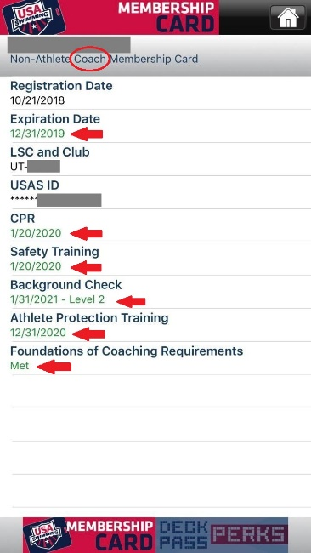

Sample Official Credentials

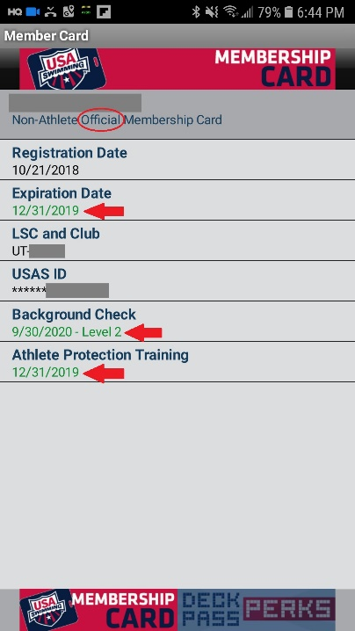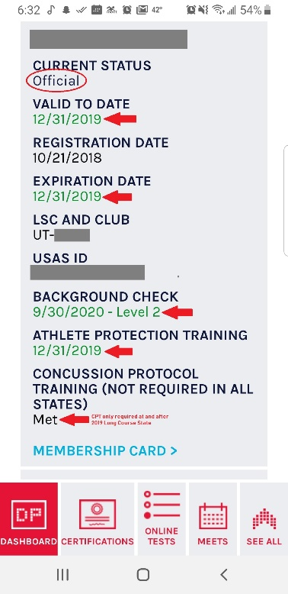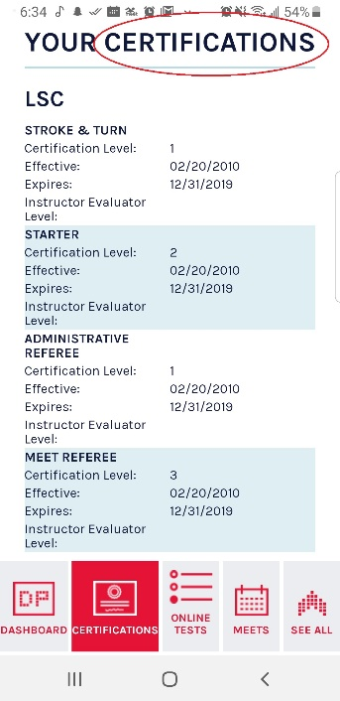

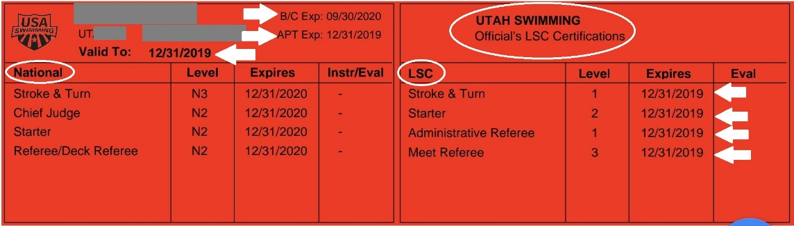

# Info for Meet Directors, Referees and Others Who Enforce Credentialing at Meets

*This information does NOT replace information in the Utah Swimming Coach and Official Membership Verification at Meets Policy. Rather, it is supplemental, aimed to help volunteers and others effectively enforce the policy at meets.*

* **Guidelines for Enforcing Credentialing Policy at Meets**
  + **What is considered “on Deck?”** If the meet host has a “closed deck,” it is the closed area. For the purpose of this policy, if the meet does not have a closed deck, it is the area adjacent to the Competition Pool.
  + Utah Swimming recognizes that the vast majority of those who host and run meets are volunteers. It’s important to be reasonable in what is asked of them. Some will naturally be more comfortable with policy enforcement than others.
  + The goal is not necessarily to “police” coaches and officials, but rather to simply verify credentials.
* **What might raise a “red flag” of someone coaching on deck without proper credentials?**
  + The person did not show credentials when needed. (Remember, there could be valid reasons for this: Perhaps they didn’t know they were supposed to check-in or where to go. Or maybe they were out of the area when someone passed through checking.)
  + Someone tells an official, or other meet personnel, that person is coaching on deck, but not properly registered.
* **PERMITTING COACHES KNOWN TO BE WITHOUT PROOF OF USA SWIMMING COACH MEMBERSHIP, OR WITH MISSING, “NOT MET” OR EXPIRED CREDENTIALS, ON DECK IN A COACHING CAPACITY** is a violation of USA Swimming rules. As a member organization the meet host receives a sanction from USA Swimming to conduct a meet. A condition of the sanction is that the host agrees to abide by USA Swimming rules and regulations.
* **It is the responsibility of the coach to ensure current Coach Membership or refrain from coaching**. Additionally, clubs have access to their coach USA Swimming membership records and should not use coaches with missing, “not met” or expired credentials on deck in a coach capacity at practices or meets.
* **How do I address the issue of someone suspected of coaching on deck without proper credentials?**
  + Here’s one idea: The Meet Referee, another designated official, Meet Director, credential person, or Meet Marshal may approach the individual on deck, introduce themselves and share their position at the meet. (i.e. The one in charge of credentialing, the Meet Referee or Director, etc.) They could then simply share that this is a USA Swimming sanctioned competition and as such, must follow USA Swimming rules. One of the rules is that only coach members may be on deck in a coaching capacity. The person could then ask to see the coach’s credentials. If the coach has them, and none are missing, “not met” or expired, thank them for staying current. If the person coaching does not have them, or something is missing, “not met” or expired, kindly but firmly let them know that USA Swimming only allows Coach Members on deck in a coaching capacity. Since that can’t be proven (no credentials) or the person is no longer a Coach Member (any credentials missing, “not met” or expired) they are welcome to observe the meet from the spectator area (show specific area) but not to coach on the deck.
  + Immediately contact the Utah Swimming Registrations person and give the name and club of the person, and date the infraction occurred. Contact information is on the Registrations page at www.swimutah.com
* **What if the person coaching does not comply with the request to move off deck?**
  + Options might include: If the person is an assistant coach and the head coach of that club is there, visit with the head coach. Or, if the Meet Referee was not the one to make initial contact, let the Meet Referee know of the issue and consult.
  + It is not necessary to force the issue or escalate the request to a scene which could mar athlete well-being and performance. If you’ve asked the person to leave the deck and the person refuses, you may move on and promptly report the person’s name, club and situation to the Utah Swimming Registrations person.

# Basic Info For Those Who Enforce USA Swimming Member Verification at Meets

*As members of USA Swimming, both Utah Swimming, and the meet host, must follow USA Swimming rules. The rules say that only current Coach Members of the organization may be on deck in a coaching capacity. Also, all officials must be non-athlete members of USA Swimming and certified in the position they work. As a result, certification and membership must be verified.*

* **How do I verify coach or official USA Swimming membership?**
  + View each person’s USA Swimming accepted proof of membership. These include *Deck Pass*, or an online or printed membership card. Check dates of required credentials. None can be missing, “not met,” or expired. *(EXCEPTION: CPT is not required by Utah Swimming until Long Course State 2019)*
* **What if one of the requirements is missing, “not met,” or expired?**
  + Unfortunately, those with missing, “not met,” or expired credentials are unable to serve at the meet as coaches or officials until all requirements are met and current.
    - COACHES without proof of current USA Swimming Coach Membership may NOT be on deck in a coaching capacity. However, they may sit in the spectator stands, or another Meet Director or Referee approved arrangement.
    - OFFICIALS without proof of USA Swimming membership or certification are welcome to serve in another volunteer capacity which does not require Non-Athlete membership, or be a spectator.
* **Why bother verifying appropriate USA Swimming membership and certification?**
  + To protect athletes, keep USA Swimming rules and retain USA Swimming insurance coverage.
* **What if a required credential just barely expired?**
  + USA Swimming requires coaches to keep required credentials current at all times. There is no grace period; coach membership is not valid if any of the requirements lapse or expire. If a required credential expires, the individual automatically becomes a Non-Athlete member of USA Swimming, and is no longer a Coach Member. A coach does not have USA Swimming insurance coverage if their Coach Membership is not valid.
  + To help coaches manage their membership requirements, the date that each requirement expires is printed on their USA Swimming coach membership card, as well as being available on the Deck Pass app and through the Club Portal. Additionally, USA Swimming notifies coaches via email well before credentials expire, so they have time to renew.

*More information available in the Utah Swimming Coach and Official Membership Verification policy*

|  |
| --- |
| *Together, we can keep athletes safer* |
| **=**  **No Coaching at**    **Meets or Practice**    **COACH**  **Membership**  **(includes expired)** |
| *USA Swimming Rule 502.6.5* |
|  |
| **Fines:** |
| *For more information, see Utah Swimming Coach and Official Membership Verification Policy*   * **$100 to Coaches with missing, “not met” or expired USA Swimming credentials who coach on deck at meets, or their club** * **$25 to meet host clubs who don’t do USA Swimming Coach Membership verification at their meets** |