Dear Meet Director,
Thank you for your work to get meets set up and available for our swimmers!
Here are a few things to remember when hosting a meet:
- Three days before the start of the meet a meet backup needs to be sent to Todd Etherington for reconciliation.
- Please check the details of meet templates. Updates are made each season to reflect new or changed rules. If changes are made, the templates will be updated, posted, and emailed out. Using outdated templates slows the sanctioning process.
- It has been brought to my attention that not all teams are having the meet referee review and approve the meet announcement before sending it in to be sanctioned. This is required!
- Please remember that new swimmers need to be racing start certified before going off the blocks at meets. Please get this done before your team starts competing this season or have them start in the water. Referees and starters are happy to accommodate swimmers that need to start in the water.
- Due to COVID-19 teams have needed to be flexible in the use of pools. Please make sure that any pool used complies with Article 103. A new rule calling for additional markers at 15 meters was added in 2019. 103.16.2
- All the additional paperwork for COVID-19 needs to continue until we are informed otherwise by USA Swimming.
Virtual Meets:
- Officiating should be equal for all sessions. For example, do not have one session held with 4 officials and another with 20.
- Start and end dates in the meet database should be the same for all sessions.
- The swimmer’s age is the start date of the meet listed in the sanction, not the individual session.
Deadlines:
- Sanctions issued within 2 weeks before the start of the meet incur a $20.00 additional fee.
- No meet can be sanctioned within 7 days of the start of the meet.
- 45 days after the meet the Meet Financial report and splash fees must be received.
Reports and Event Files:
The most common issues I see are Event Files and Meet Summary reports.
To create an event file on MM File -> Event file -> export -> events for TM
You can find the Meet Summary report under the reports drop down menu. Select “Meet Summary” Report type = Summary, Format = by Athlete (See example below).

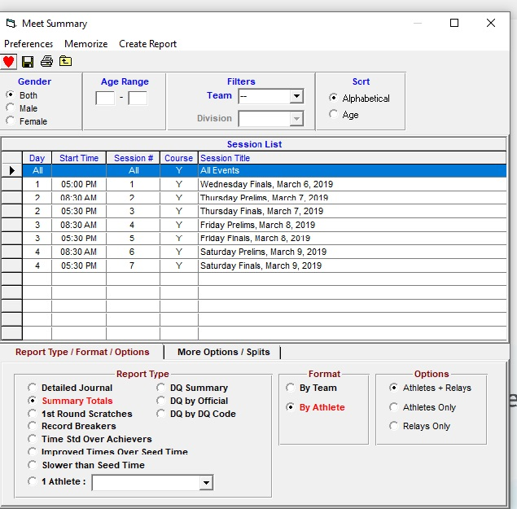

Finally, I am getting more and more last-minute meet requests. My goal is to be as helpful and accommodating as possible. Please help me help you by:
- Completing and sending RTC plan, Application and Supplemental application.
- Sending in the meet announcement for review preferably at least a month in advance of the meet.
- Sending in the meet sanction fee before or at the time of application.
If there is anything I can do to help you or make sanctioning a meet easier, please let me know.
Thank you again and I look forward to a great LC Season,

Carri Oviatt, UTSI Sanctions Coordinator

