**45 minute Dry-land Workout**

**4 min**

1. **4 x 45 sec hold crunches**, 15 sec rest. Blow all air out, isolate core, keep head elevated, hands behind head w/o lifting, raise shoulders off ground by contracting core, and curling back, keep elbows wide to isolate core. Keeping the elbows “flat” or in the plane of the body, helps isolate the core, and limits pulling on the neck.

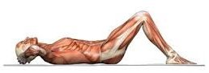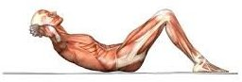

A

B

**3 min**

1. **3x40 sec air kick**, 20 sec rest. Put thumbs under hips. The kick should be high frequency (fast), small amplitude (toes 2-3 inches apart), with toes curled and pointed towards.

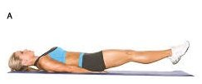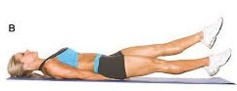

**2 min**

1. **20 pushups**: keep back straight, touch nose and chest to the ground

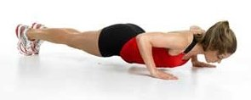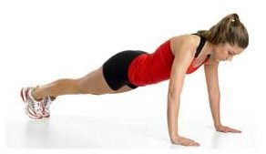

**4 min**

1. **"The bridge"** performed on back with knees bent, hips elevated, so that a line can be drawn from knees to shoulders, one leg is then extended and 10 slow air kicks with each leg, isolating gluts, core, and low back. ***Start and Stop*** with hips up and both feet on the ground to verify proper isolation of gluts, and foot position.

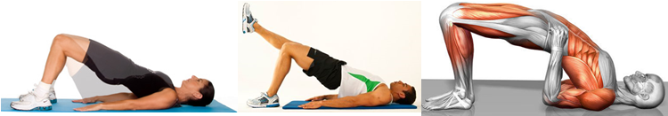

**4 min**

1. **"The plank"** body is held straight on elbows and toes, one leg is held away from body at 30-45 degrees for 10 sec, repeat with each leg 4X, isolating core, low and upper back. When starting this

exercise, beginners may start with the first pose below, advance to the second pose, and then finally

do more advanced poses (not shown) where the leg is moved away from the body.

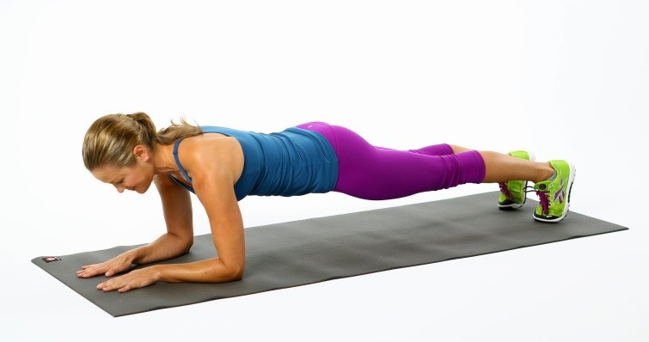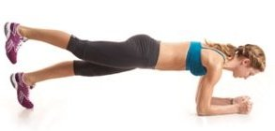

**2 min**

1. **Arms at sides (or overhead) back arch, balance on hips, legs off ground** 3x (30 sec contraction 15 sec rest). Keep top of head perpendicular to the ground (this is a butterfly/breast stroke drill), arms at sides, fingertips pointed to ground, elbows “popped

 

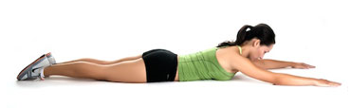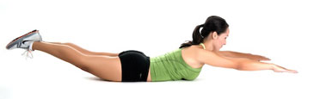

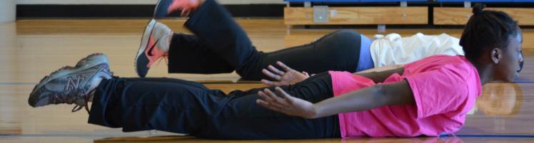

**2min**

1. **Arms wide “thumbs up, Hitch Hiker drill”, on stomach**. Stomach, hips, shoulders and chin stay on the ground. Squeeze shoulder blades (see pics), lift hands off floor, and move slightly towards head to look like a “Y”, hold 5-10 sec, rest 5-10 sec. With improvement Hold longer

[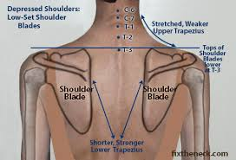](http://www.google.com/url?sa=i&rct=j&q=&esrc=s&source=images&cd=&cad=rja&uact=8&ved=0CAcQjRw&url=http://fixtheneck.com/shoulder_blades.html&ei=b99TVJ-mJouiyATl5YLwAw&psig=AFQjCNGOCKORT_oCV_hKcJ8jZ-j1j1oeIw&ust=1414869118548954) [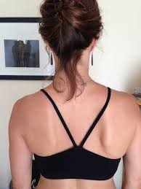](http://www.google.com/url?sa=i&rct=j&q=&esrc=s&source=images&cd=&cad=rja&uact=8&ved=0CAcQjRw&url=http://yogaforhealthyaging.blogspot.com/2013/06/which-way-should-your-shoulder-blades-go.html&ei=4t5TVMjzN9GUyATo04DoDw&psig=AFQjCNFTgRdVzwQET4m2Psa8HJTscEBBHg&ust=1414869311322086) 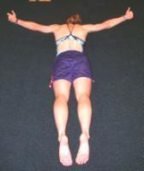

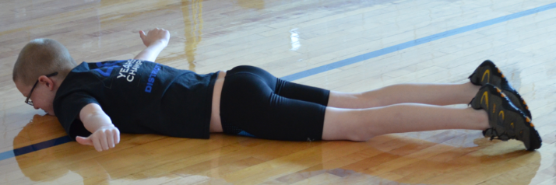

**2 min**

1. **20 straight leg raises**: legs never touch the ground, raise legs to 45 degrees.

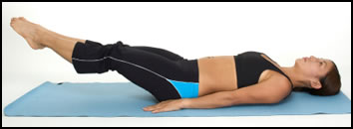 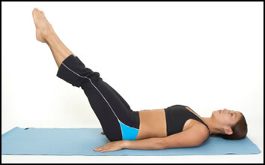

**2 min**

1. **Bent Row Pull.** Standing with a rope attached to an anchor, KEEPING the ELBOWS ON BODY with perfect posture (necks in line with the spine, shoulders blades back and down, head-shoulders- hips-heels in-line) perform an isometric contraction. You will need to adjust your grip on the rope to precisely allow no slack in the rope between your hands and the “anchor”, all the while keeping elbows on body. Keeping back vertical, good posture, contract shoulder blades, and pull on rope without letting elbows leave body. 30 sec isometric contraction, 15 sec rest, repeat 3X. The pull can also be done by leaning 10-20 degrees from vertical, and just maintaining the elbows on the hips, shoulder blades contracted, and necks in line with the spine.

