Integrity, Inclusion, Education, Excellence
Halloween Town USA -Open Invite
Hosted By: Brighton Aquatics
October 23-24
Sanction – This meet is sanctioned by Michigan Swimming, Inc. (MS), as a timed final meet on behalf of USA Swimming (USA-S), Sanction Number MI2122012. MS or USA-S may revoke this sanction at any time in response to the COVID-19 pandemic.
It is understood and agreed that USA Swimming shall be free and held harmless from any liabilities or claims for damages arising by reason of injuries, including exposure to or infected with COVID-19 which may result in illness, personal injury, permanent disability, and/or death, to anyone during the conduct of the event.
It is further understood and agrees that Michigan Swimming, Inc. shall be free and held harmless from any liabilities or claims for damages arising by reason of injuries, including exposure to or infected with COVID-19 which may result in illness, personal injury, permanent disability, and/or death, to anyone during the conduct of the event.
An inherent risk of exposure to COVID-19 exists in any public place where people are present. COVID-19 is an extremely contagious disease that can lead to severe illness and death. According to the Centers for Disease Control and Prevention, senior citizens and individuals with underlying medical conditions are especially vulnerable.
USA Swimming, Inc., cannot prevent you (or your child(ren)) from becoming exposed to, contracting, or spreading COVID-19 while participating in USA Swimming sanctioned events. It is not possible to prevent against the presence of the disease. Therefore, if you choose to participate in a USA Swimming sanctioned event, you may be exposing yourself to and/or increasing your risk of contracting or spreading COVID-19.
BY ATTENDING OR PARTICIPATING IN THIS COMPETITION, YOU VOLUNTARILY ASSUME ALL RISKS ASSOCIATED WITH EXPOSURE TO COVID-19 AND FOREVER RELEASE AND HOLD HARMLESS USA SWIMMING, MICHIGAN SWIMMING, AND Brighton High School, Brighton Aquatics AND EACH OF THEIR OFFICERS, DIRECTORS, AGENTS, EMPLOYEES OR OTHER REPRESENTATIVES FROM ANY LIABILITY OR CLAIMS INCLUDING FOR PERSONAL INJURIES, DEATH, DISEASE OR PROPERTY LOSSES, OR ANY OTHER LOSS, INCLUDING BUT NOT LIMITED TO CLAIMS OF NEGLIGENCE AND GIVE UP ANY CLAIMS YOU MAY HAVE TO SEEK DAMAGES, WHETHER KNOWN OR UNKNOWN, FORESEEN OR UNFORESEEN, IN CONNECTION WITH EXPOSURE, INFECTION, AND/OR SPREAD OF COVID-19 RELATED TO PARTICIPATION IN THIS COMPETITION.
You acknowledge the contagious nature of COVID-19 and voluntarily assume the risk that your family, including child(ren), may be exposed to or infected by COVID-19 while on site at the pool or facility and that such exposure or infection may result in the personal injury, illness, permanent disability and death. You understand that the risk of becoming exposed to or infected by COVID-19 at the pool or facility may result from the actions, omissions, or negligence of myself and others, including but not limited to employees, volunteers and program participants and their families.
Brighton Aquatics will include the above information in meet announcements, heat sheets and posted around the pool facility.

COVID-19 Procedures/Requirements
All athletes, coaches, officials, clubs, spectators, and other individuals participating in this meet or seeking ingress into the facility in which this meet is conducted will abide by (1) all federal, state, and local laws, orders, administrative rules, and guidelines; (2) all protocols outlined in the COVID-19 LSC Supplemental Sanction Requirements documents for this meet; and (3) all COVID-19 preparedness plans for the relevant facility. Failure to maintain strict compliance with all COVID-19 procedures and protocols will result in disciplinary action by the Michigan Swimming, Inc. Board of Directors, including, but not limited to, fines, suspension of certain membership privileges, or referral to the USA Swimming National Board of Review with a recommendation to terminate a member’s membership in Michigan Swimming and USA Swimming.

Minor Athlete Abuse Prevention Policy Acknowledgement
All applicable adults participating in or associated with this meet acknowledge that they are subject to the provisions of the USA Swimming Minor Athlete Abuse Prevention Policy (“MAAPP”), and that they understand that compliance with the MAAPP policy is a condition of participation in the conduct of this competition.

Location
Brighton High School: 7878 Brighton Rd. Brighton, MI 48116

Times- Subject to change depending on entry submissions.
Saturday AM 9:30 Warm up; 10:15 Start
Saturday PM 1:00 Warm up; 1:45 Start
Sunday AM 9:30 Warm up; 10:15 Start
Sunday PM 1:00 Warm up; 1:45 Start

Facilities
Brighton High School, is a 12 lane pool with a supervised warm-up and warm down area available. Depth at start is 8.5-13ft and 4ft at turn. Permanent starting blocks and non-turbulent lane markers will be used. Colorado timing system with a(n) 8 lane display will be used.
Course Certification
The competition course has not been certified in accordance with 104.2.2C(4)

Meet Format
This is a timed final meet

Eligibility All athletes and clubs registered with Michigan Swimming or another USA Swimming LSC are eligible to participate in this meet.

Entry Procedures
Entries may be submitted to the Administrative Official as of October 1 9:00am. The Administrative Official must receive all entries no later than October 12 11:59pm. Entries must include correct swimmer name (as registered with USA/MS Swimming), age and USA number. All individual entries should be submitted via electronic mail at the e-mail address listed in the last section of this meet information packet.

Entry Acceptance and Processing Entries will be accepted and processed on a first come, first served basis in the order in which they are received after the entry open date listed.

Individual Entry Limits
Swimmer may enter a maximum of 4 events per day.

Entry Fees
$ 5.00 per individual event. Make checks payable to Brighton Aquatics

Surcharges
A $1.00 per athlete Michigan Swimming athlete surcharge applies.

Paper Entries
MS rules regarding non-electronic entries apply. $6.00 per individual event. There is $1.00 additional charge per event paid if the entry is not submitted in Hy-Tek format. Any surcharges detailed in the previous section also apply to paper entries. Paper entries may be submitted to the Administrative Official on a spreadsheet of your choice however, the paper entry must be logically formatted and must contain all pertinent information to allow the Administrative Official to easily enter the swimmer(s) in the correct events with correct seed times.
Refunds
Once a team or individual entry has been received and processed by the Administrative Official there are no refunds in full or in part unless the “over qualification exception” applies (see MS Rules).

Entry Paperwork
Your club’s Entry, Entry Summary Sheet, Release/Waiver, Certification of Entered Athletes and Check should be sent via U.S. mail or nationally recognized overnight courier to:

Brighton Aquatics Attn: Jason Black
7878 Brighton Rd. Brighton MI 48116

Check In Check-in will not be required.

Marshaling
Swimmers will be responsible for reporting to the marshaling area when their event is called.

Seeding
The meet will be pre-seeded after entries are closed.

Deck Entries
Deck entries will be allowed for events with open lanes and will be conducted in accordance with current Michigan Swimming, Inc. rules & procedures, including all Michigan Swimming, Inc. COVID-specific sanctioning or approval policies. The deck entry fee is $7 per event. If an athlete is not currently registered with Michigan Swimming or another USA Swimming LSC, the athlete must deck register for a $168.00 fee before being entered into the meet.

Meet Programs/Admissions
The admission fee will be $5.00 per person per day. No heat sheets will be sold, they will be available on meet mobile.

Scoring
There will be no individual or team scores kept.

Awards
Heat winners and ribbons up to 8th place per event.

Results
Complete Official meet results will be posted on the Michigan Swimming Website at http://www.miswim.org/. Unofficial results will also be available on flash drive (HY-TEK Team Manager result file) upon request. Teams must provide their own flash drive.

Concessions
No concessions will be available. No food or beverage will be allowed on the deck of the pool, in the locker rooms or in the spectator areas. A hospitality area will be available for coaches and officials.

Lost and Found
Articles may be turned in/picked up at the lost and found bin outside the pool office door on deck. Articles not picked up by the end of the meet will be retained by the Meet Director or a representative for at least 14 days (any longer period shall be in the sole discretion of the Meet Director).

Swimming Safety
Michigan Swimming warm up rules will be followed. To protect all swimmers during warm-ups, swimmers are required to enter the pool feet first at all times except when sprint lanes have been designated. No jumping or diving. The same rules will apply with respect to the warm-down pool and diving well. Penalties for violating these rules will be in the sole discretion of the Meet Referee which may include ejection from the meet.

Racing Start Certification
Any swimmer entered in the meet must be certified by a USA Swimming member-coach as being proficient in performing a racing start or must start each race from within the water without the use of the backstroke ledge. When unaccompanied by a member-coach, it is the responsibility of the swimmer or the swimmer’s legal guardian to ensure compliance with this requirement.

Deck Personnel/Locker Rooms/Credentialing
Only registered and current coaches, athletes, officials and meet personnel are allowed on the deck or in locker rooms. Access to the pool deck may only be granted to any other individual in the event of emergency through approval by the Meet Director or the Meet Referee. The Michigan Swimming Board of Directors, Officials Chairs of MS, and the Michigan Swimming Office staff are authorized deck personnel at all MS meets. Personal assistants/helpers of athletes with a disability shall be permitted when requested by an athlete with a disability or a coach of an athlete with a disability.
Lists of registered coaches, certified officials and meet personnel will be placed outside the main pool entry door. Meet personnel will check the list of approved individuals and issue a credential to be displayed at all times during the meet. This credential will include the host team Brighton Aquatics as well as the function of the individual being granted access to the pool deck (Coach, Official, Timer, or Meet Personnel). In order to obtain a credential, Coaches and Officials must be current in all certifications through the final date of the meet. Meet personnel must return the credential at the conclusion of working each day and be reissued a credential daily.
All access points to the pool deck and locker rooms will either be secured or staffed by a meet worker checking credentials throughout the duration of the meet.

Swimmers with Disabilities
All swimmers are encouraged to participate. If any of your swimmers have special needs or requests, please indicate them on the entry form and with the Clerk of Course and/or the Meet Referee during warm ups.

First Aid
Supplies will be kept in the pool office.

Facility Items
(A) No smoking is allowed in the building or on the grounds of any facility listed above.
(B) Pursuant to applicable Michigan law, no glass will be allowed on the deck of the pool or in the locker rooms.
(C) No bare feet allowed outside of the pool area. Swimmers need to have shoes to go into the hallway to awards or concessions.
(D) An Emergency Action Plan has been submitted by the Host Club to the Safety Chair and the Program Operations Chair of Michigan Swimming prior to sanction of this meet and is available for review and inspection at the pool office.
(E) To comply with USA Swimming privacy and security policy, the use of audio or visual recording devices, including a cell phone, is not permitted in changing areas, rest rooms or locker rooms.
(F) Deck changing, in whole or in part, into or out of a swimsuit when wearing just one
suit in an area other than a permanent or temporary locker room, bathroom,
changing room or other space designated for changing purposes is prohibited.
(G) Operation of a drone, or any other flying apparatus, is prohibited over the venue (pools, athlete/coach areas, spectator areas and open ceiling locker rooms) any time athletes, coaches, officials and/or spectators are present.

General Information and Errors/Omissions
Any errors or omissions in the program will be documented and signed by the Meet Referee and available for review at the Clerk of Course for Coaches review. Information will also be covered at the Coaches’ Meeting.

Meet Personnel

Meet Director: Jason Black/(810)299-4146/blackj@brightonk12.com
Meet Referee: Chuck Krochmal/(313)378-4954/krochmal@chartermi.net
Safety Marshal: Kelsey Hudson
Administrative Official: Alyssa De Leon/phone/(313)399-8289/swimentriesAW@gmail.com

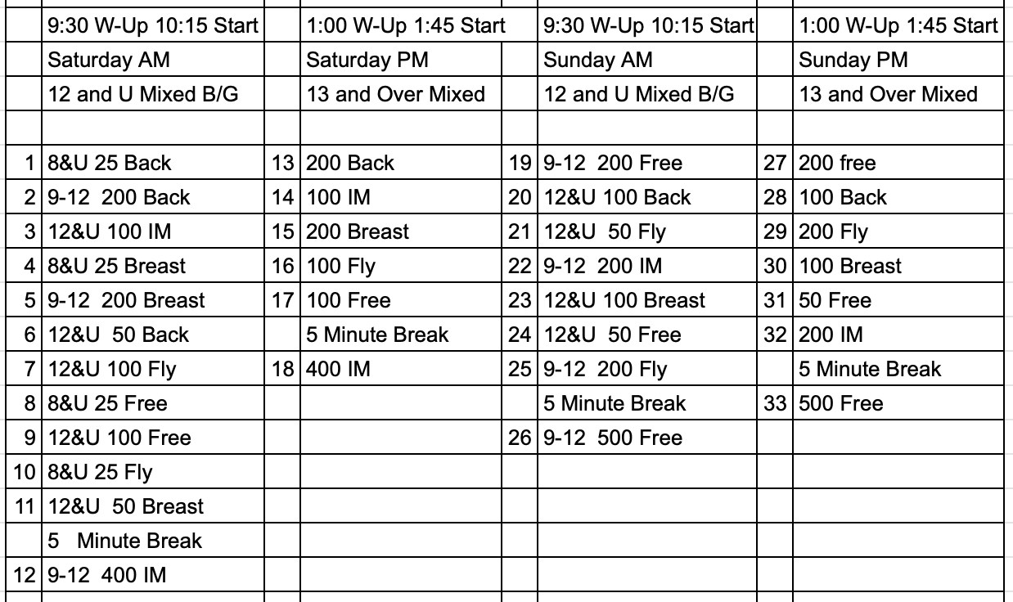

CERTIFICATION OF REGISTRATION STATUS OF ALL ENTERED ATHLETES
RELEASE AND WAIVER
Halloween Town USA
Sanction Number: MI2122012
Enclosed is a total of $__________ covering fees for all the above entries. In consideration of acceptance of this entry I/We hereby, for ourselves, our heirs, administrators, and assigns, waive and release any and all claims against Brighton Aquatics, Brighton HS Pool, Michigan Swimming, Inc., and United States Swimming, Inc. for injuries and expenses incurred by Me/Us at or traveling to this swim meet.
>>>>>>>>>>>>>>>>>>>>>>>>>>>>>>>>>>>>>>>>>>>>>>>>>>>>>>>>>
In granting the sanction it is understood and agreed that USA Swimming and Michigan Swimming, Inc. shall be free from any liabilities or claims for damages arising by reason of injuries to anyone during the conduct of this event.
Michigan Swimming Clubs must register and pay for the registration of all athletes that are contained in the electronic Entry File or any paper entries that are submitted to the Meet Host with the Office of Michigan Swimming prior to submitting the meet entry to the meet host. Clubs from other LSCs must register and pay for the registration of their athletes with their respective LSC Membership Coordinator.
A penalty fee of $100.00 per unregistered athlete will be levied against any Club found to have entered an athlete in a meet without first registering the athlete and paying for that registration with the Office of Michigan Swimming or respective LSC Membership Coordinator.
Submitting a meet entry without the athlete being registered and that registration paid for beforehand may also subject the Club to appropriate Board of Review sanctions.
The authority for these actions is: UNITED STATES SWIMMING RULES AND REGULATIONS 302.4 FALSE REGISTRATION – A host LSC may impose a fine of up to $100.00 per event against a member Coach or a member Club submitting a meet entry which indicates a swimmer is registered with USA Swimming when that swimmer or the listed Club is not properly registered. The host LSC will be entitled to any fines imposed.
>>>>>>>>>>>>>>>>>>>>>>>>>>>>>>>>>>>>>>>>>>>>>>>>>>>>>>>>>
I certify that all athletes submitted with this meet entry are currently registered members of USA Swimming and that I am authorized by my Club to make this representation in my listed capacity.
Signature: | Position:
Street Address: | City, State Zip:
Club Email: | Phone:
Coach Name: | Club Name:
Coach Email: | Club Code:

