BYNS Suits
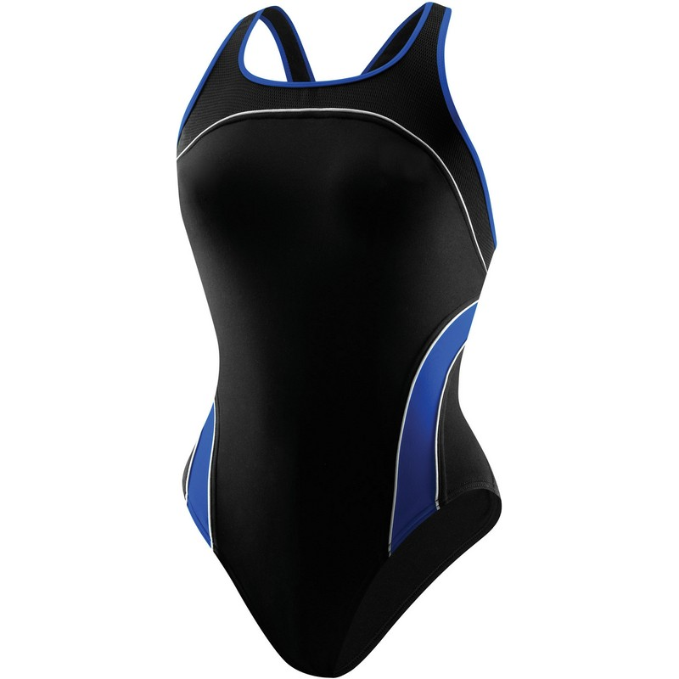
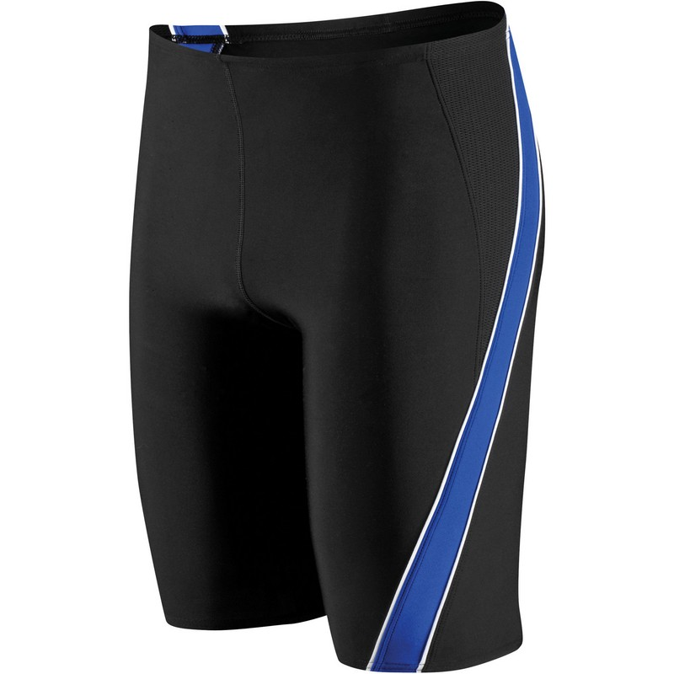
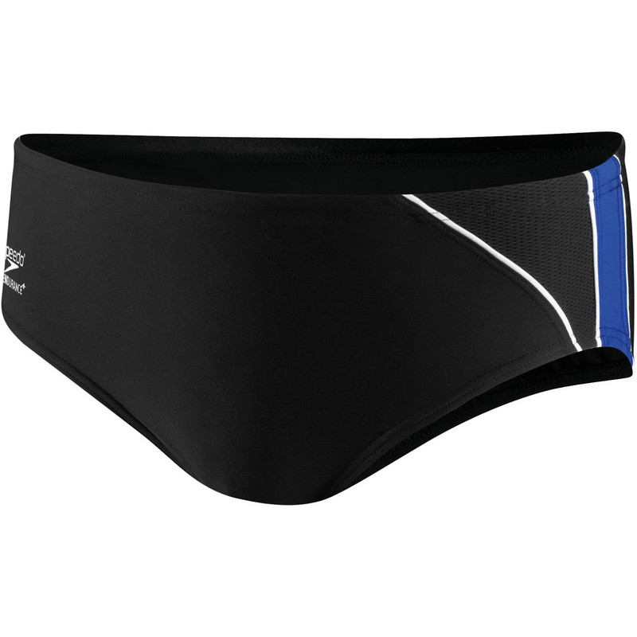

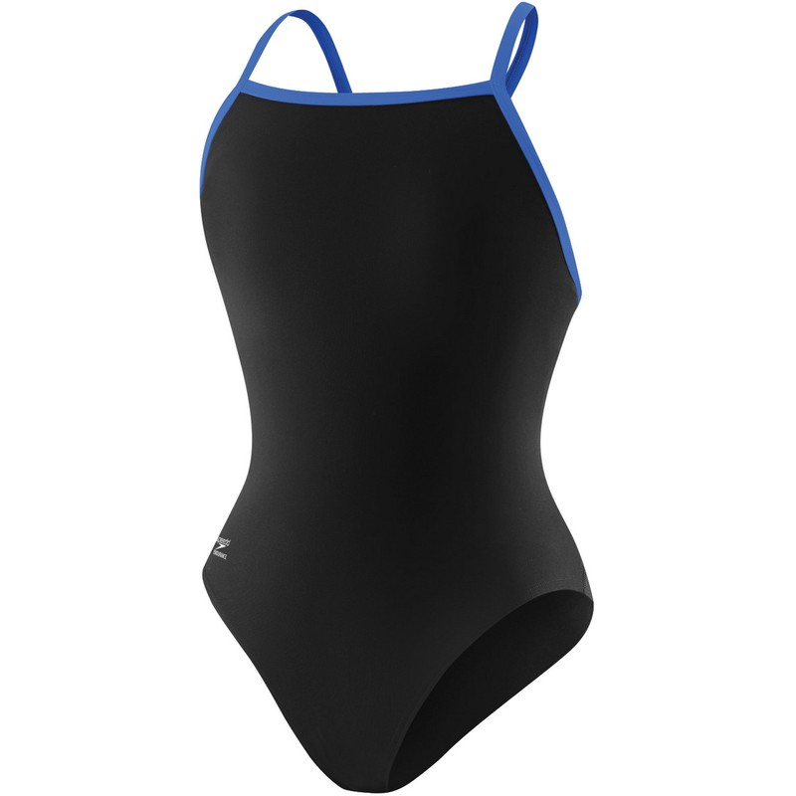
Mercury Female | $56.18
Flyback Female | $47.40
Jammer | $38.16
Brief | $31.80

Female Mercury Splice(thick strap):______
Female Flyback Blue Strap (thin strap):____
Men’s Jammer:______
______________________________________

Name__________________
Phone(__ __ __)__ __ __--__ __ __ __

D&J Sports
Orders Due September 29, 2013

BYNS Swimming 2013

Speedo Hydralign Center Snorkel $33.00 _______________

Speedo Cardio L02 Top $7.99 ___________________
Speedo DT Top (Dry Top) $11.99________________

Speedo Short Blade Training Fin $26.00____________
Strokemaker Paddle $15.00________________

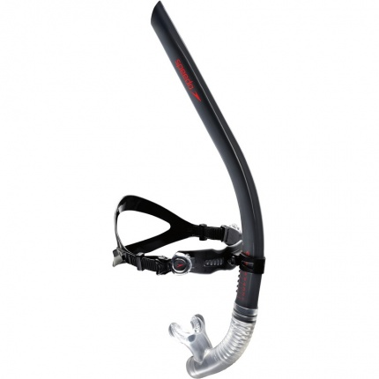
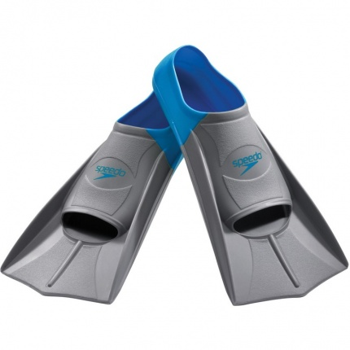
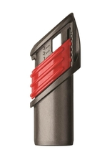
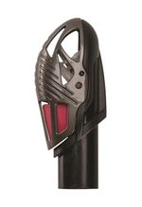
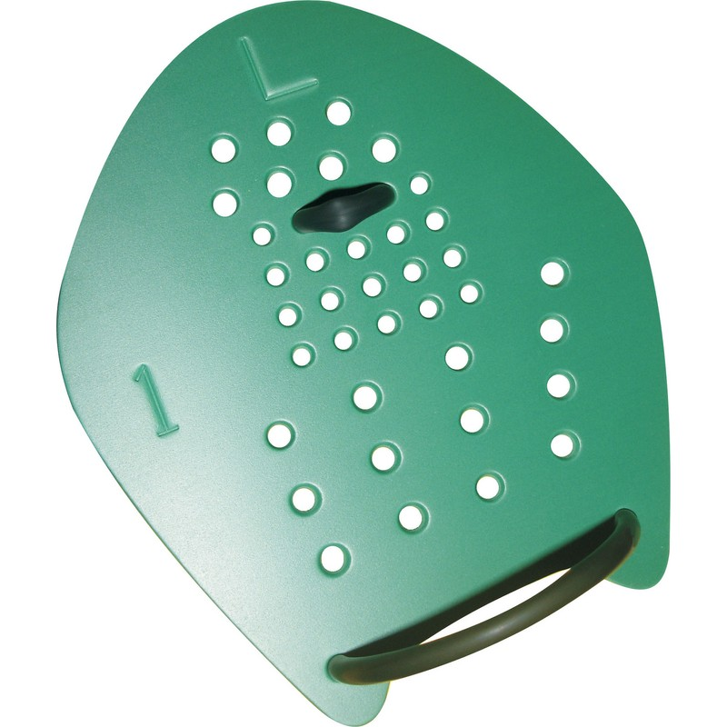

Name________________ Phone#(__ __ __) - __ __ __ - __ __ __ __

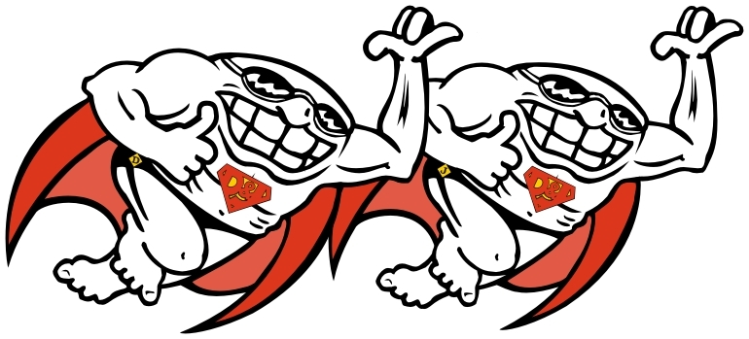
^{Please Print}
E-Mail_________________________________________________________
Deadline October 1, 2010
jway@djsports.com

D&J Sports
610-282-5895
BYNS 2013 Team Apparel

SPEEDO Boom Force Jacket: Adult $72.00 Youth $65.00

Jacket will have embroidery on chest and back with option for name.

Circle One: Youth (S-L only) Male Female
Circle One Size: XS S M L XL XXL (male only)
Name to be embroidered $9.00 ___________________________

SPEEDO Boom Force Pants: Adult $39.00 Youth $33.00
Circle One: Youth (S-L only) Male Female
Circle One Size: XS S M L XL XXL (male only)

Speedo Team Back Pack: $62.00 (includes embroidery and name)

Name to be embroidered:__________________________

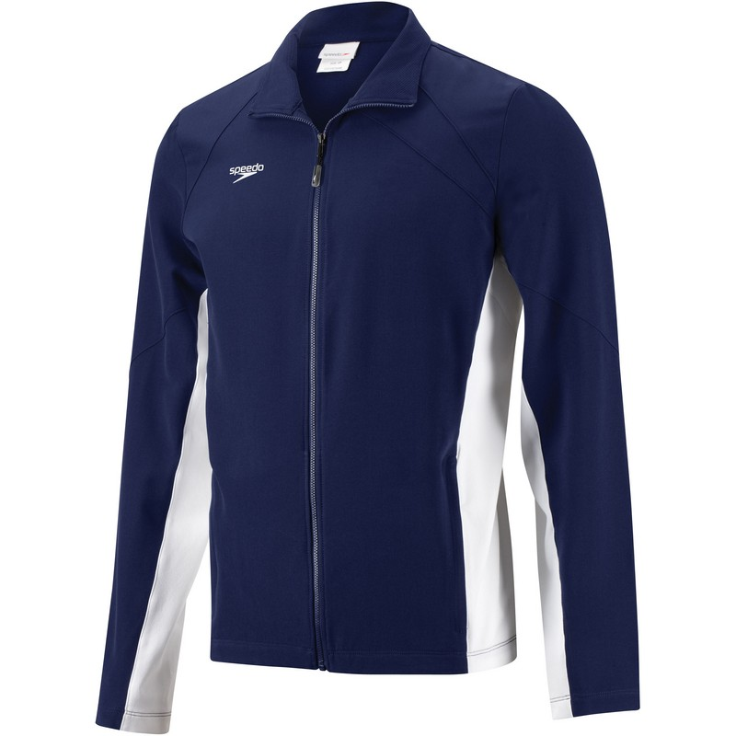
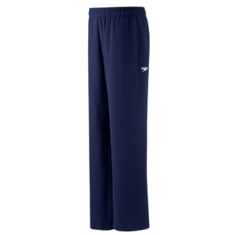
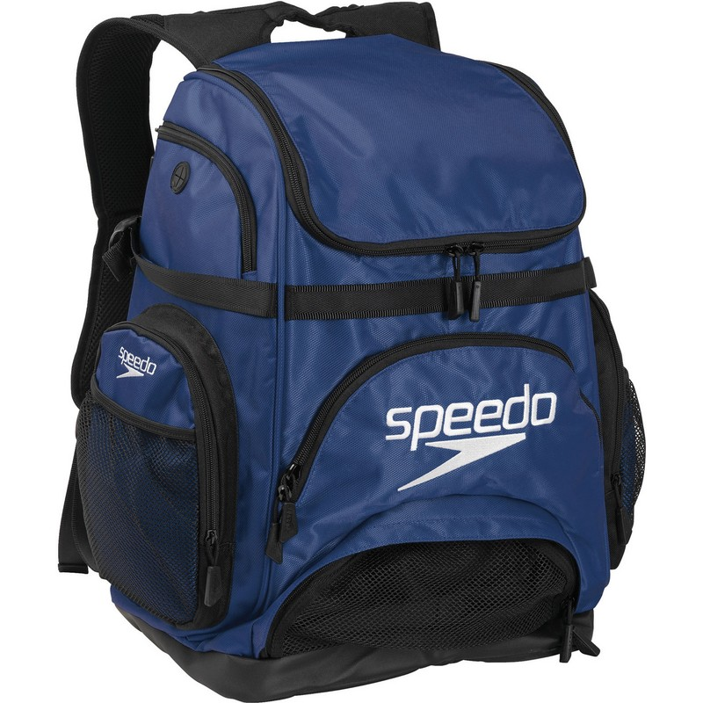

Name________________________ Phone#(__ __ __) - __ __ __ - __ __ __ __

^{Please Print}

D&J Sports
610-282-5895

Deadline September 29, 2013

BYNS Cap

Circle One

Silicone Cap No Personalization $8.50

2 Silicone Cap with Personalization $24.00

2 Latex Caps with Personalization $12.50

Personalized caps are a minimum of 2 per order

Name to be personalized

Name__________________
Phone(__ __ __)__ __ __--__ __ __ __

Deadline September 29, 2013


