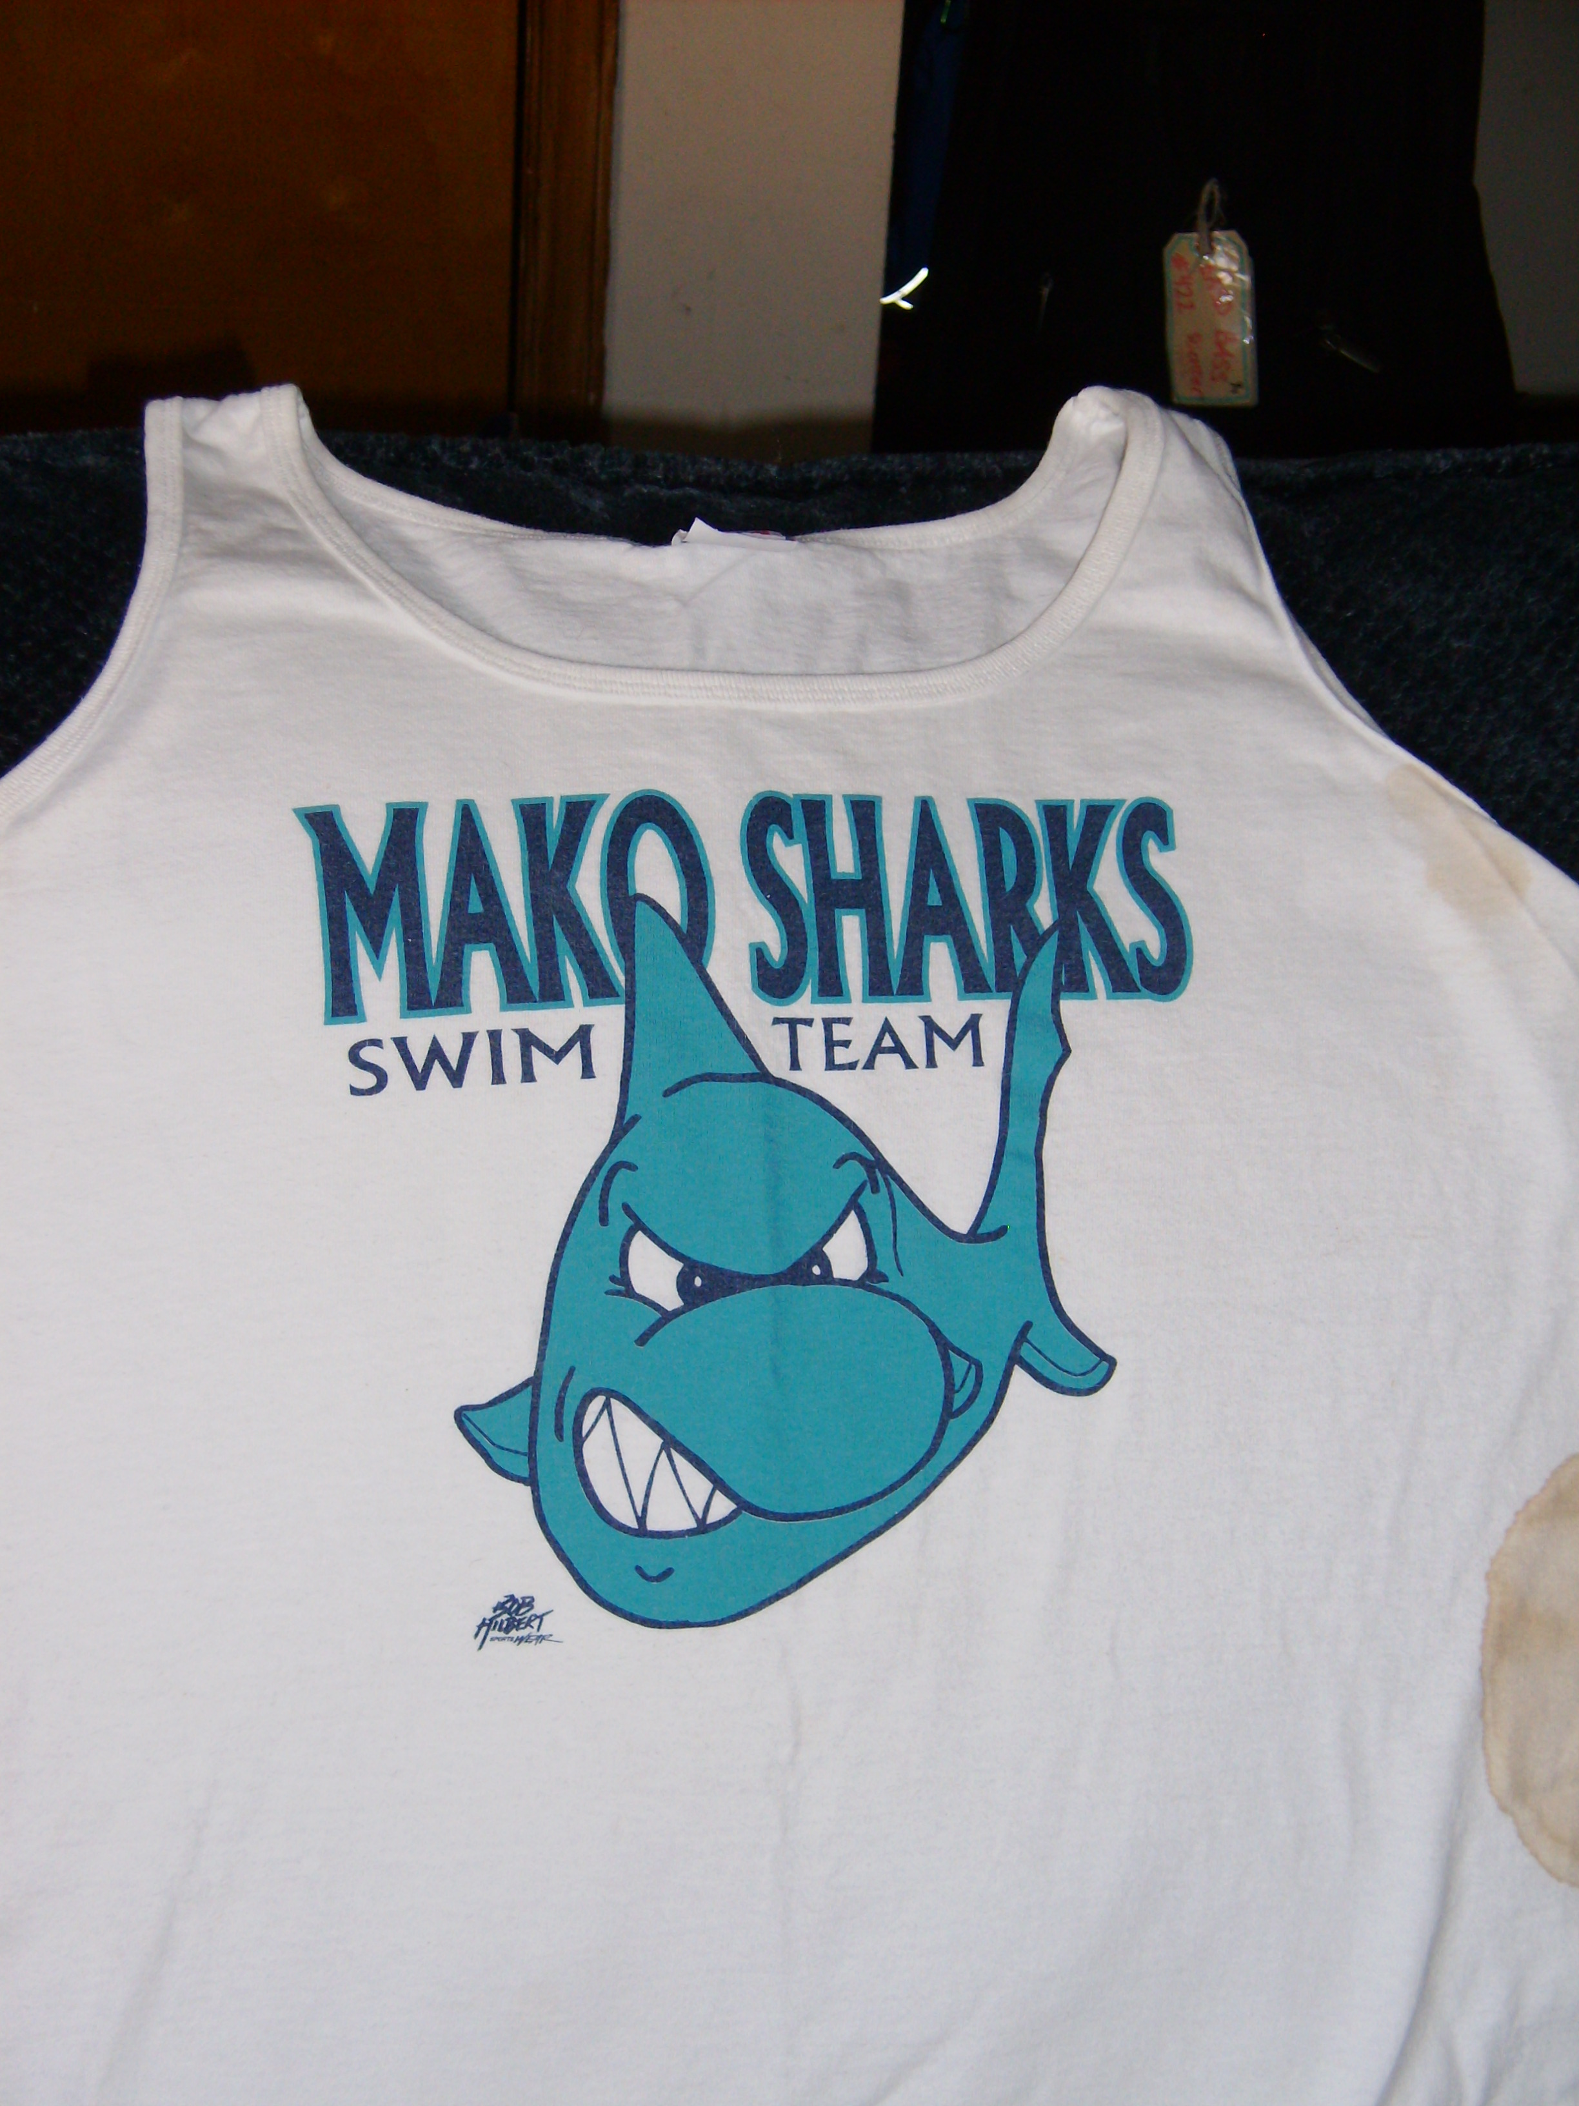
Order your Mako Sharks tank top today!
 | S | M | L | XL | 2XL
LADIES |  |  |  |  | N/A
MENS
This tank top is the same design as the one the
swimmers on the 2009 Mako Sharks Team will
receive as the team gift. Tank tops are $10 each.
No. Shirts ordered _______ x $10 = ____________ due

Name______________________ Phone # ___________

Please make all check payable to:
Boyertown Area YMCA

Please put all orders with payment in the
“Parent Tank Top” Folder by July 20, 2009.
Order will be placed the morning of July 21, 2009.

