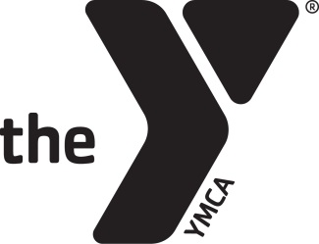
..

PHILADELPHIA FREEDOM VALLEY YMCA BOYERTOWN BRANCH SWIM TEAM PARENT VOLUNTEERS
CLEARANCE INSTRUCTIONS

All Boyertown YMCA Swim Team Parent Volunteers are required to obtain a PA Child Abuse History Clearance and a PA State Police Criminal Record Clearance. The state of Pennsylvania has now made these clearances no charge for volunteer purposes only.
**If you have obtained these clearances for another purpose, please bring us copies of those forms**
To obtain the PA State Police Criminal Record Clearance please log on to https://epatch.state.pa.us/Home.jsp and click on the yellow box that states New Record Check (Volunteers Only). Follow the instructions throughout the next few screens and in most cases your clearance will be ready to print in a few minutes.
To obtain the PA Child Abuse History Clearance please log on to https://www.compass.state.pa.us/cwis/public/home and create an individual account. You will then be prompted through a number of screens asking for information. On the screen where it asks for Application Purpose please mark Volunteer Having Contact with Children: Applying for the purpose of volunteering as an adult for an unpaid position as a volunteer….. In some cases it might take a few days for the clearance to be ready to print so please remember your log-in information. When your clearance is ready to print you will see a green box that says Your application has been processed. To view the result, click here.

Please return copies of your clearances to Head Coach Raynelle Shirk as soon as possible.
If you have any questions, please contact Raynelle at 610-369-9622, ext. 3216.

