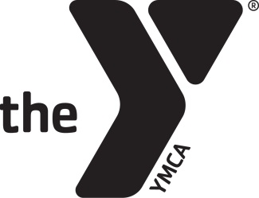
..

Thank you for offering to volunteer your time at the Boyertown YMCA. In order to volunteer you will need to complete the following:
- Obtain FBI(if you lived outside Pennsylvania within the last 10 years), Criminal Background and Child Abuse Clearances
- Complete Mandated Reporter and Safety/Childcare Orientation On-line Training
- Sign and date the PFVY safe sports volunteer form
- Review Keeping Kids Safe document

Once you agree to complete the volunteering requirements you will receive instructions on how to complete the requirements.

_______________________________ ________________________________

Print Name Signature

E-mail address:_____________________________

