How to Guide: Signing up for a Team Function or Event
Click on The Team Functions Tab under Events at the bottom of our Home Page.
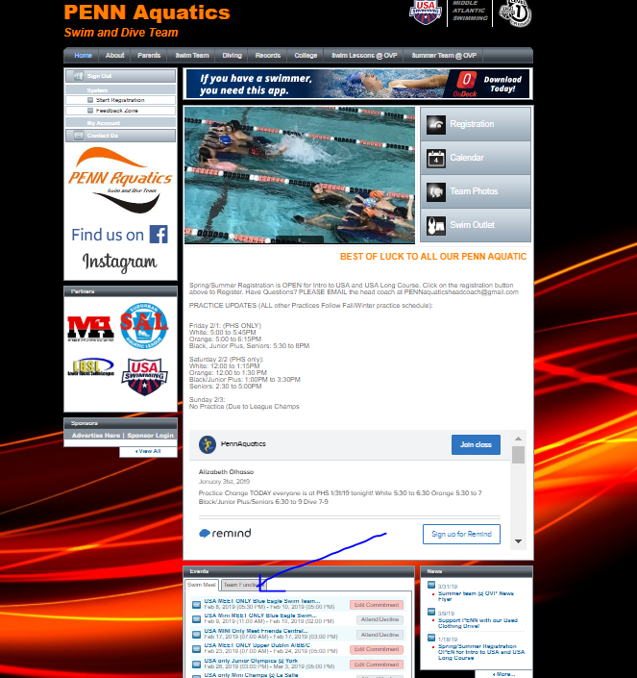

Click on the event you will be attending:
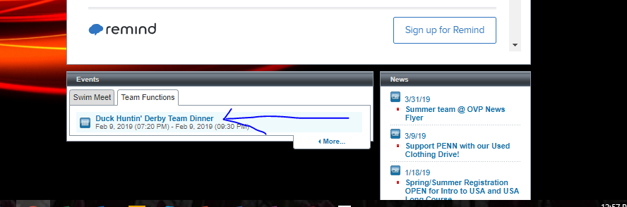

Click the Register Online Button.
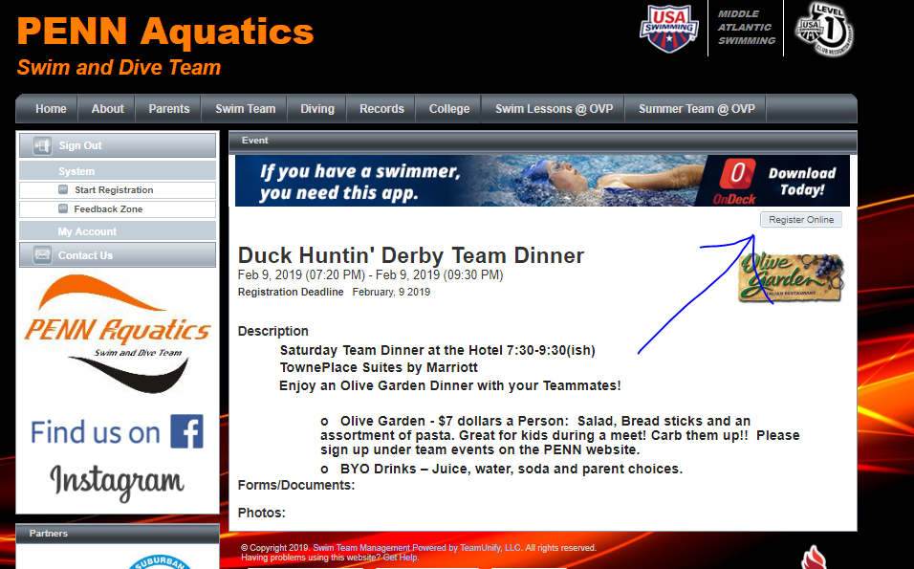

Click Continue.

Click on your child’s name and select Event/Activity Tickets under Register for this group and then click continue. Please do not add any members on this page.
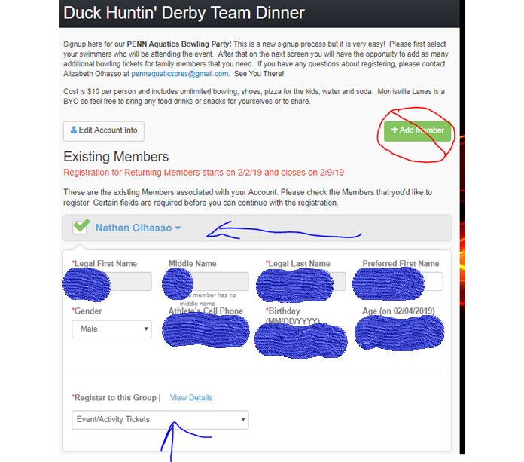

Under Registration Fees, you can see your Child’s name listed and the cost for the event. Add as many additional people you are bringing to the event directly underneath. For example, 2 parents plus your child. The system will automatically calculate the cost. Then click Proceed to Checkout. Please do not add or edit members on this screen.
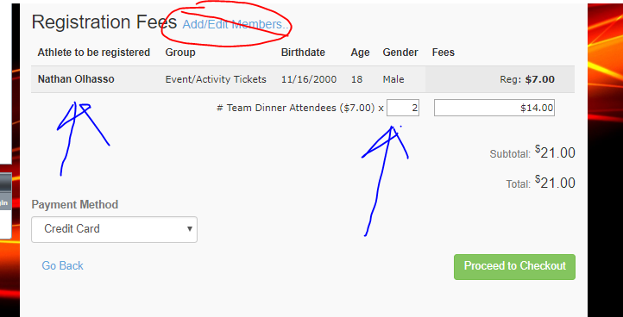

When you check out, just enter the CVV or your credit card and click submit registration. That’s it! If you have any questions, please feel free to email us at pennaquaticspres@gmail.com.

