NAVIGATING THE CALENDAR FOR EVENTS
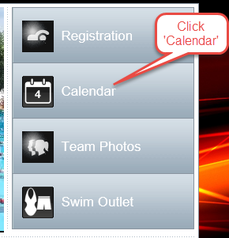

MONTH FORMAT CALENDAR
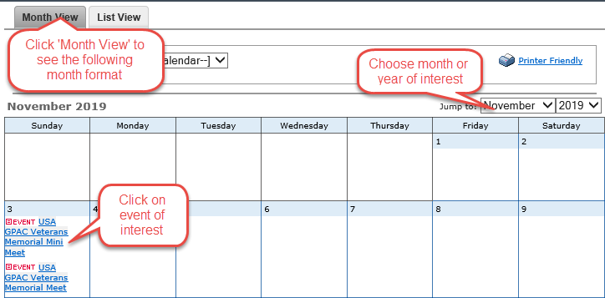

LIST FORMAT CALENDAR
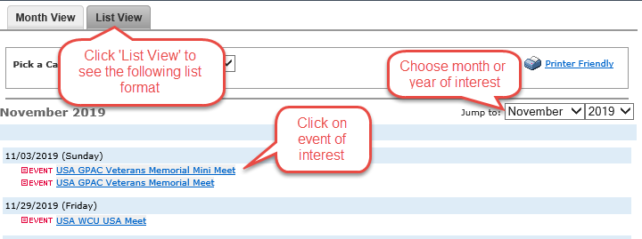

VIEW EVENTS IN THE CALENDAR
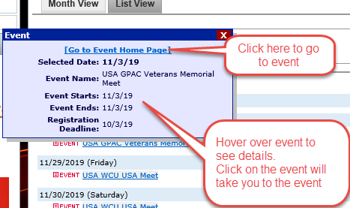

EVENT VIEW
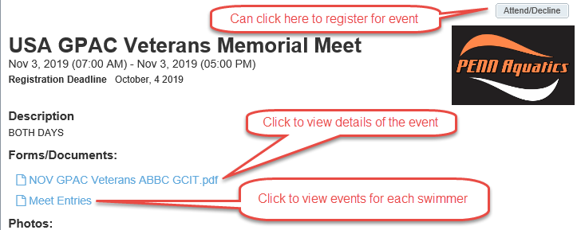

MEET DETAILS
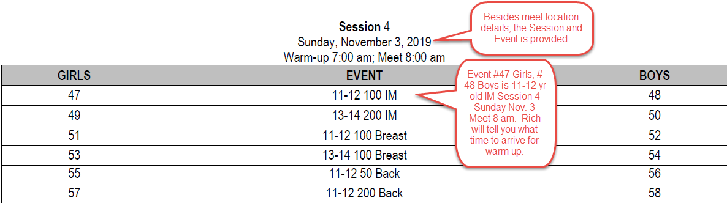

MEET ENTRIES
