TRITON Swim Team Registration Form 2019-2020
In partnership with MN Recreation

Swimmer’s Information

First Name _____________ Middle Name_____________ Last Name__________________

DOB ____/_____/____ Age ______ Grade _______ School _________________________

Number of years in competitive swimming ____

Previous Club Team(s) ___________________Summer Team(s)______________________

T-Shirt Size __________ How did you hear of Triton? ______________________________

Parent Name(s) __________________________________________________________

Phone #____________________Parent Email___________________________________

Address ________________________________________________________________

City/State/Zip ___________________________________________________________

Parent Volunteer Area of Interest: ______________________________________________

Parent’s Cell Phone for Emergency Text _______________ Carrier _____________________

Emergency Contact _____________________________Phone ______________________

Name of Insurance Plan __________________________Group Number ________________

Medical Conditions ____________________________ Allergies_____________________

Name and Address of Father’s Employer:

_________________________________________________________________________________________________________________________

_________________________________________________________________________________________________________________________

Name and Address of Mother’s Employer:

_________________________________________________________________________________________________________________________

_________________________________________________________________________________________________________________________

Please use reverse side for or attach additional medical information, health issues, conditions, behavioral concerns, etc.

Please check if such information is included: _______

TRITON Swim Team Registration Form 2019-2020
In partnership with MN Recreation

Session Registering For: Fall (Sept. 3-Nov. 16) _______ Winter (Nov. 18-March 28) _______

Spring (March 30-May 22) _______

Group Placement: ____________________________________ (Determined By coaches)

Mid Atlantic Groups – Training Groups – Swimmers committed to Swimming as their main sport
Platinum – Top Group – Swimmers ages 11 & up. Swimmers committed to training 5 or 6 days a week, attending meets including championship meets. Swimming is their main sport during the season (Nov. to March). 11-12-year-old swimmers must have 3 BB times in 2 different strokes and must be able to complete 10 x 100 on 1:40.

Royal – Swimmers ages 10 to 14. Swimmers committed to training 4 days a week during the peek season (Nov. to March). Committed to attending meets and Championship meets. 10-year olds must have 3 BB times in 2 different strokes and must be able to complete 10 x 100 on 2:00.

SAL Groups – Teaching Groups – Swimmers are committed to SAL Meets
Blue – Swimmers ages 8 to 12. Swimmers work on stroke technique. They are expected to compete in our dual meet season in the SAL. Also encouraged to compete in MA meets.

White – 8 and under group – Mini team. Swimmers work on stroke technique. They are expected to compete in our dual meet season in the SAL and are encouraged to compete in MA meets.

Clinic Groups – Teaching and Pre-Season Training
High School Group – High School age swimmers that are getting in shape for HS season. Practice is offered 4 days a week for 1 ½ hours per day (Mon.–Thurs.). Swimmers work on technique and conditioning – No meets are required.

Red Group – Swimmers age 9 to 14 that are interested in working on technique but are unable to commit to the training schedule and requirement of the Blue, Royal or Platinum groups. Swimmers are still expected to compete in the SAL meets. Practices will be held 2 times a week for 1 hour.

Payment: Cash, Check or Credit Card. Check Payable to Marple Newtown Recreation.
- Secure your place on the team with a Non-Refundable $75 Registration Fee due once a year for September through August. (*)
- USA Swimming is an additional $75 each year. Registration effective date is September to the following December. (**) if applicable.

Fall Fees Registration Fee USA Swim
High School $275 $75 $75 Total Due
Platinum $360 $75 $75
Royal $325 $75 $75 ________
Blue $265 $75 $75 Total Paid
White $225 $75 $75
Red $215 $75 $75 ________
Winter Payment Special Note:
Winter Payment can be split into 2 payments. 1st payment will be due in November and 2nd payment will be charged on 1/3/2020. This is only if a credit card is on file in November for the start of the session.

Winter Fees Registration Fee USA Swim
Platinum $655 $0/$75* $0/$75** Total Due
Royal $585 $0/$75* $0/$75**
Blue $470 $0/$75* $0/$75** ________
White $405 $0/$75* $0/$75** Total Paid
Red $390 $0/$75* $0/$75**
________
Spring Fees Registration Fee USA Swim
High School $275 $0/$75* $0/$75** Total Due
Platinum $360 $0/$75* $0/$75**
Royal $325 $0/$75* $0/$75** ________
Blue $265 $0/$75* $0/$75** Total Paid
White/Mini $225 $0/$75* $0/$75**
Red $215 $0/$75* $0/$75** ________

Meet Fees Account
A Meet Fee Account set up for your Fall and/or Winter Session swimmer. This is your money to be used towards meets. We will communicate with you when additional funds are needed.

If the money is not used through USA Championships, the money will be forfeited to the team on Wednesday, April 8, 2020.

USA Swimming Meets/USA Championships Meets
White Group -> Pay only as you compete
Blue Group -> Pay only as you compete
Royal Group -> $90
Platinum Group -> $90

SAL Meets (Nov. thru Feb. - Must commit to both Fall and Winter Sessions)
White Group -> $75
Blue Group -> $75
Red Group -> $75

“Spring Session Only” swimmers will not have a Meet Account.

TRITON Swim Team Registration Form 2019-2020
In partnership with MN Recreation

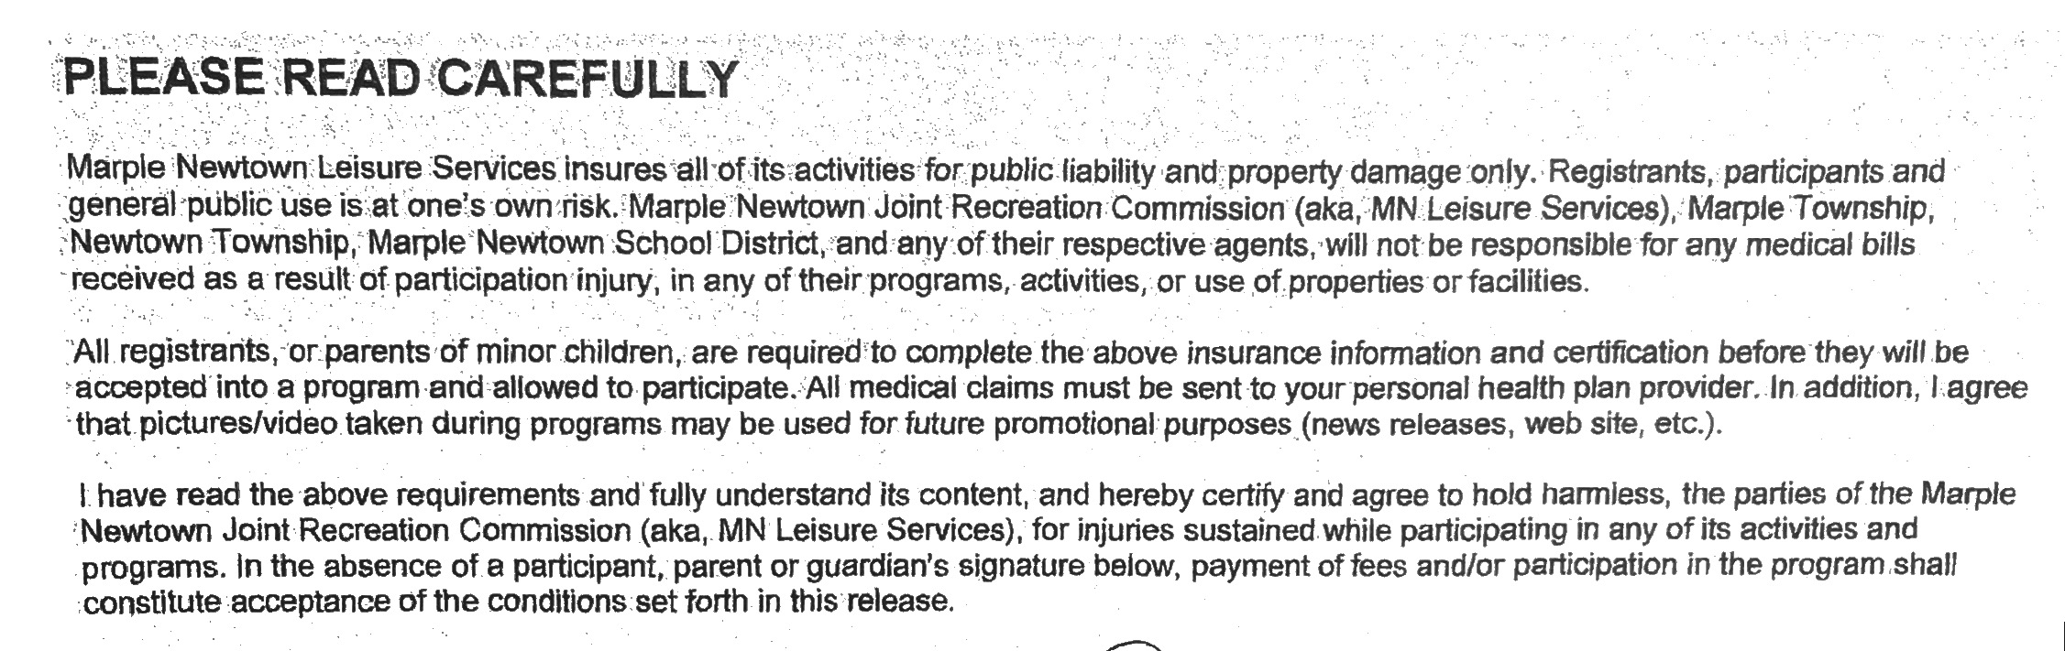

_______________________________ ___________________
Signature of Registrant or Signature of Parent of a minor Date

