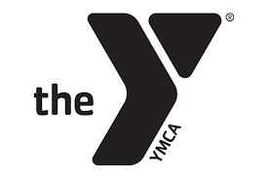
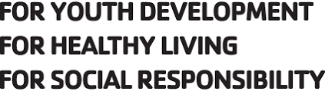
UMLY Locker Room Monitoring Procedures

Attention UMLY Parents and Swimmers
Please be aware of the policy regarding children ages 12 and under at the Upper Main Line YMCA. It reads as follows:
“YMCA facilities and services are available to members within scheduled times. The YMCA will provide direct supervision for youth enrolled in YMCA programs during scheduled programs. The YMCA will not be held responsible for the supervision of children outside program areas or beyond indicated program times. During non-scheduled programming, children under age 12 must be accompanied by an individual over the age of 18 at all times.”
Children under age 12 must be accompanied by an adult over age 18 while in the YMCA. Please make sure you are accompanying your children under age 12 into the building and bring them down to the pool for practice. Please be there to supervise them in the locker rooms and out of the building. Our coaching staff is not responsible for the swimmers outside of the program area (the pool). The UMLY building is very large and we want your children to be safe.

